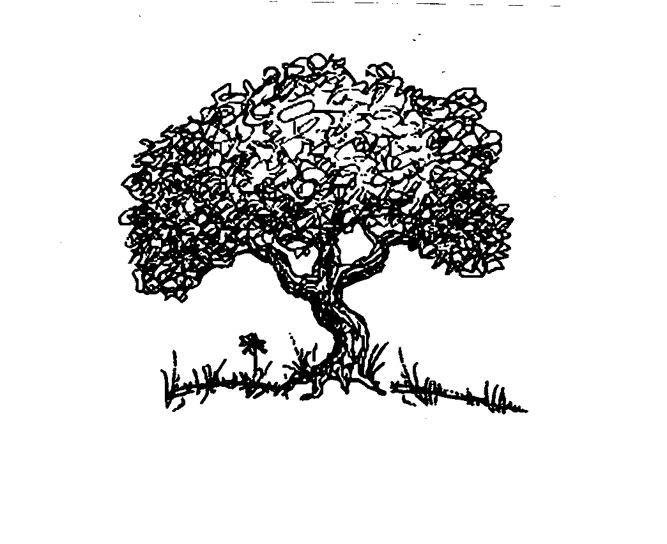

Fawn Gonzales, LCSW
Independent Practitioner
The Sharing Place
14 Cottage Street
Medford, OR 97504
p. (541) 779-2390
f. (541) 779-3260

Electronic Communication Consent

Client Name_____________________________________ Date of birth__________________________

Electronic communication via cell phone, text and email is potentially unsecure. Therefore, electronic communication cannot be guaranteed as confidential.

If I choose to communicate with Fawn Gonzales, LCSW via cell phone, text, and/or email I consent and understand that Fawn Gonzales, LCSW is not responsible for information disclosed.

I have read and I understand the risk associated with electronic communication and I consent to the above terms.

________________________________________________________________ ________________
Signature of Consenting Client and/or Parent, Guardian, or Legal Representative Date

Informed Consent to Telehealth Services

Telehealth involves the delivery of health care services, including assessment, treatment, diagnosis and education, using interactive audio, video and data communication. Potential benefits of telehealth include access to behavioral health care if unable to travel to provider’s office; and during the COVID-19 pandemic, reduced exposure to clients, practitioners and individuals in a physical location.

Potential risks of telehealth include loss of information or unauthorized access to my information due to technological failures.

I agree to receive telehealth services. I consent to, understand and agree that: I have a right to discuss benefits and risks associated with telelhealth; I can request a referral to a different practitioner in effort to be seen face to face; and in the event of technological failures, Fawn Gonzales, LCSW is not responsible for information lost or breached.

________________________________________________________________ ________________
Signature of Consenting Client and/or Parent, Guardian, or Legal Representative Date

