Male Enhancement Capsules by LifeGen Sciences INC

"Quite Simply The Most Potent And Scientifically Backed All Natural Penis Enlargement Product - Ever!" - Dr. A. Woodstock

Yes, this is the very same penis enlargement product that took the adult film industry by storm, and now is being brought to you at an amazing knock down price while still being the same pharmaceutical grade highly potent and totally legal product!

ViaGro - "The Penis Enlargement Pill That Works"
ViaGro is the most powerful penis enlargement pill currently available, and is fast becoming the number one alternative to complicated and painful surgical procedures. This powerful male enhancement product increases penis length and girth, sexual desire and gives you stronger, fuller erections. With an outstanding array of clinical trials and scientific backing, now you can experience this amazing product too!
ViaGro combines all the most potent all-natural herbal ingredients scientifically proven to enhance penis fullness and size, sexual performance and sexual satisfaction, as well as boosting fertility and dramatically increasing sperm count production. It combines all the most potent ingredients from many leading "penis enlargement" products on the market (we won't mention names) as well as including some extras which are important formula keystones making this the most powerful penis length and girth enlarger. What's more all of the ingredients are of the highest standardised pharmaceutical quality, making this the ultimate sexual performance formula. If you are looking for the ultimate all-in-one formula at an outstanding price then you have come to the right place! And please remember that these pills have the maximum potency concentration allowed under UK law!

ViaGro helps you achieve your peak sexual health and performance naturally and safely. ViaGro will allow you to be spontaneous, without the need of taking anything prior to sexual intercourse. For most men, decreased sexual performance, reduced energy level and lack of stamina are the symptoms of an imbalance in the body. Mostly experienced as the effect of poor diet or lifestyle choices, this imbalance is often caused by reduced levels of key androgens and other important hormones. ViaGro works by addressing the root cause of the decline in sexual health and performance, as well as boosting it SIGNIFICANTLY above and beyond what is naturally possible! All the while safely restoring and supporting the balance of your natural hormones that are required for peak sexual performance, virility and penis enlargement.
As a product composed of all natural ingredients, ViaGro is not a synthetic chemical, and has none of the adverse side effects associated with chemical drugs. It is safe, non-habit forming, and has no contraindications.
So what are the benefits?
The unique formula contained in each capsule of this truely amazing product has been clinically and scientifically proven to:-

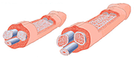
*Increases the erect and flacid size of the tissue in the penis
With this unique formula and the stimulation in growth of the penile tissue you can be up to 3-4 inches longer and up to 25% wider. The average penis size when erect is only 5.7" to 6". Over 90% of men posses this size, so why not stand out from the crowd and enlarge your penis with ViaGro. Don't just be an average guy for your lady!

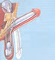
*Increase sexual drive and erection strength
Erections are caused by blood filling up the corpus caverneum, two spongy cylinders inside of the penis. This supplement and it's ingredients are known to stimulate erectile responses, increase penile blood flow (firmness) and also improve central nervous system function.


*Increase sperm production (by up to 500%)
Amongst the many ingredients that can influence your sperm production we combine the most effective, such as Zinc and L-Arginine. Zinc supports the enzymes responsible for the creation of testosterone, a key hormone involved in sperm production. As for Arginine, it is an amino acid. It plays the role of biochemical precursor in the synthesis of spermidine and spermine, two important components of semen. Each capsule is also loaded with large amounts of amino acids!


*Boost potency and fertility
L-Arginine supplements are successful in improving fertility in men by increasing sperm count. L-Arginine also produces a natural growth hormone, thus helping increase the erect size of the erectile tissue in the penis.


*Help increase the length and intensity of your orgasm
Having more seminal fluid can help to greatly increase the force with which the semen leaves your penis, making orgasms more intense and increasing the likelihood of multiple orgasms. The physical aspect of the orgasm such as the way climax occurs in men, is enhanced and intensified by a greater volume of semen. When your body ejaculates more fluid upon release, the extended pumping and orgasm that results will also improve the experience for your partner!


*Help increase self-confidence
With the wide range of benefits presented to you by using ViaGro, it is only natural that you will increase in self confidence and overall feeling of well being. Quite simply, you will be shocked at the new you!

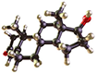
*Help increase testosterone production
ViaGro provides your body with essential nutrients that stimulate testosterone and sperm production. Testosterone is the key male sex hormone and is responsible for sexual function in men and other masculine features such as muscle development, strength and size. Low testosterone is linked to poor erection quality.

*Help stop premature ejaculations
Enhance sexual stamina and staying power.

*Help naturally treat many common sexual performance problems
Scientifically proven dramatically enhanced fertility!
This unique blend of all the most powerful sexual performance ingredients of the highest standardised yield possible can be used for two main reasons, the first of these is recreational pleasure, the other to increase fertility. ViaGro is hands down the most potent natural formula currently available to help male fertility problems and promote penis enlargement.
While the average man produces hundreds of millions of sperm per day, there are some external factors that can adversely affect the sperm count. Smoking, drug use, poor diet, lack of exercise, and even wearing tight clothing in the groin area can all decrease the sperm count. If you are trying to have children, the number of sperm you ejaculate is essential, as is their condition.
ViaGro provides you with high quality and volume of sperm needed, as well as a host of other great benefits!
ViaGro is manufactured only at GMP-certified facilities. This enables it to deliver the freshest, safest, and highest quality ingredients possible. No corners have been cut, and the key ingredients in many of the most popular sexual performance/semen volume/penis enlargement products are contained in this formula - and in many cases at a dose much higher than these other products!

* Zinc Gluconate - Zinc aids in sperm mobility and quality. It is also is very important in the metabolism of testosterone. Zinc, in the form of zinc gluconate, is more easily tolerated than other forms. Studies have shown Zinc supplements to be essential in replenishing Zinc levels absent in many modern diets. Zinc is also very important in increasing fertility and sexual vigour.
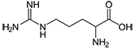
* L-Arginine - L-Arginine is an amino acid that can be found naturally in almonds, dairy products or meat. These acids are the building blocks from which the body creates proteins needed for growth and repair in the human body. Among these, L-Arginine plays a vital part in the male sexuality by affecting erections and sperm production.It is also an important source of nitrous oxide, which relaxes muscles and increases the blood flow to erectile tissues. Thus, L-Arginine can help men get stronger and harder erections more frequently. As for sperm production, L-Arginine is a biochemical precursor in the synthesis of spermidine and spermine, two important components of semen. It also plays a helpful role in the cellular replication of semen, as well as biosynthesis of signalling molecules necessary for penile erection.
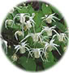
* Epunedum Sagitum or Horny Goat Weed - Known in China as Yin Yang Huo and originating from Japan. Chinese top medical doctors report that horny goat weed boosts libido and improves erectile function. Used to restore sexual fire and allay fatigue. Works by freeing up testosterone allowing to you to have a more incredible sex drive and endurance. Has been proven to be a powerful, natural aphrodisiac which will enhance physical and sexual sensations. It is well known to effect blood vessels as well as testosterone levels. Testosterone is a male hormone responsible in part for a person's sex drive and also influences sperm production. Also, Epimedium can inhibit the AchE enzyme, thus supporting higher levels of key choligernic nerotransmitters associated with sexual arousal.
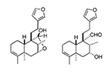
* Muira Pauma - Three studies conducted by Dr Jacques Waynberg have scientifically and absolutely established the credibility of Muira Pauma (Ptychopetalum olacoides) as a safe and effective tool to improve libido and sexual functions in subjects. It is amazingly effective at combating many male sexual dysfunctions.

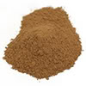
* Tribulus Extract - Contains highly purified extracts of Tribulus terrestris (with the main active ingredient of protodioscin). The benefits of Tribulus' protodioscin are proven by more than 10 clinical studies. These studies have been presented and featured in various scientific conferences and publications on sexual health, including the prestigious Asian Congress of Sexology and the Journal of Impotence Research. A breakthrough in the scientific purification process has allowed the extraction of larger quantities of the active ingredient of Tribulus, a natural plant compound called protodioscin. Enriched over 100- folds, the concentrated protodioscin in Libilov allows men to experience its benefits in a much shorter period of time.
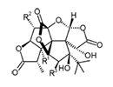
* Ginkgo Biloba - Medicinal use of ginkgo can be traced back 5,000 years in Chinese herbal medicine. The action of the herb may help support the brain, central nervous system and impotence. Ginkgo is known for increasing blood flow to the brain which aids in mental function. The herb also increases blood flow to the genitals which improves sexual function. In one study 78% of a group of men with impotence reported significant improvement without side effects. Ginkgo improves peripheral circulation and oxygenation.
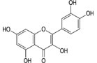
* Semen Cuscutae - Also known as the Dodder. Traditional Chinese Medicine attributes to the Dodder virtues in fighting impotence, nocturnal emissions, premature ejaculation and low sperm count. It is said to work very efficiently when combined to Epimedium Sagittatum. In China, a study on humans solidly linked Semen cuscutae to promotion of sperm motility and membrane functions.

Other powerful pharmaceutical grade ingredients include:-
- * L-Carnitine
- * L-Lysine
- * Pumpkin Seed
- * Avena Sativa
- * Maca Root
- * Longjack Root Extract (high yield Eurycoma Longifolia)
- * Maca
- * And More!
ViaGro is fast becoming the male enhancement pill of choice for many men around the world. Combining all the most potent elements of many proven penis enlargement formulas has given ViaGro a truly unrivalled success rate amongst it's users.
Try ViaGro today and discover your new potential!
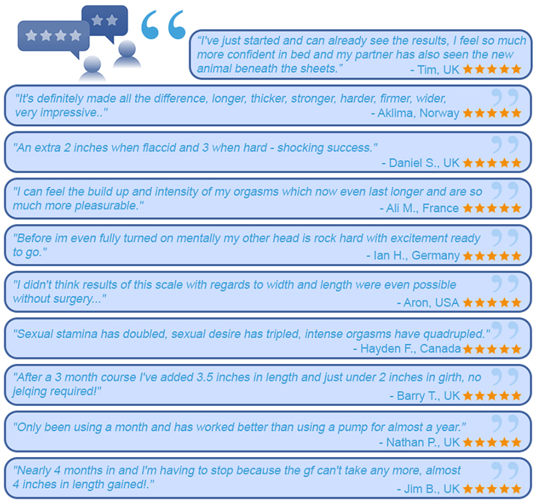

Q. Does ViaGro really work? 98% of customers are happy with their results.
Q. Are the results permanent? Yes they are. You control the growth because once you reach your optimum size you could stop taking ViaGro pills. We say you could stop taking ViaGro pills because it is not necessary to be larger then 9 inches. Most women can only comfortably accommodate a 9 inch penis. Anything larger than that may be too large for most women. Nine inches or more than 9 inches, the choice is yours.
Q. When can I expect to see results? See dramatic results in a few weeks!
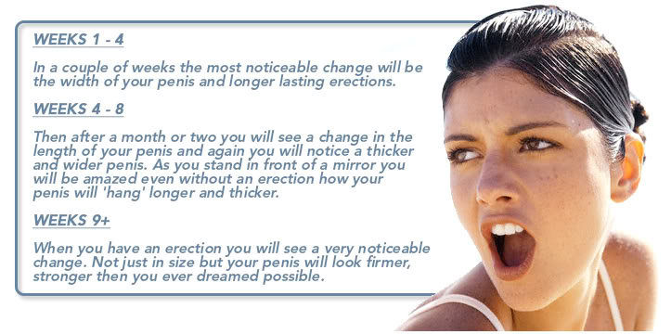
Q. How many pills in the pouch and how long does it last? Each pouch contains 30 high potency pharmaceutically formulated capsules. Take 1 pill a day with water or a meal. Also if you wish to enhance your sexual performance take 1 pill 30 minutes before sexual activity. For optimal results a 3 month+ course is highly recommended.

Ingredients Profile:

  - L-Arginine: l arginine is an amino acid and is known for giving better quality erections. It does this by increasing the flow of Oxygen-enriched blood around your body (and your penis).

  - Epunedum Sagitum: In fact horny goats weed, an aphrodisiac and elevated your Libido. Also used to give increased stamina.

  - Muira Puama: it also goes by its latin name Ptychopetalum Olacoides , Boosts and improves your sexual function and fertility by boosting sperm/Semen levels.

  - Tribulus Extract: Now this ingredient is mainly used by bodybuilder and fitness fanatics to boost testosterone levels. With this your sex drive and libido get a positive push.

  - Gingko Biloba: Widely used by impotence sufferers. Also gives better concentration and focus. A much-used supplement therapists use to treat depression and anxiety.

  - Semen Cuscutae: Used in Chinese medicine and mainly for its benefits in boosting male fertility and sperm motility.

  - Zinc Gluconate: At least doubles your semen production with the right dose. Gives better erection strength.

  - L-Camitine: Eases high blood pressure which is beneficial when using certain male enhancement pills due to the boost in blood circulation. In turn helps with erectile dysfunction. Also boosts testosterone levels.

  - L-Lysine: Boosts want and desire for sex, studies prove it to intensify the male orgasms.

  - Pumpkin Seed: Has been used for hundreds of years to boost libido. helping men who lack Libido.

  - Avena Sativa: Definitely greatly increases stamina when making love and enables you to last longer great at fighting erectile dysfunction.

  - Long Jack Root Extract: Sportsmen and women use Long Jack to boost their fitness level and to give added stamina. Obviously helps in the same way with boosting stamina when making love.
• Reliable & Proven Results with 100% Natural Ingredients
• No Prescription Required
• Bigger & Firmer Erections
• Fight Premature Ejaculation
• Combat Erectile Dysfunction
• Boost Stamina / Performance / Libido to Maximum Levels
• Manufactured in the UK for your Highest Level of Safety

†This product is not intended to diagnose, treat, cure or prevent any disease.
The statements on this website have not been evaluated by the FDA.
Individual results may vary.

