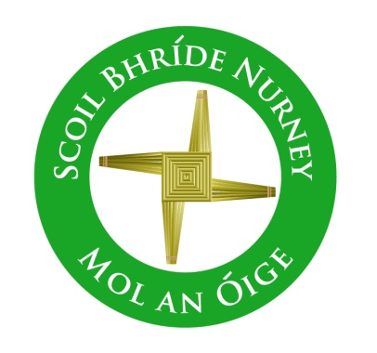
Scoil Bhríde,
Nurney,
Principal – Vinny Thorpe
Dep. Principal – Catherine Owens

County Kildare.
Te/Fax: (045)526767
Email: sbnurney@gmail.com
www.nurneyns.com
Roll no: 16345A
August 23rd
Dear Parent / Guardian

Welcome back everyone to our school next week!

The BoM and School Staff are looking forward to welcoming all our pupils and parents / guardians back to school for the 2021/2022 school year on Tuesday August 31st 2021. Arrival times for each class, will be sent to you in the last of our re-opening information letters this Wednesday.

We are satisfied that we have control measures in place to ensure a safe re-opening. It will take some time for everyone to get used to the “new circumstances” and become familiar with the routines and procedures designed to keep everyone safe and to prevent the spread of the virus. There will, undoubtedly, be some unforeseen challenges, but we will deal with these as they arise.

We would like to thank you for your co-operation in making preparations to date and look forward to working with you as we assist the children to adapt to any changes which may be necessary in the year ahead. We are conscious of the fact that our pupils are looking forward to coming back to school to meet their friends again. We are aware that our pupils are beginning a school year at a challenging time and we have made plans to ensure that their arrival will be as smooth as possible.

Wonderful new Resources for pupils and their families about returning to school.
The Department of Education has released some useful resources and information for both pupils and parents about the September 2021 re-opening of school. We would highly recommend both you and your child(ren) watch these 3-minute videos in light of the new DELTA variant.

Here is the link for a video about returning to school especially for parents and guardians.
https://youtu.be/WbsH11wOByM

Here is the link for a video, especially for those going into junior infants
https://youtu.be/UomH_vakjDI

Here is the link especially for those going into senior infants up to 2nd class.
https://youtu.be/4smnni5jpGI

Here is the link especially for those going into 3rd up to 6th class
https://youtu.be/8fWeCikohlA
There is also a nice new feature for parents....an excellent FAQ section on common calls being made by parents and schools to the HSE and the Dept of Education helpline on face coverings, Special Education Needs, uniforms, temperature checks, close contacts, updated COVID-19 symptoms etc. It gives you all the advice and information and resources you need as a parent to prepare your child returning to school
I would advise all parents to check it regularly so you can be up to date with current issues
gov.ie - Information for students, parents and families (www.gov.ie)
I CANNOT RECOMMEND IT HIGHLY ENOUGH!!!!

For advice on COVID-19 for parents please go to
COVID-19 (coronavirus) - HSE.ie

I CANNOT RECOMMEND IT HIGHLY ENOUGH!!!!

All of these documents and all the information sent to you over the last month regarding school start times, arrival procedures for the children etc. are also available on our school website https://www.nurneyns.com/covid-19

Please also find attached to this email a super poster regarding school and COVID-19 which gives everything in a very easy to read picture format. You can access it here at this link original (cimpress.io)

IMPORTANT INFORMATION REGARDING THE SCHOOL BUS!!!
The following link is to a letter from the Department of Education and Bus Éireann for all those families who are using the school bus this year. It is vital that those availing of this service read this letter. It can be accessed at the following link original (cimpress.io)

We look forward to seeing you all again next week.
If you have any more questions or queries, please email us at sbnurney@gmail.com where we will only be too delighted to help.
Till then God Bless to you all and your lovely families.
All the team in Scoil Bhríde Nurney

