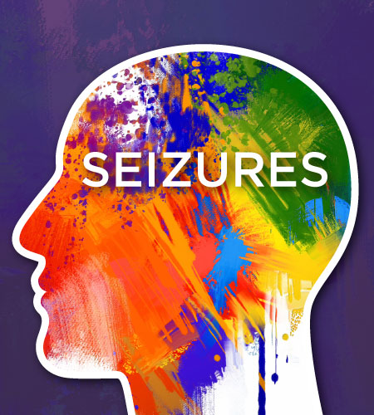
Seizures

Seizures are caused by electrical disturbances in the nerve cells in a section of the brain.
There are two forms of seizures:
- Sensory Seizure: involves only a change in sensation or a loss of consciousness
- Convulsive Seizure (convulsion): involves abnormal muscular behaviour.
The cause of seizures are unknown, but research shows that they may be the result of head injury, oxygen deprivation at birth, infection, rabies, tetanus, meningitis, rickets, nutritional deficiencies, hypoglycemia, fever, or hereditary.

The two forms of seizures listed above can be further broken down into several types: (see details below)
- Absence (petit mal)
- Atonic (drop attack)
- Complex partial (temporal lobe)
- Generalized tonic-clonic (grand mal)
- Myoclonic
- Simple partial (Jacksonian)

Checklist for Seizures:
  - Provide DAILY essential fatty acids for the brain (Omega 3, Lecithin and Omega 6)
  - Provide Probiotics for the gut to optimize absorption of nutrients
  - Provide a GUARANTEED DAILY supply of ALL nine essential amino acids – Raw Soy Protein powder)
  - Optimize electrolyte balance daily with Alfalfa and/or Performance (Shaklee electroloyte drink)
  - Enhance oxygenation to the brain with appropriate exercise (a rebounder and/or a chi machine are recommended)
  - Do a hair analysis to determine if heavy metals are causing the problem (it will also show mineral concentration in the cells … if this is out of balance, it must be corrected) (call 905-871-4281 to order kit)
  - Do a parasite cleanse
  - If candida overgrowth is a problem, a yeast flush MUST be done

Nutritional supplementation is very important for people with epilepsy. It is essential for the central nervous system & the neurotransmitters to receive adequate nutrients to perform their intricate tasks.

GOOD PROGRAM; 1. Shaklee Soy Protein OR Life Shake (Raw, complete, balanced amino acid supplement)
- Shaklee Vitalizer (80 nutrients most essential to health)
- Shaklee Alfalfa (Mineral Smorgasbord
- Shaklee Lecithin (inositol and choline for the brain)

BETTER PROGRAM: Add the following to “Good Program” above:
- Extra B Complex
- Calcium/Magnesium
- Vivix
- Additional Vitamin D3 (at least 4000 I.U.)
- GLA (Omega 6 Fatty Acid)

BEST PROGRAM: Add the following to “Good & Better” Programs above:
- Extra OmegaGuard (Omega 3 Complex)
- Vitamin C
- CarotoMax
- Mental Acuity (Gingko Biloba Complex)
- CoQHeart
- Optimize Vitamin E

Other Helpful Tip
- The birth control pill or hormone replacement therapy should be AVOIDED. They can trigger seizures or make them worse.
- Have the patient’s progesterone levels monitored frequently. Low progesterone can trigger seizures. A natural progesterone cream may be necessary on a regular basis.
- Avoid the herb sage
- Soured milk products like yogurt, kefir & cottage cheese are beneficial provided there is no allergy to these foods
- Always have indepth testing done on the thyroid gland to test for malfunctioning.
- Drink raw juices from juice extractor
- Avoid aspartame (NutriSweet), caffeine & nicotine
- Stay away from pesticides
- Avoid aluminum cookware
- Drink reverse osmosis filtered water
- Do a detoxification bath in baking soda + lemon once a week

TYPES OF SEIZURES
There are several types of seizure including:

Absence (petit mal). This type of seizure is most common in children. It is characterized by a blank stare lasting about half a minute; the person appears to be daydreaming. During this type of seizure, the individual is unaware of his or her surrounding.

Atonic (drop attack). A childhood seizure in which the child loses consciousness for about ten seconds and usually falls to the ground because of a complete loss of muscle tone.

Complex partial (temporal lobe). A blank stare, random activity, and a chewing motion are characteristic of this type of seizure. The person may be dazed and unaware of his or her surrounding, and may act oddly. There is no memory of this seizure. A person may experience a distinctive warning sign called an aura before this type of seizure. The aura is itself a form of partial seizure, but one in which the person retains awareness. The aura may be experienced as a peculiar odour, “butterflies” in the stomach, or a sound. One man with epilepsy, an ardent racetrack gambler, said he always heard the roar of a crowd, followed by the name of a favorite racehorse, just before his lost consciousness.

Generalized tonic-clonic (grand mal). This type of seizure is characterized by sudden cries, a fall, rigidity and jerking of the muscles, shallow breathing, and bluish skin. Loss of bladder control is possible. The seizure usually lasts two to five minutes, and is followed by confusion, fatigue, and/or memory loss. It can be frightening to witness, especially for the first-time observer.

Myoclonic. Brief, massive muscle jerks occur.

Simple partial (Jacksonian). Jerking begins in the fingers and toes and progresses up through the body. The person remains conscious.

Simple partial (sensory). The person may see, hear, or sense things that do not exist. This may occur as a preliminary symptom of a generalized seizure.

Nutritional supplementation is ESSENTIAL for people with seizures.

