Leita Thompson Memorial Park- 1200 Woodstock Road, Roswell Ga
We will meet in large parking lot next to the dog park. See the red arrow below
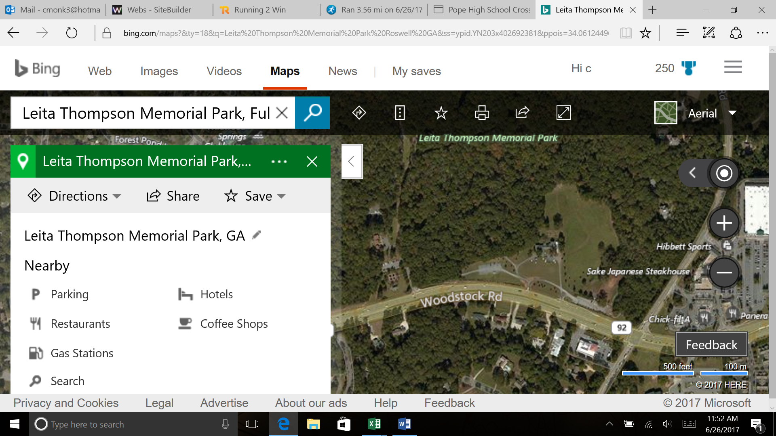

Here are directions from Pope to Leita Thompson.
_{http://mapq.st/2u8ODJt}

