Amelia-Nottoway Technical Center News 12/04/2020
ANTC STUDENT SPOTLIGHT!
Sydney Evans, ACHS Senior
Cosmetology II
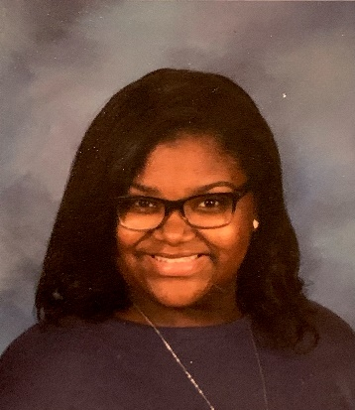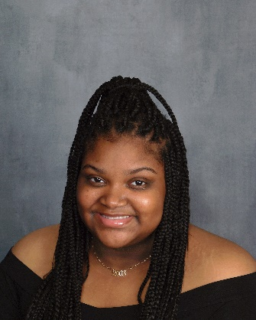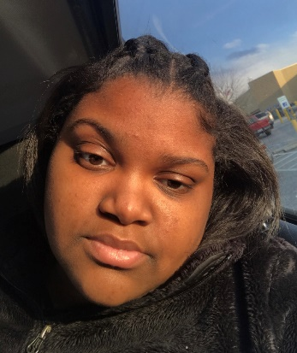
What brought you to ANTC? I just wanted to take Cosmetology.
What is your dream job? My dream job is to become a Labor and Delivery Nurse.
What is your favorite class that you have taken so far? Why? Cosmetology because I get to do a lot of hands on things and learn how to do hair.
What is the best advice you have been given by your instructor at ANTC? The best advice I have received is to always speak your mind.
What is your favorite memory at ANTC? The best memory I have is the party we had last December.
What was the first feeling you had when you attended ANTC? The first feeling I had was being both nervous but excited to start Cosmetology.
What words of wisdom do you have for other students? Some words of wisdom I would share with others is to always work hard.

ANTC ALUMNI HIGHLIGHT!
Tiffany Banton
High School: Nottoway High School 2020
ANTC Program: Medical Assistant
Career: Enrolling at SVCC in the Spring
Future: Registered Nurse (RN)
My plans are to be in the medical field
and help save lives. My mom is the
one who put me on the right path.
DID YOU KNOW?
Mrs. Vantrece Rajah
Current Position: Cosmetology Instructor, ANTC
Previous Positions: Cosmetology Instructor at Virginia College
Hobbies: Arts & Crafts, cooking, and traveling
Other Interest: I enjoy spending time outside taking walks to relax, and being a motivational speaker as well. I also enjoy watching and cheering for my football team, Washington.
Family: Mrs. Rajah has been married to Omarh Rajah for 24 years, and they have two children Yasmin and Omarh Jr.

Jear

ANTC serving our Alumni!

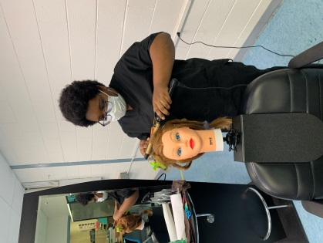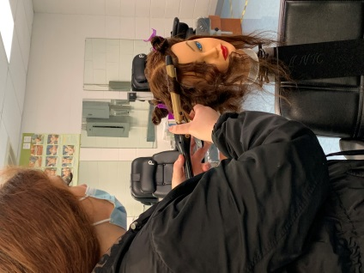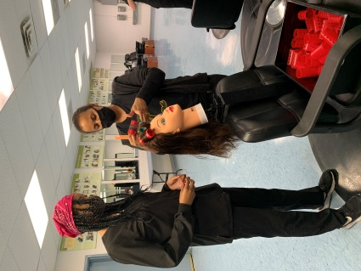
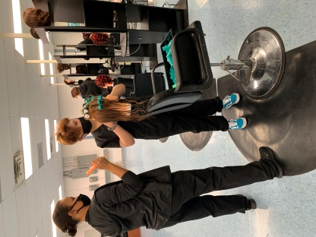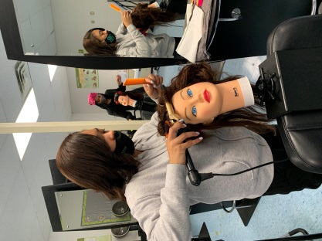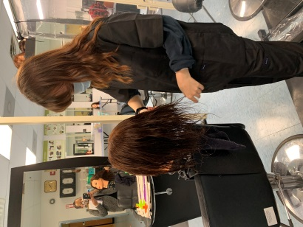
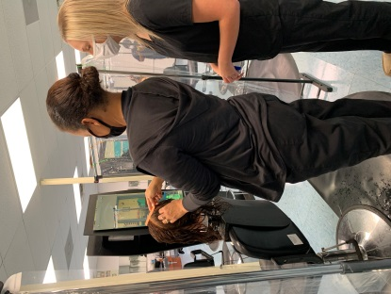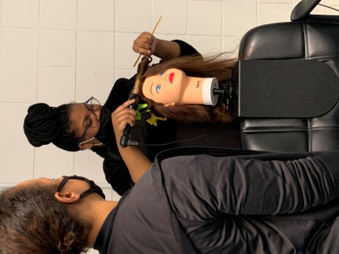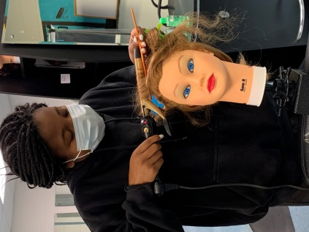
Current Program Feature: Medical Assistant, Amelia County High School & Nottoway High School

Skills: Vital signs, Injection Documentation, Processing Blood Samples, Order of Draw, Venipuncture Tube Additives

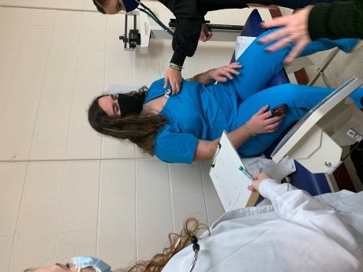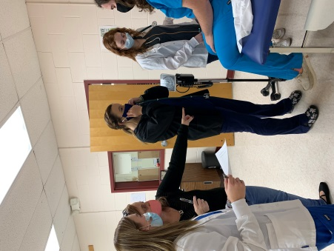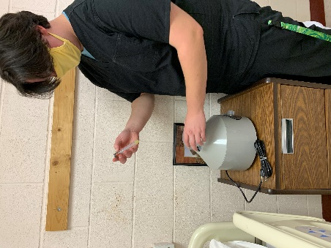
Processing Blood Samples!
Vital Signs!

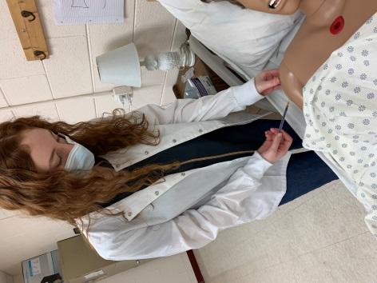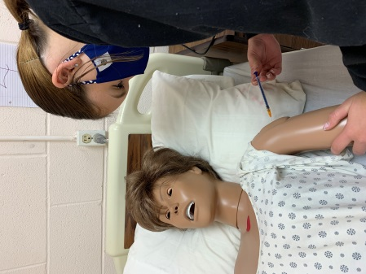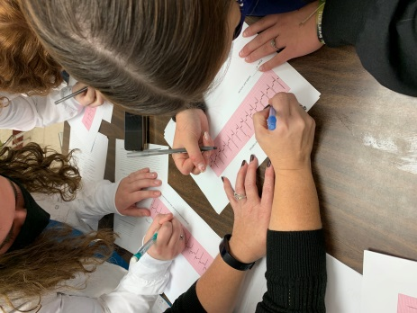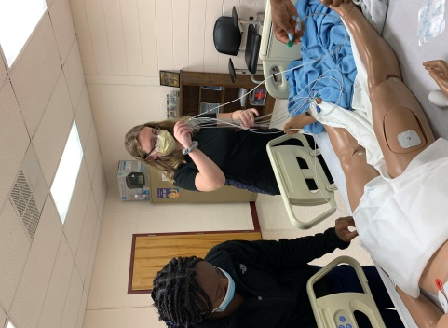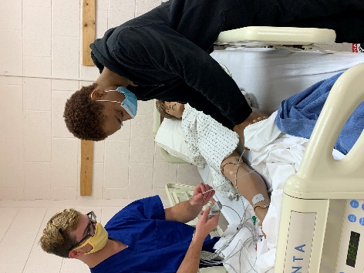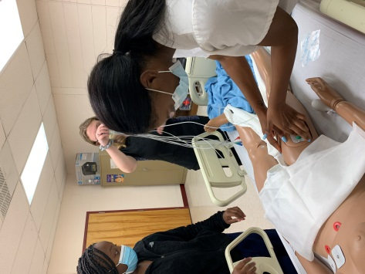
Measles Shot!
Flu Shot!
Reading an EKG!
MA II students teaching MAI students how to prep their patient for an EKG!

Current Program Feature: Auto Body I & II, Amelia County High School & Nottoway High School

Skills: Have you ever had a screw in your tire or a slow leak and did not know how to repair the tire? At ANTC there are amazing moments where classroom preparation meets real-world circumstances. During this mini lesson, our student learned how to repair the tire. This is a skill that we all need to learn!

Tasks/Competencies: Demonstrate critical thinking and problem solving.
Demonstrate continuous learning and adaptability.
Demonstrate proficiency with technologies, tools, and machines common to a specific occupation.

