Cold Sores:
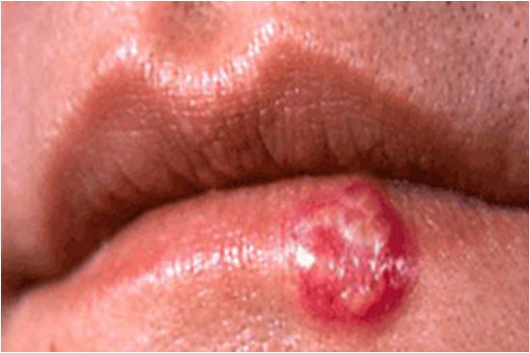

- For cold sores, always choose Shaklee Lip Treatment Stick externally (see info below).
- Internally, Protein Smoothies because they contain Lysine
- Also extra B Complex & Vita C is very helpful
- AND get lots of rest!
- If you have Shaklee C+E Repair cream, this helps it heal more quickly (but it may sting initially when you apply it)

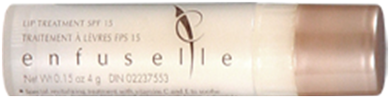

For cold sores, I always recommend Shaklee Lip Treatment Stick.

This little tube is far more than a Lip Protection Stick

Enfusellé Lip Treatment from Shaklee is drenched with vitamins, calendula, moisturizing oils, and lysine, It contains:

Two sunscreen agents … to provide broad-spectrum protection from damaging UV rays

- Vitamin C … which encourages the production of collegan and minimizes the appearance of
fine vertical dryness lines that crack or cause lipstick to run

- Vitamin E … which helps nourish and soften the lips

- Calendula … an herb which acts as an anti-microbial agent, and has anti-inflammatory and wound-healing properties

- Borage Oil … which strengthens the skin of the lips and makes them more resistant to chapping

- Lysine Hydrochloride … which soothes irritated lips and helps treat and/or prevent canker sores & fever blisters

