

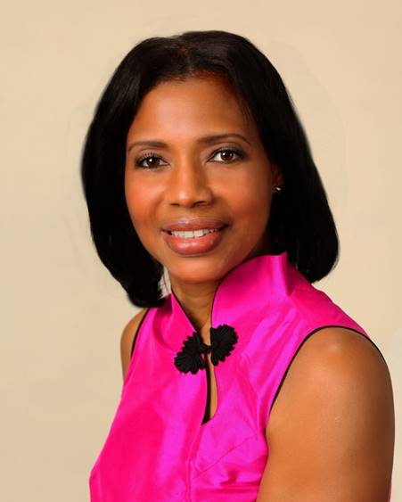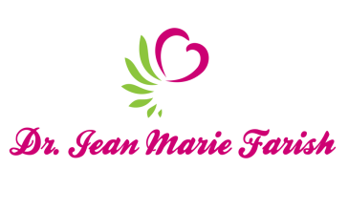

LOVE LIGHT NewsLetter

***I am excited to host my VoiceAmerica Empowerment Show-LOVE LIGHT with amazing Guests to cultivate a lifestyle of love and wholehearted connections through worthiness. My show is aligned with my mission to live an altruistic and heart centered life.***

**MEET LOVE LIGHT GUEST**

**EMILY REGINA HSU**

**Certified Holistic Health & Life Coach**

**Wellness Educator, Health Ambassador**

**Functional Medicine & Lifestyle Medicine**

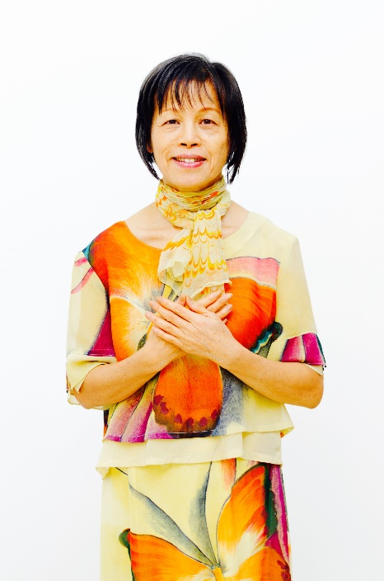

**April 10, 2020**

***MINDFUL EATING FOR VIBRANT LIVING***

**About Emily Regina Hsu**

**Emily is a Breast Cancer survivor, Functional Medicine advocate, wellness educator, and health ambassador. Due to high dosages in chemo treatment, she almost died tow times. She is a Transformational Health and Life Coach in Functional Medicine and Lifestyle Medicine. She is passionate about prevention and root-cause resolutions. She believes that a natural, whole-food diet, healthy lifestyle and supportive community are powerful allies in healing, preventing/reversing chronic diseases, and aging well.**

**As a result of her services, her clients understand the root causes of their chronic diseases. They receive science-based and personalized recommendations for proper food, lifestyle, and supplements. In addition, they reconnect with their bodies’ authority, wisdom, and healing powers so they can transform into the best version of themselves and live vibrantly and happily with purpose.**

**Encountering an awakening health crisis, Emily Regina Hsu has spent two decades studying and researching holistic and natural remedies for optimizing health and wellness. Her practice of “*Mindful* *Eating*” transformed and saved her life. The practice is a culmination of three resources: the wisdom from her mother and grandmother, the wisdom of the ancient ZEN Meditations, and the wisdom from her prayers.**

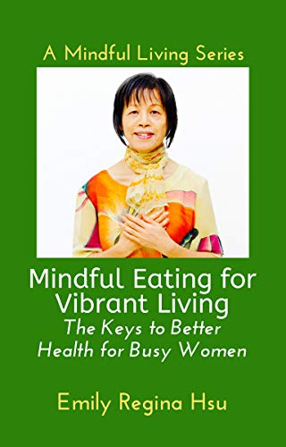

**Contact Emily Regina Hsu**

**Facebook Support: Women’s Mindful Eating Circle**

**Email: ehsu@shaw.ca**

***“An empowered self is a loving self, and keep your love light shining.”***