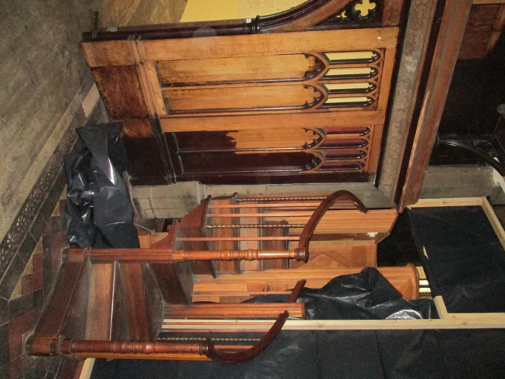
One feature not to be seen for awhile are the steps to the pulpit which are of course behind the screening – we will see them again when the pulpit is turned and the works completed.
The last of the pews left St Mary’s and are now stored safely at St Mark’s. It has been quite a task for our team from Lambert Walker and brought in to assist (in rather a big way as he has the truck) John from W H Bridge Haulage Ltd.
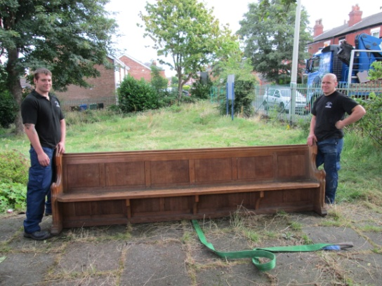

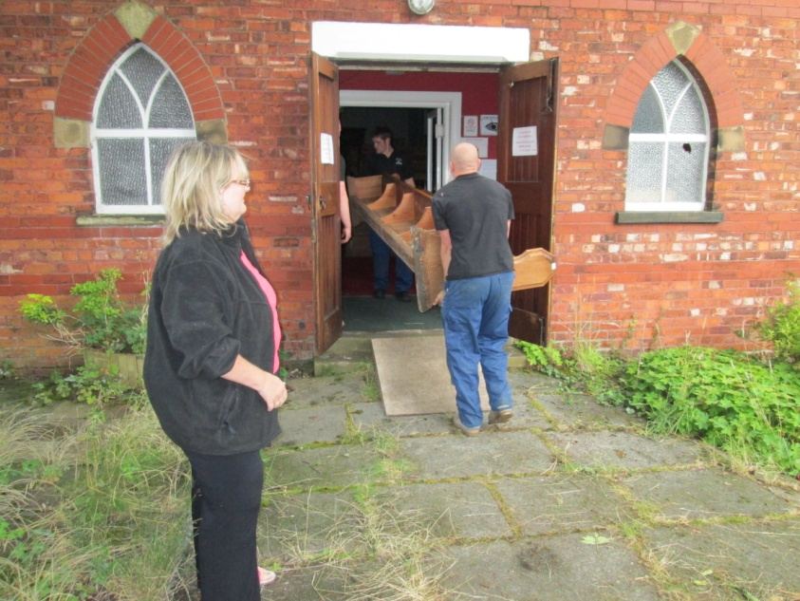

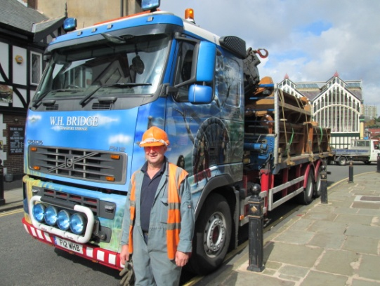

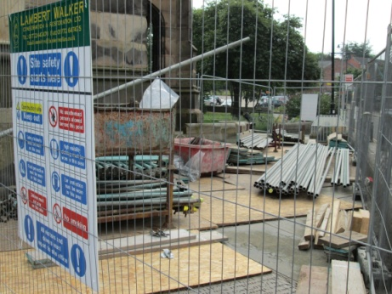
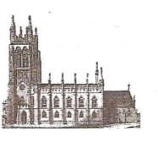
St Mary’s in the Marketplace
No 4
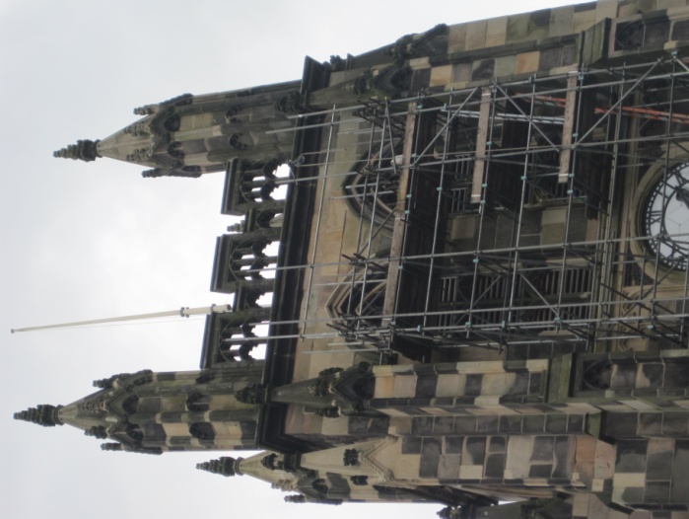
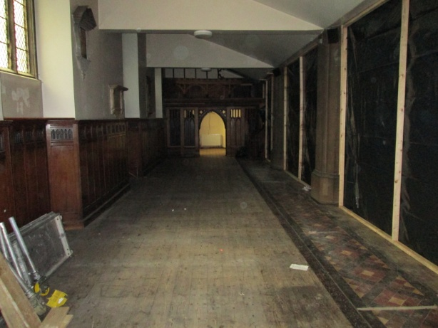
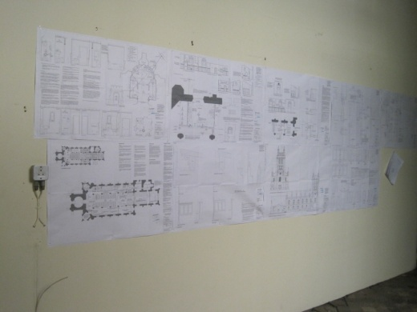
The scaffolding on the front of the tower is nearly to roof height, as can be seen by those passing by. Inside however is another matter, as behind the black screens work will soon be starting in the now clear north aisle area. The plans are on the wall in the old office ready for our contractors to refer to. Work has already started taking out the old kitchen and toilet.

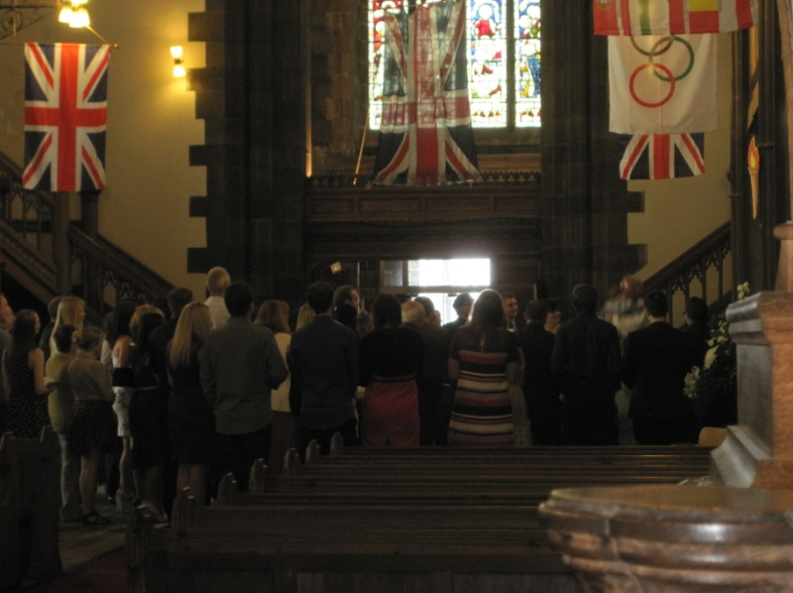
Meanwhile back in Church the first Sunday service incorporated the baptism of young Alfie, with plenty of space for family and friends to gather round the font in the newly created open space.
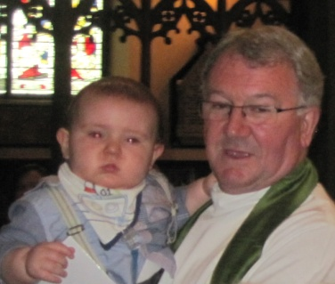

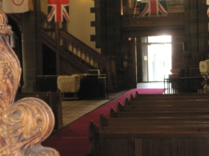

Our Tuesday congregation gathered in the Chancel for the morning service of Holy Communion whilst visitors were able to continue to be greeted at the back of Church.
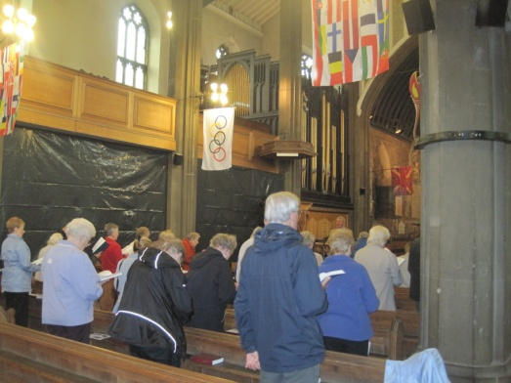
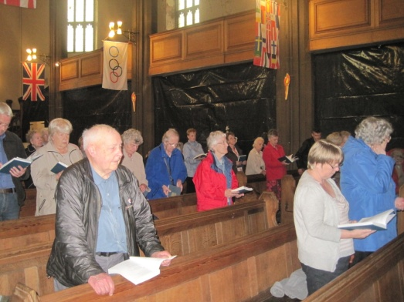
The lunch-time service was well attended and held in the newly arranged Nave

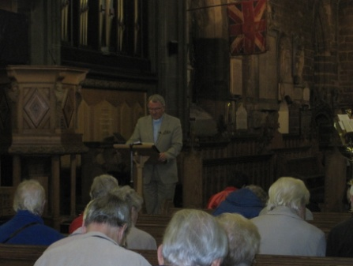

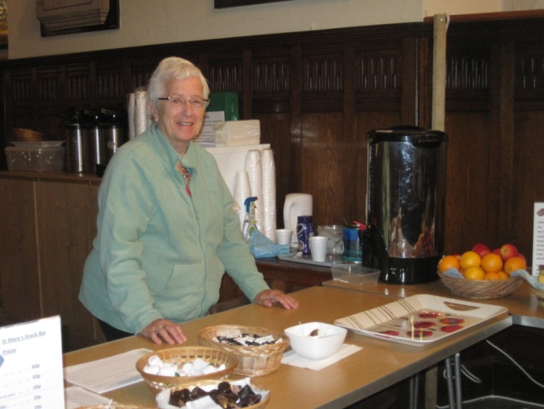
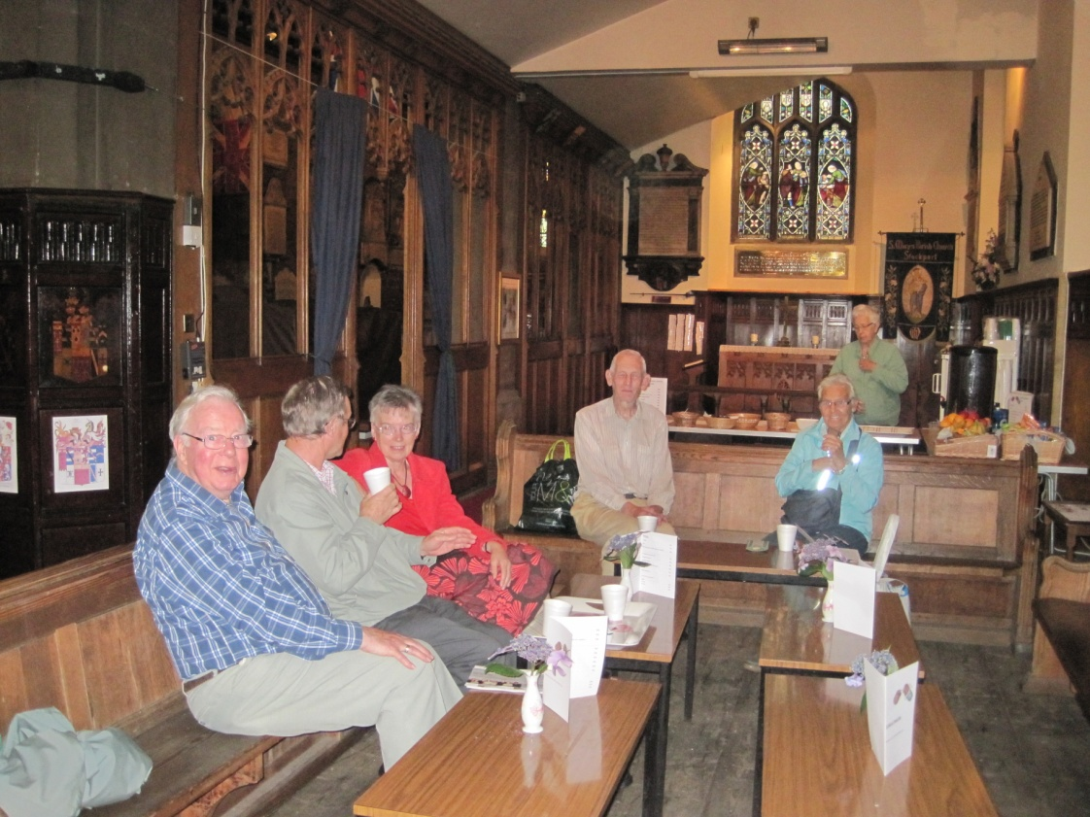
The “new look” hospitality area is now fully operational in the south aisle, offering tea, coffee, hot chocolate and a small range of snack items. Facilities are limited having no kitchen or food preparation areas - we are at the present time offering only pre-packaged food – milk and sugar available in packets/cartons.

