On 20 January 1842 while visiting Rome, Marie-Alphonse Ratisbonne, an anti-Catholic Jew, had a vision of the Virgin Mary. He converted to Catholicism and began a ministry for the conversion of the Jews.
Together with his brother, who had converted and become a priest years before, he founded the Sisterhood of Our Lady of Sion. Ratisbonne eventually joined the priesthood himself and becomes a Jesuit.
In 1855, he moved the sisters to Jerusalem, where he founds the Convent of Ecce Homo and the Convent of St John.
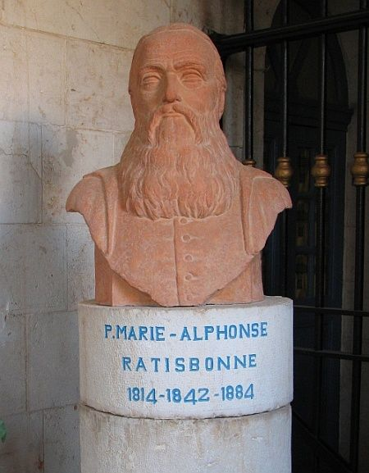

Bust of Marie-Alphones Ratisbonne at the Ratisbonne Monastery in Jerusalem. Image: Gilabrand, CC BY 3.0

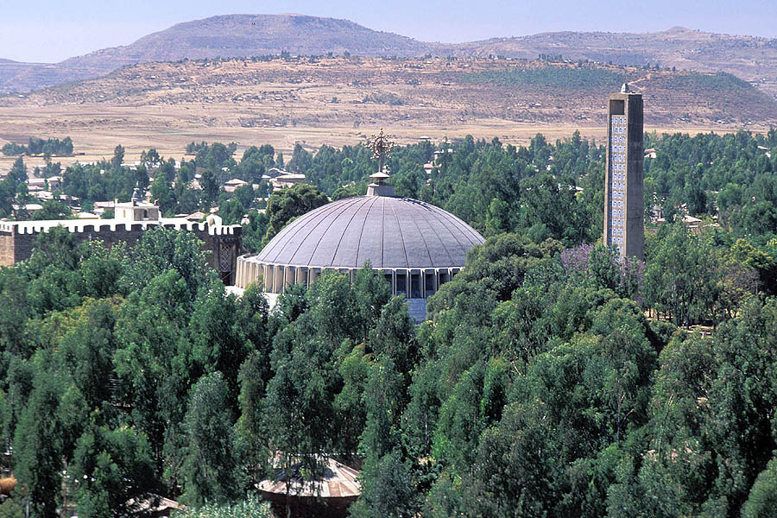

The dome and bell tower of the New Cathedral of Our Lady Mary of Zion, built by Emperor Haile Selassie in the 1950s

