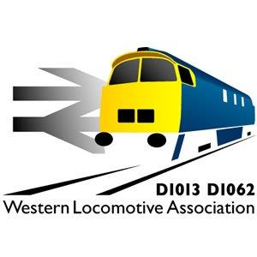
WESTERN LOCOMOTIVE ASSOCIATION LIMITED
Membership Renewal Form
The Western Locomotive Association was founded in 1974 and incorporated in 1999. To renew membership of the Association, this membership application form must be completed and signed before being submitted with the appropriate fee to the Membership Secretary. This provides the WLA with all the information required by the Companies Act. It is kept in written format so as to be readily available by the registrar. It will not be otherwise disclosed or used for other than WLA business without your authority. This form includes your guarantee to contribute £1.00 to the WLA in the event of it being wound up. This guarantee continues for a period of 12 months after ceasing to be a member.
Data Protection Act: Members names, addresses and email details are held on a computer. This information is only used
for WLA administration purposes. If you have any objection to this, please advise the membership secretary.

The period of membership runs from 1st January to 31st December.

Please complete in BLOCK CAPITALS

Forenames_________________________________________________________________________________________

Surname___________________________________________________________________________________________

Address____________________________________________________________________________________________

Postcode___________________________________

Email____________________________________________________________

I wish to renew my membership of the Western Locomotive Association and agree to be bound by the Articles of Association, to pay the appropriate annual subscription and in the event of dissolution to pay the sum of one pound.

Usual signature__________________________

Date _____/_____ /_________

Membership category required (please tick)
Adult £25  Family £30  Junior/ Senior Citizen £10 
If you are under 18 then your parent or guardian must sign on your behalf and confirm your date of birth (_____/_____ /_______).

Optional donation. The membership subscription is set to cover the basic cost of running the WLA. Locomotive maintenance, restoration and operation can be an expensive business. We rely greatly on donations, large and small to continue our activities.
I enclose a donation of (please tick) £10  £20  £50  £100  Other amount £________________

Gift Aid
The Inland Revenue will help us if you are a UK taxpayer and pay an amount of income tax or capital gains tax at least
equal to the tax we reclaim. We can gain an additional 25 pence for every pound that you pay both in membership fees and donations provided that you sign the following declaration. You can cancel this declaration at any time should you wish or your circumstances change and you become a non-taxpayer.

 I wish the Western Locomotive Association to further benefit from Gift Aid on this subscription and/or donation and subsequent subscriptions / donations now or in the future – please delete as applicable. I confirm that I will have paid an amount of Income Tax or Capital Gains Tax equal to the Tax deducted from such donations.

Usual Signature____________________________

Please make cheques payable to the Western Locomotive Association Limited
Please return the form fully completed together with your cheque and a stamped addressed envelope to:
Mr Paul Tucker, Membership Secretary (WLA), 4 Oaklawn Court, Barton Road, Torquay, South Devon TQ1 4EN

