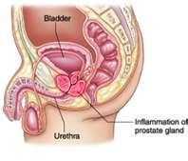
Prostatitis
- Infection in the prostate

- Symptoms:
  - Pain between the scrotum and rectum
  - Fever (infection often in the bladder)
  - Blood or pus in the urine
  - Frequent urination accompanied by a burning sensation
  - In advanced prostatitis, urination becomes more difficult

- Traditional treatment involves antibiotics
  - These may successfully kill the infection, but weaken the immune system even more, so that a man is far more prone to future infections

Prostatitis … Chronic Pelvic Pain Syndrome
(Headache in the Pelvis)

There are three forms of prostatitis:
- acute bacterial prostatitis
- chronic bacterial prostatis
- chronic pelvic pain syndrome
  - Non-bacterial prostatitis & prostatodynia
  - Also called Chronic Pelvic Pain Syndrome (CPPS)

Prostatitis Protocol

First 10 days
- 3 tablespoons of Soy Protein 2x a day
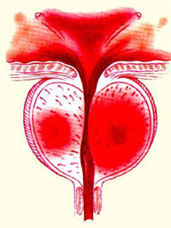
- Vitalizer
- 1 extra Optiflora each day
- 4 Vitamin C 500
- 4 NutriFeron each day
- 2 CarotoMax
- 1 Zinc
- 2 Garlic 3x a day
- Vivix
- Shaklee DR (Defend
  - Day 1 to 4 = 3 – 3x a day
  - Day 5 to 7 = 2 – 3x a day
  - Day 8 to 10 = 1 – 3x a day

Maintenance:
- 3 tablespoons of Soy Protein
- Vitalizer
- 1 additional Vitamin C 500
- 3 NutriFeron
- 1 CarotoMax
- 1 Zinc
- 3 Garlic
- 1 teaspoon Vivix
- Rotation of Defend & Resist (Shaklee DR) until there has been no prostatitis for 6 months
  - 4 days on of 3 Defend & Resist (Shaklee DR)
  - 3 days off
  - You can stay on the rotation after that with 1 per day on the “on” days

