EMERGENCY PLAN – HENDRA PONY CLUB
Chief Warden: Instructor In the event of Club house fire emergency:
Deputy Wardens: Parent(s) * Alert others in the immediate area
H&S Officer: Justin Rosenberg * Utilise kitchen extinguisher if trained
First Aid Officers: Claire Thompson * Call Emergency Services: 000
Fiona Mamet * Evacuate the area as per assembly plan

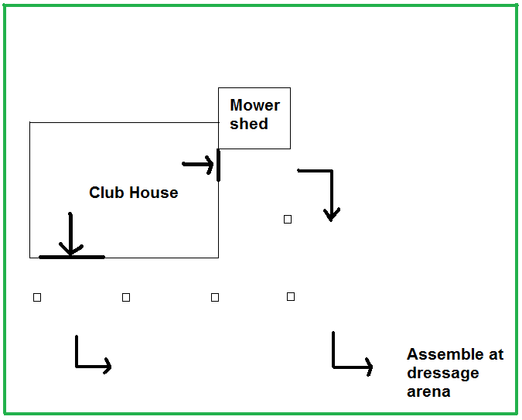
In the event of a Rider emergency:
- Alert parent, or guardian
- Call 000
- Assign an adult to accompany child
to hospital

In the event of a Horse emergency:
- Call owner, or if not available call a Club
Official for advice
- Call vet: Lester Walter, 0419 227 728
Brett Morris, 0408 720 843
Samford vet, 3289 1322

Club Officials: Tina Smith – 0411 148 148, Gael Gant – 0425 431 179, Rebecca Hanlon – 0433 069 912

