

150CC HP CAM INSTALL

Note: Disconnect Battery Terminals from both positive and negative battery terminals before starting this procedure.

Get access to top of motor.

- Support kart at mid section under seats with jack support. (ie floor jack)
- Remove Electrical interconnect cover.
- Disconnect main wiring harness connector going to front of kart and cut wire wraps so wires can be set aside.(Main harness is the large wire loom cable attached to the throttle cable above the battery.)
- Disconnect tail light wire connections.
- Remove throttle cable from carburetor.
- Remove fuel line, and pulse line from auto fuel valve.
- Remove chain cover from reverse assy. (if not it will break.)
- Remove reverse cable at reverse unit.
- Remove rear shock lower bolts.
- Remove bolts from Link Arm Dogbones on both side of motor.
- Raise the unit and remove the Dogbone Arms.
- Tip motor so valve cover is vertical.

Get access to Cam Assy.

- Remove airbox from unit.
- Remove black plastic fan cover from intake side of motor.
- Remove carb and air intake from motor.
- Remove plastic cover from top of motor to gain access to cam chain tensioner.
- Move flywheel until (T) mark is aligned with the arrow mark on the engine case.
(T) is for Top Dead Center (F) is for Fire spark on flywheel marks and flywheel is
keyed to shaft in correct position.
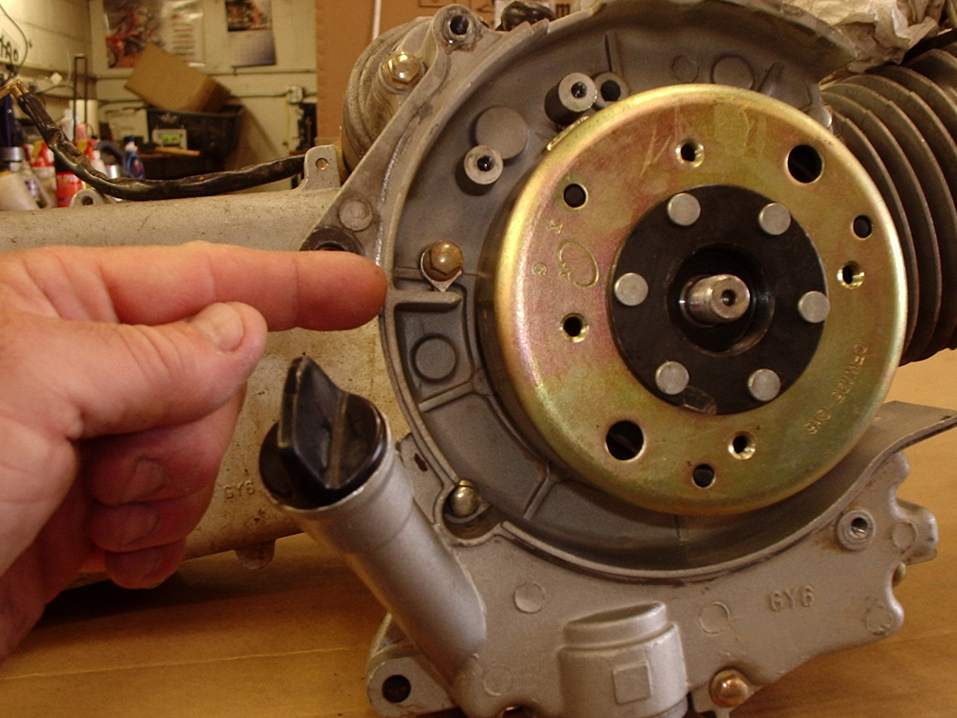

- Remove valve cover bolts.
- Verify the cam is at TDC position with hash marks aligned perpendicular across the valve cover surface and TDC hole is at the top of the cam gear.
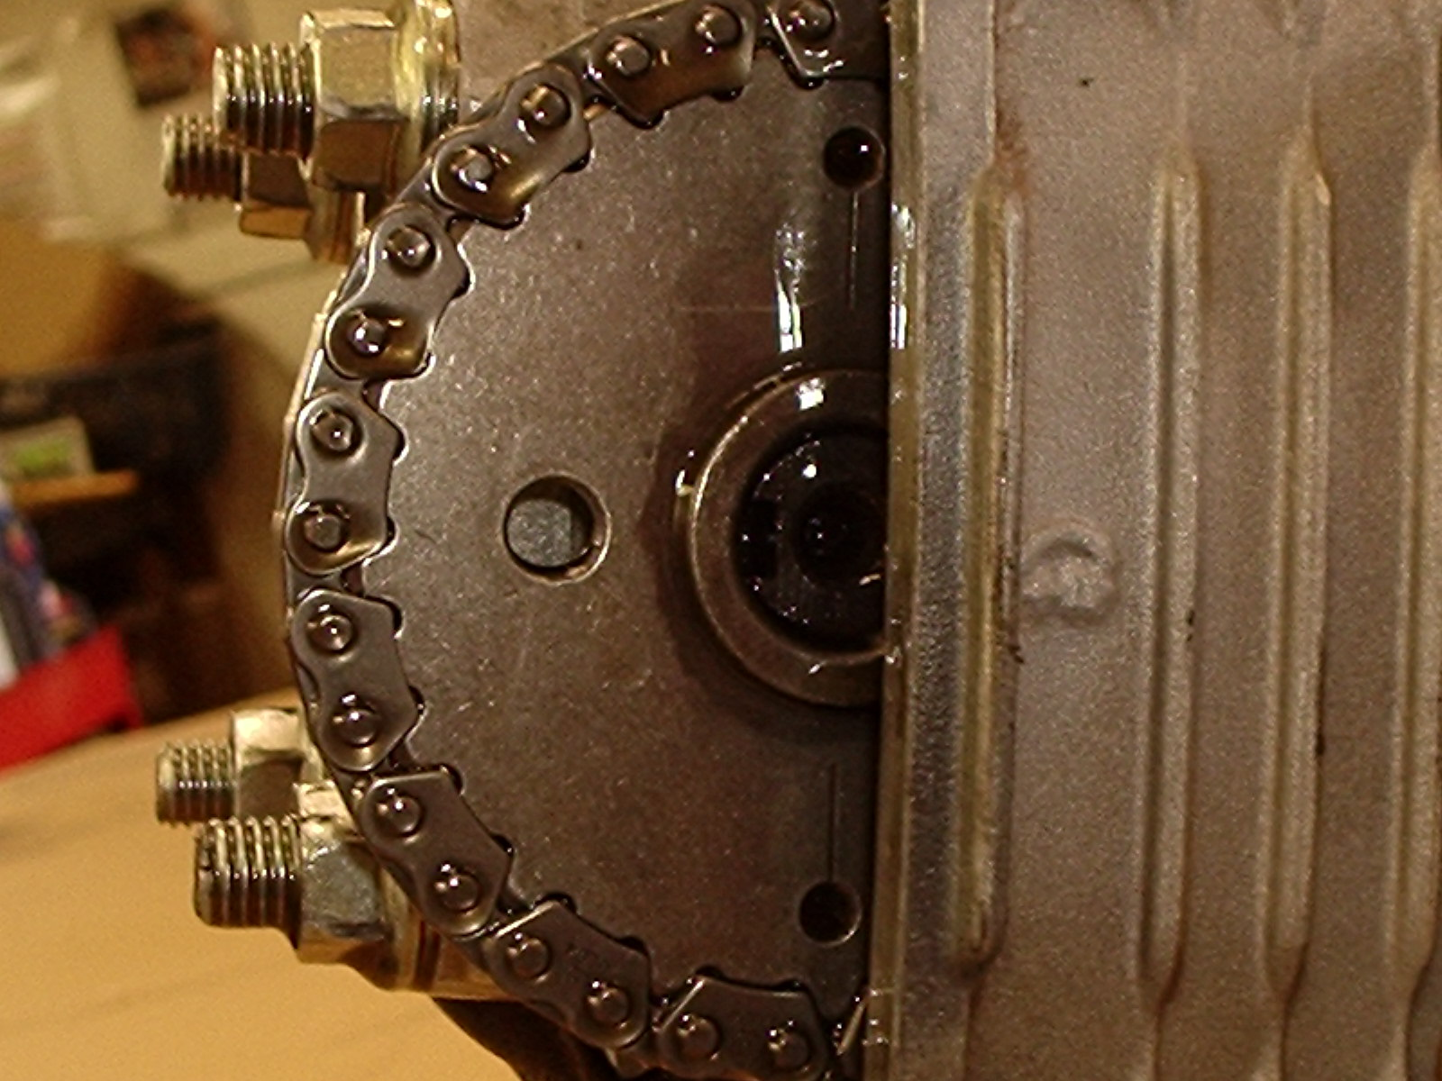

Remove cam from head.

- Remove the Cam Chain Tensioner by removing the 2 bolts that secure it to the cylinder. (use caution with gasket it is most usually reused.)

Caution: Failure to release the tension on the Cam Chain Adjuster during reassembly will damage the Cam Chain beyond use. (The cases must be split to replace the cam chain.)

- Remove the 4 head bolt nuts from the rocker Cover and remove it.
- Tip the Cam Gear down and remove the Cam Chain.
- Secure the cam chain using a wire or tywrap so it can be accessed on reassembly.

Prepare Rocker Cover for reassembly.

1. Remove the Rocker Arms from the Rocker Cover by using a flat blade
screwdriver to gently turn the Rocker Arm Shaft while pulling it out the
side opening in the cover.
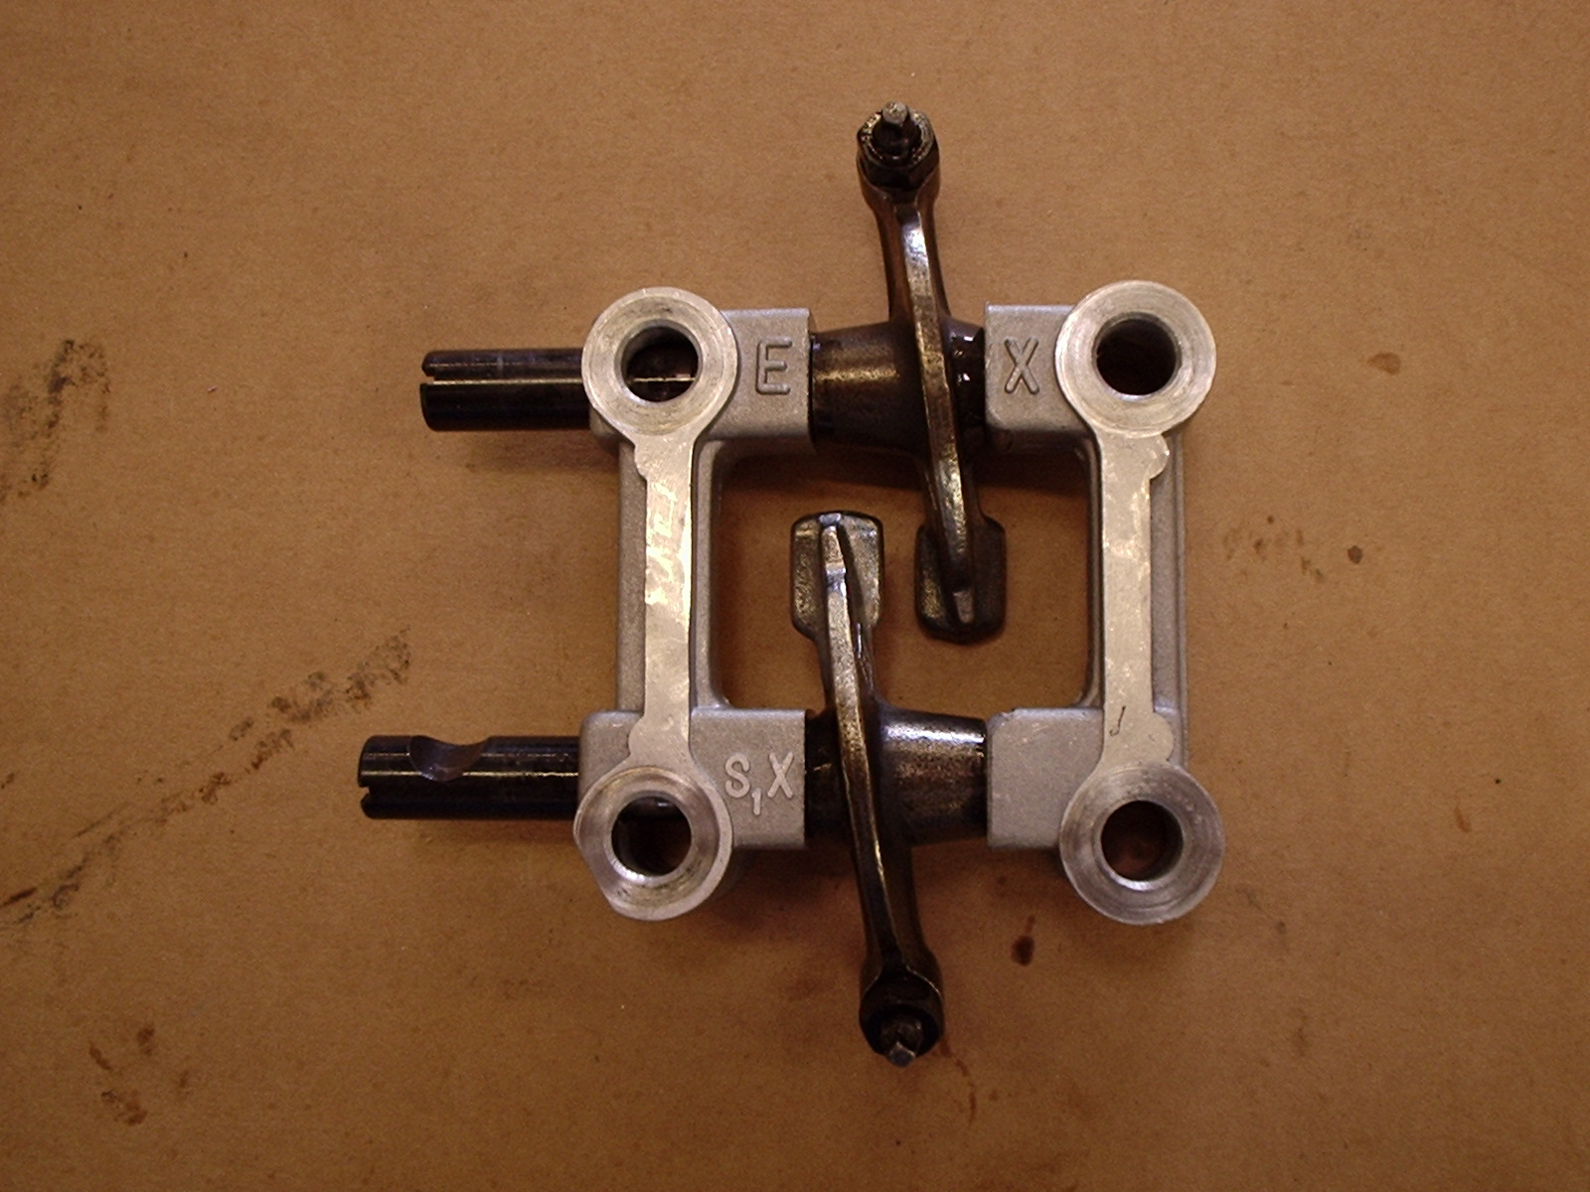
2. The Cam Kit is supplied with a new cut Rocker Arm Cover that is clearanced
for a new Stopper Plate for the Exhaust Valve de-comp. The stopper plate is
also supplied with the cam kit. As well as 2 new Pin Dowels to locate the
Rocker Cover in the correct placement.

Caution: Failure to install the Stopper Plate with the new Cam Kit will cause the motor to start the immediately die. The stopper must be installed.

3. Insert the rocker arm shafts into the new rocker arm cover and engage the
rocket arm and the stopper plate in the correct positiopns.
4. Loosen the lock nut on the valve tappet adjuster and back the valve adjustment
out for clearance on reassembly.

Reassembly

1. Insert the Cam by again tipping the Cam Gear down and attaching the Cam
Chain making sure the alignment is set to the T mark on the Flywheel and the
Hash Marks on the Cam with the Cam Top Hole at the top of the assembly.
2. Install the Rocket Arm Cover back onto the Cylinder Studs with the EX
towards the exhaust valve.
3. Install the Head Stud Nuts and torque to 1st 25 lbs then on to 35 lbs using a
cross pattern.
4. Recheck the cam alignment chain to ensure the Cam is in the correct position
to the T mark on the Flywheel.
5. Release the spring tension on the Cam Chain adjuster by removing the screw
cap and turning the adjuster inside using a small flat blade screwdriver
counterclockwise until it stops this will remove all tension from the adjuster.
6. Insert the adjuster and tighten the 2 mount screws while holding the 0 tension
on the adjuster.(Make sure gasket is in place.)
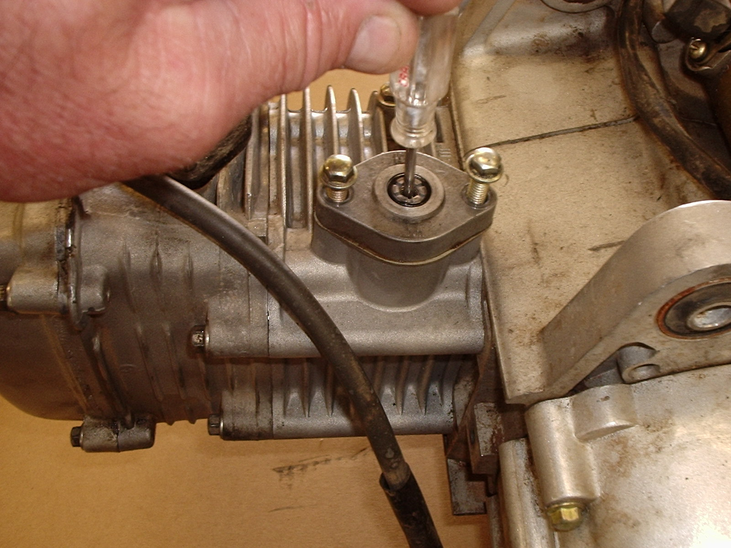
7. Release the tension on the adjuster and reinstall the cap screw.

Caution: Failure to release the tension on the Cam Chain Adjuster during reassembly will damage the cam chain beyond use. (The cases must be split to replace the cam chain.)

8. Adjust the valve tappets using a feeler gauge to a clearance of
Intake- .002- .004 “ Exhaust .003-.006”
9. Rotate the assy several times by turning the flywheel then recheck the T-
Mark to Cam alignment. as above.
10. Reinstall all remaining assy’s in the reverse direction of disassembly.
Final Test and Tune

  - Check operation of motor. ( Does it start and idle?)
  - Check jetting and set as required by intake, exhaust and cam use.
Pipe, Air Intake, and Cam should jet to appx-135 main at 1500-5000 ft.
Always jet as required by your location.
Mixture screw should start at 2.5 turns out and go up from there in most cases.

