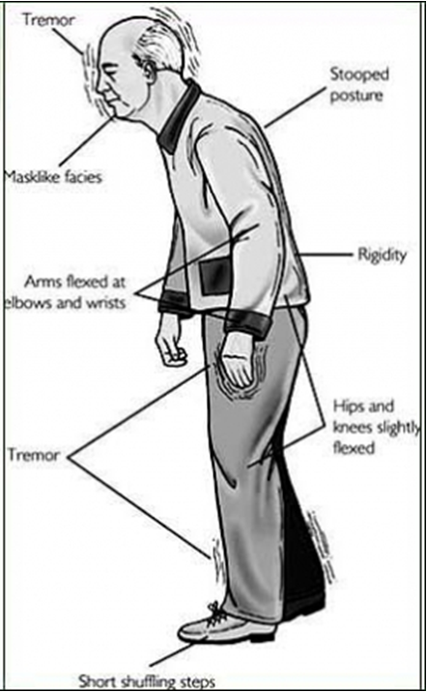
Parkinson's
Disease

- Parkinson’s disease (PD) is a chronic & progressive disorder
of the nervous system that impacts movement.
- PD involves the malfunction and death of vital nerve cells in
the brain, called neurons. PD primarily affects neurons in the
area of the brain called the substantia nigra. The cells in
this area of the brain produce dopamine, a chemical that
sends messages to the part of the brain that controls
movement and coordination. As PD progresses, the amount
of dopamine produced in the brain decreases, leaving a
person unable to control movement normally.
- PD often comes in like a lamb with barely noticeable
symptoms in the beginning ... but then it can turn into a lion
as the disease symptoms significantly increase and become
more pronounced and noticeable.
- There is no known cure, but there are natural system
support options that can significantly slow up the progression
of the disease, and help to manage the symptoms.
- Parkinson’s is a disease that can be incredibly devastating and life changing to not only the person affected, but can also impact all of those in that person's immediate circle of friends and loved ones.

Symptoms:
- Shuffling Gait, Shorter Steps - Parkinson’s disease affects movement, and few movements are naturally as inherent for people as is walking. PD sufferers will often take short, uneven steps (shuffling), and as the disorder progresses, challenges in judging obstacles and negotiating turns and corners.
- Akenisia: Reduced Arm Swinging - inability to swing arms naturally when walking
- Tremors - develop in the hands and arms, although they may also surface in the jaw and foot. Typically tremors manifest in the rubbing of the thumb against the forefingers and is most prevalent when the hand is at rest or the individual is under stress. In the early stages of the disease, it is usually only one side of the body or one limb that is affected, but as the disease progresses, other parts of the body may be affected.
- Bradykinesia: Mask-Life Facial Expression - Parkinson's affects facial muscles that may give a mask-like appearance to those with the disease ... their spontaneous response seems "flat", and smiles are rare. Bradykinesia is the gradual degradation of movement and the perpetual loss of spontaneous activity. This is caused by the brain's lethargy in transmitting instructions to the desired parts of the body. It can be as dramatic as a sufferer moving freely and seemingly uninhibited one moment, and then completely unable to move the next.
- Cognitive: Loss of executive functions, including planning, decision making and controlled emotions.
- Head Bent Forward & Forward Tilt of Posture (Stooped Posture)
- Balance Difficulty / Dizziness - balance is the even distribution of weight enabling someone or something to remain upright and steady. Multi-tasking like dribbling a basketball or even simpler tasks like walking while holding a glass of water can prove very time-consuming, difficult, and in some cases, impossible.
- Depression - is one of the most common side-effects experienced by people suffering from Parkinson's disease, although it is a little more complicated than that. While depression is a symptom of many diseases, both neurological and physical, in the case of Parkinson’s it might be prudent to view depression as a off-shoot of the other symptoms, or, even simpler, a symptom of a symptom. Parkinson’s is a life-changing ailment, and one that affects nearly every aspect of the individual's life. Things that were once easy become difficult or impossible, and it is only natural that this plays heavily on the psyche of the afflicted.
- Motor Skill Loss - Poor dexterity ... what were once simple tasks can prove to be very difficult for sufferers of Parkinson’s disease. Putting a puzzle together, cooking meals, and even tying ones shoelaces can prove not only difficult, but in some cases impossible without assistance. This loss of motor skills isn’t sudden, as it is more akin to gradually present itself as the severity of the disease increases. A loss of motor skills is also a large contributing factor to overall depression.
- Deterioration in Handwriting - A common symptom and telltale sign of Parkinson is a significant change in the penmanship of the individual suffering. Again, as is the nature of the disease, this does not happen suddenly, but rather is a gradual process of change. Very often, people with Parkinson’s report a predisposition to write smaller than usual and their writing is typically ‘messier’ than it once was.
- Voice and Speech Differences - A natural ‘softening’ of the voice is a common symptom with many people reporting a need to ‘lean in’ in order to hear and converse with a person with Parkinson’s. PD sufferers also make experience difficulty in enunciating words, especially larger ones. Dysarthria is a condition in which the muscles you use for speech are weak or you have difficulty controlling them. Dysarthria often is characterized by slurred or slow speech that can be difficult to understand.
- Memory Loss - Parkinson’s disease sufferers will experience some degree of cognitive change. Common occurrences of dementia may include memory loss, difficulty thinking, trouble with problem-solving and changes in language, both tone and vocabulary. Dementia is progressive, meaning that the symptoms, like everything with this terrible disease, comes on gradually.
- Muscles more Rigid - muscles feel tight ... can eventually lead to drooling and difficulty swallowing.
- Constipation/Bladder Accidents - Involuntary muscles (bladder and bowels) can be affected.
- Difficulty Breathing - due to less oxygen ... therefore, exercise is essential.
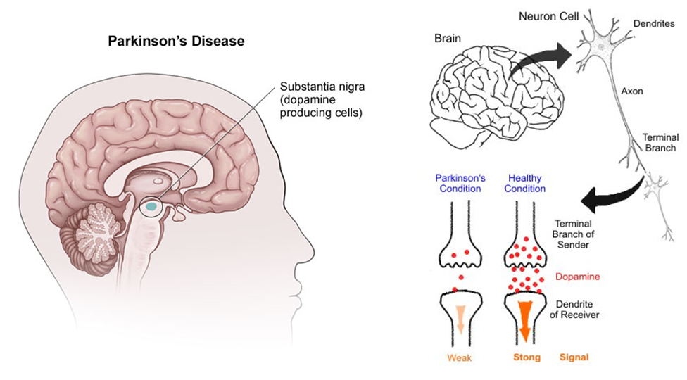

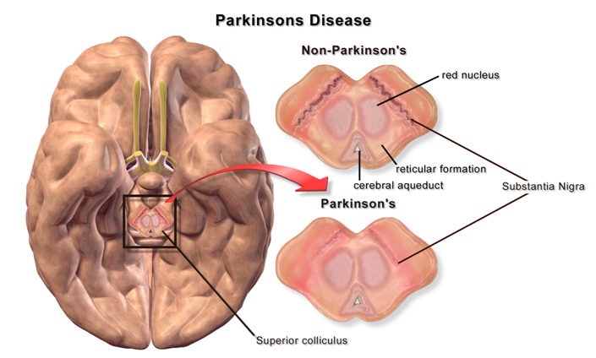

Causes and Types of Parkinson's Disease
- Primary Parkinson's: trauma injury to the head
- Secondary Parkinson's: chemical exposure & toxicity
- pharmaceutical drugs including:
- anti-depressants, high blood pressure, cholesterol statins and cardiovascular
- viagra
- post-vaccination syndrome
- heavy metals
- environmental chemicals, pesticides, herbicides, head lice treatment, chlorine in water
- industrial chemicals
- Post Encephalitis Parkinson's - viral damage
- Pseudo Parkinson's - made worse from stress

Recommendations: there is no cure, but supplements & lifestyle can really reduce the progression of the disease. An integrated program is necessary ... a recipe, like making a cake including all of the components, is ESSENTIAL. It takes a complete commitment from the patient to put the effort into warding off the progression of the disease.
- Exercise: 40 minutes 5x a week (work up a sweat) ... can cause 70% improvement
- Infrared Saunas: detoxification is critical
- High Fiber & Optimal Hydration: to support better detoxification / 60 to 80 oz. per day
- CoenzymeQ10: 6 per day
- Lecithin: phospholipids are the structural part of the brains where communications occur, and increases use of dopamine
- Vitamin E: tocopherols become deficient and need to be optimized
- Vitamin D3: helps in a number of neurological problems (is a pre-hormone nutrient)
- B Complex: Optimize intake ... work with a holistic practitioner regarding optimizing B6, (but not with dopamine) ... also B3
- Essential Fatty Acids:
- Resveratrol: triple Vivix intake
- Protein (later in the day): soy protein is especially beneficial
- Zinc / Copper / Iron: These 3 minerals must be optimized & in correct balance
- Ginkgo Biloba: Stimulates oxygen uptake
- Glutathione Supplementation: supports the production of dopamine ... available in oral form (contact Martha Willmore 905-871-4281)

Traditional Medical Treatment (due to the side effects of drugs, many people choose to be far more proactive with natural support
- Drugs:
- anticholinergics / antispasmodics (hyoscyamine, atropine, scopolamine, chlordiazepoxide, methscopolamine,
dicyclomine, glycopyrrolate, belladonna, phenobarbilal, atropine, mepenzolate, propantheline)
Side Effects: Bloated feeling; blurred vision; constipation; decreased sweating; dizziness; drowsiness; dry mouth; enlarged pupils; excitability; headache; nausea; nervousness; trouble sleeping; weakness, rash; hives; itching; difficulty breathing; tightness in the chest; swelling of the mouth, face, lips, or tongue); agitation; behavior changes; confusion; decreased sexual ability; diarrhea; difficulty focusing eyes; disorientation; exaggerated sense of well-being; fast or irregular heartbeat; hallucinations; loss of consciousness; loss of coordination; memory loss; mental or mood changes; severe or persistent trouble sleeping; speech changes; taste changes or loss; trouble urinating; unusual tiredness or weakness; vision changes; vomiting.
- anticholinergic antiparkinson agents (procyclidine, diphenhydramine, benztropine, trihexyphenidyl, biperiden)
Side Effects: Blurred vision; constipation; dilated pupils; dry mouth; giddiness; lightheadedness; loss of appetite; nausea; upset stomach; vomiting, severe allergic reactions (rash; hives; itching; difficulty breathing; tightness in the chest; swelling of the mouth, face, lips, or tongue); chest pain; confusion; difficult or painful urination; difficulty swallowing; eye pain; fast or pounding heartbeat; mental or mood changes; uncontrolled movements.
- adamantane antivirals (amantadine, rimantadine)
Side Effects: Agitation, anxiety, or nervousness, difficulty concentrating, headache, irritability, loss of appetite, nausea, purplish red, net-like, or blotchy spots on the skin, trouble in sleeping, nightmares, constipation, diarrhea, drowsiness, dryness of the mouth, nose & throat, false, vomiting, unusual tiredness, severe mood or mental changes, skin rash, slurred speech, thoughts of suicide or attempts at suicide, unexplained shortness of breath
- monamine oxidase inhibitors (Isocarboxazid - Marplan; Phenelzine - Nardil; Selegiline - Emsam; Tranylcypromine -
Parnate)
Side Effects: dry mouth, nausea, diarrhea or constipation, headache, drowsiness, insomnia, dizziness or lightheadedness, involuntary muscle jerks, low blood pressure, weight gain, difficulty starting a urine flow, muscle cramps, prickling or tingling sensation in the skin, suicidal thoughts
- cholinesterase inhibitors- for Dementia (tacrine, galantamine, rivastigmine, donepezil, memantine
Side Effects: clumsiness or unsteadiness, diarrhea, loss of appetite, nausea, vomiting, fainting, fast or pounding heartbeat, fever, high or low blood pressure, skin rash, slow heartbeat, aggression, irritability or nervousness, change in stool colour, convulsions, troubled breathing, wheezing, stiffness of arms or legs, slow movement, trembling and shaking, trouble in urinating.
- prolactin inhibitors (bromocriptine, cabergoline)
Side Effects: dizziness, lightheadedness, nausea, confusion, hallucinations, uncontrolled movements of the body
- Dopamine: (dopaminergic antiparkinsonism agents) works only 5 to 10 years, and then does not work at all
- Shock Treatments: brain stimulation

Detoxification is ESSENTIAL:
Degenerative disease is often facilitated by the accumulation of toxins in the body. The following herbal formulas are recommended:
- Herb Lax – enough to maintain three easy eliminations daily
- Liver DTX – milk thistle & dandelion is essential to detoxify the liver
- Stomach Soothing Complex – improves digestion & reduces fermentation in the intestinal tract.
- Some people with Parkinson’s disease have been found to have high levels of heavy metals. A hair analysis is recommended. (contact Martha Willmore at 905-871-4281 to order your hair analysis) Shaklee 180 energy tea, garlic, Chelation suppositories, infrared sauna treatments, and/or therapeutic levels of Vitamin C are recommended to deal with heavy metals.
- Parasites are a frequent problem with people with Parkinson’s. It is a good idea to do a parasite cleanse 2x a year.

Diet Recommendations:
- Follow the Healthy Body Diet.
- ONE tablespoon of Coconut Oil EVERY DAY is EXTREMELY BENEFICIAL
- Make sure the diet is at least 50% raw.
- Fresh extracted vegetable juice from a juicer is recommended daily.
- Ensure adequate low-fat protein – at least 3/4 gm per pound of body weight (50% should be raw complete powered protein source). Shaklee 180 Smoothees are GREAT due to the added leucine.

Purchase a Chi Machine or a vibrator machine ... and use it 2 or 3 times per day. (call 905-871-4281)

Curcumin (Turmeric) shows promise in attacking Parkinson’s disease

Just one more reason why one or two teaspoons of turmeric in an ounce or two of prune juice every morning is a good idea!

Published: March 20, 2012
EAST LANSING, Mich. — Curcumin, a compound found in the spice turmeric, is proving effective at preventing clumping of a protein involved in Parkinson’s disease, says a Michigan State University researcher.
A team of researchers led by Basir Ahmad, an MSU postdoctoral researcher, demonstrated earlier this year that slow-wriggling alpha-synuclein proteins are the cause of clumping, or aggregation, which is the first step of diseases such as Parkinson’s. A new study led by Ahmad, which appears in the current issue of the Journal of Biological Chemistry, shows that curcumin can help prevent clumping.
“Our research shows that curcumin can rescue proteins from aggregation, the first steps of many debilitating diseases,” said Lisa Lapidus, MSU associate professor of physics and astronomy who co-authored the paper with Ahmad. “More specifically, curcumin binds strongly to alpha-synuclein and prevents aggregation at body temperatures.”
Lapidus’ lab uses lasers to study protein folding. Proteins are chains of amino acids that do most of the work in cells. Scientists understand protein structure, but they don’t know how they are built – a process known as folding. Lapidus’ team is shedding light on the process by correlating the speed at which protein folds with its tendency to clump or bind with other proteins.
When curcumin attaches to alpha-synuclein it not only stops clumping, but it also raises the protein’s folding or reconfiguration rate. By bumping up the speed, curcumin moves the protein out of a dangerous speed zone allowing it to avoid clumping with other proteins.
Finding a compound that can fix a protein when it first begins to misfold can lead scientists to identify drugs that can treat certain diseases. Doctors won’t be prescribing curcumin pills any time soon, though, Lapidus said.
http://msutoday.msu.edu/news/2012/curcumin-shows-promise-in-attacking-parkinson/

