COPD – Chronic Obstructive Pulmonary Disease
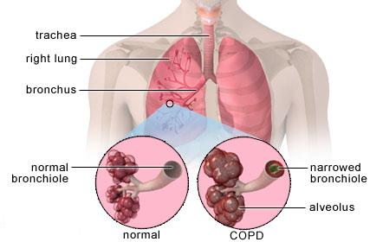
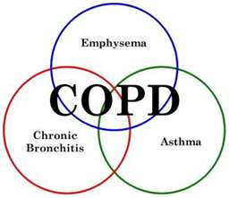

COPD is the fourth leading cause of death in the United States.

What is COPD?
- It is a lung condition that makes it more and more difficult to breathe
- It is often CONFUSED with asthma, a bad cough, or a natural part of aging
- Symptoms include shortness of breath, chronic cough, wheezing, chest tightness, increase and/or change is sputum / phlegm, etc.
- Both chronic bronchitis and emphysema are considered part of COPD
- Tobacco smoke causes approximately 80 to 90% of it
- Indoor & outdoor pollutants is a common cause … surveys show that possibly up to 20% is attributed in part to work-related exposure to pollutants
- It can be caused by a rare genetic condition called Alpha-1-Anti-trypsin deficiency

Lifestyle Recommendations:
- Don’t smoke, and choose a smoke-free environment
- Get an Air Purifier (Shaklee AirSource is recommended)
- Eat a very healthy diet, including ground flaxseed for the oil & fibre
- Use digestive enzymes if the GI tract is challenged (Shaklee EZ-Gest)
- Oxygenation of cells are compromised … therefore, use a Chi Energizer to enhance circulation with enhances the distribution of oxygen. Since people with COPD are limited in the amount of physical activity they can do, a Chi Energizer is a WONDERFUL investment.
- Liquid cayenne drops are helpful to open up the air-waves
- Use only toxin-free cleaners in the home to reduce inhaled pollutants
- Supplemental oxygen may be essential for serious cases (or even occasional use is very beneficial
- Humidifiers may be helpful
- A 75% alkaline diet is recommended to reduce inflammation

Supplements:
- Basic “General Health” product recommendations:
  - Shaklee Soy Protein or Shaklee 180 Smoothees … provides essential smorgasbord of essential amino acids daily
  - Shaklee Vitalizer – 80 bio-optimized nutrients essential for optimal health (including 26 anti-oxidants and Probiotics
  - NutriFeron … to maintain an optimal immune system … it is imperative to keep we well, since a lung infection could be fatal for someone with COPD
  - Vivix – anti-inflammatory

- Additional Optional focused products:
  - Shaklee Lecithin and OmegaGuard - Essential Fatty Acids are ESSENTIAL … reduces inflammation in the lungs … they act as nature’s prednisone
  - Shaklee Pain Relief … is wonderful for chronic inflammation (available in the USA only)
  - CoQHEART … strengthens the heart beat, which enhances the flow of oxygen
  - Alfalfa … used abundantly, thins the mucous & sputum/phlegm
  - VitalMag … relaxes constriction in muscular tissue
  - Garlic … natural anti-inflammatory
  - Ginkgo Biloba – enhances the blood flow throughout the whole body
  - Zinc … is healing to the inflamed lung tissue
  - Cal/Mag (additional Magnesium enhances lung function and can reduce wheezing & hyper reactions of the air passages leading to the lungs …. Shaklee VitalMag is recommended)

