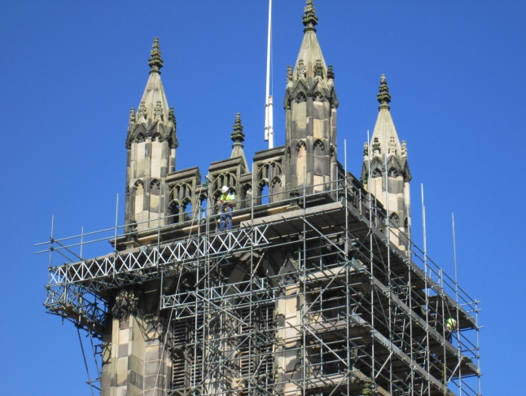
Work continues on the scaffolding with our experts checking how best distribute the enormous weight of not only the scaffolding itself but the stonework to be placed upon it. Great efforts are being made to protect the roof below.

Some of us needed time to reflect upon life in general or were they simply deciding what to do next! Everyone has certainly been busy outside with the ground now fully prepared for the building of the outer walls to the new toilet area.
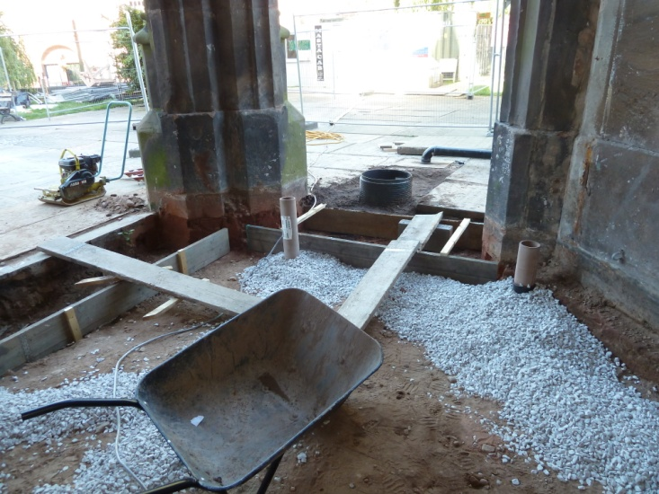
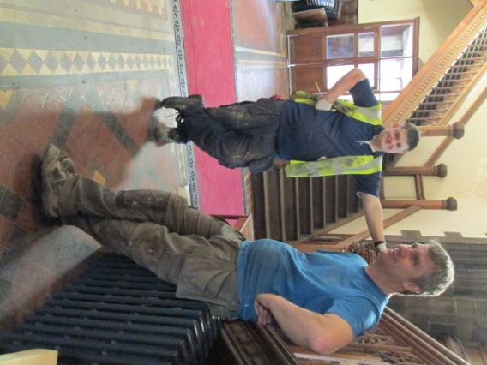

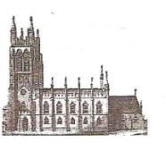
St Mary’s in the Marketplace.

No 8 (9th September 2012)
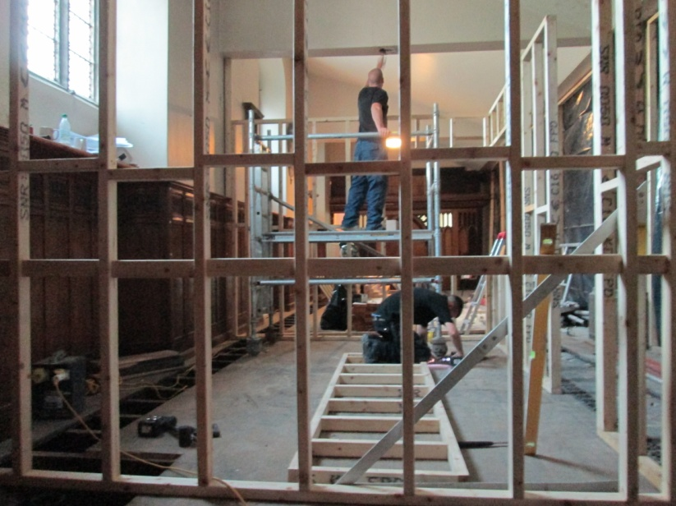
The framework for the new kitchen is quickly taking shape behind the black covers. It is all getting quite exciting!
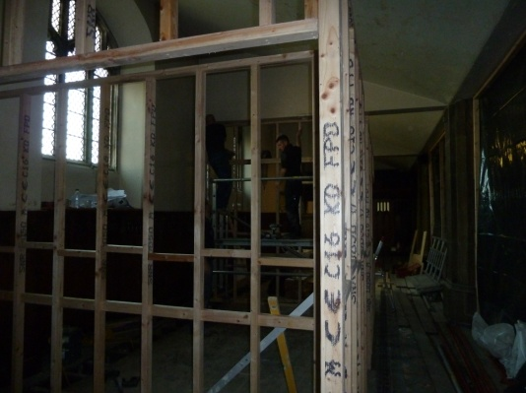

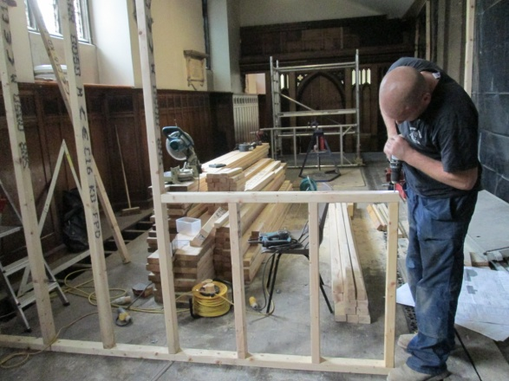

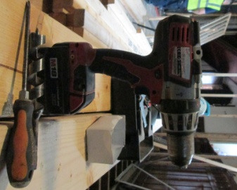

At the same time, taking advantage of the Church being closed, under-floor modifications are taking place to the pipework for the central heating. Still they haven’t found a stash of cash down the gratings! I’m very disappointed….. all there seems to be – believe it or not – pipes and a whole load of dust! Still the radiators look good – we should be warm this winter – assuming we can actually pay the gas bill that is!

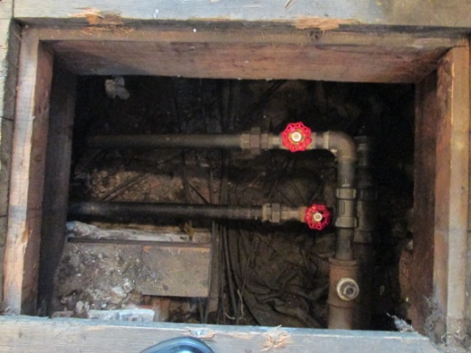
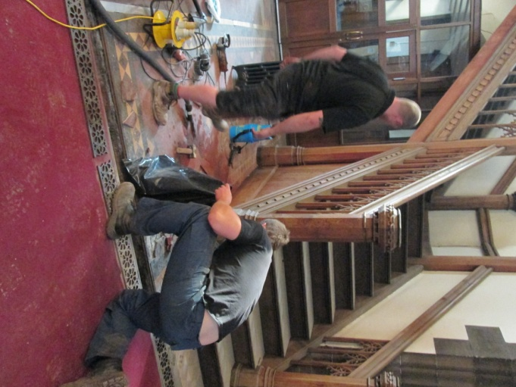

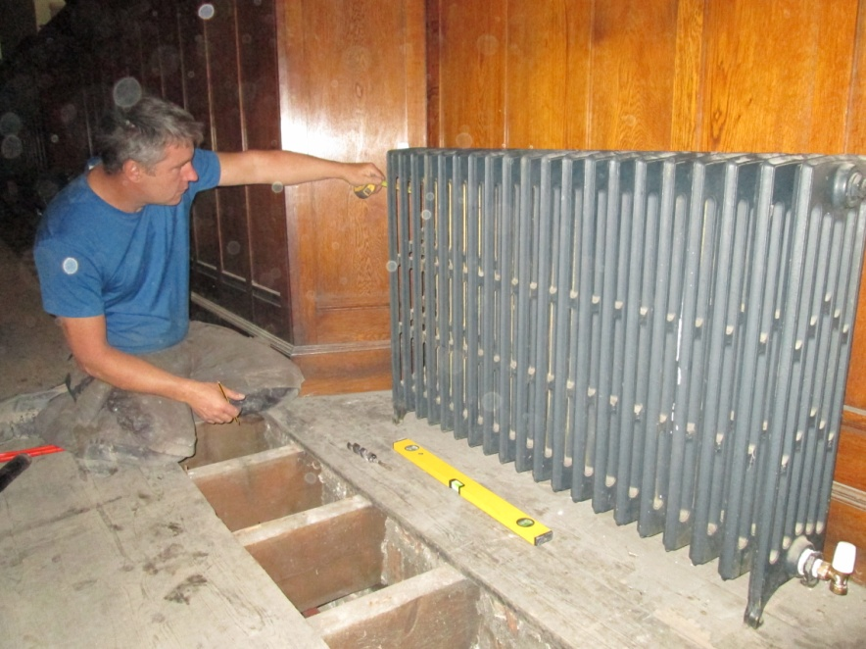

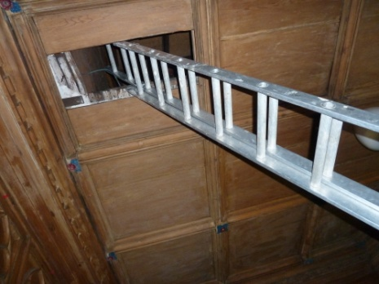
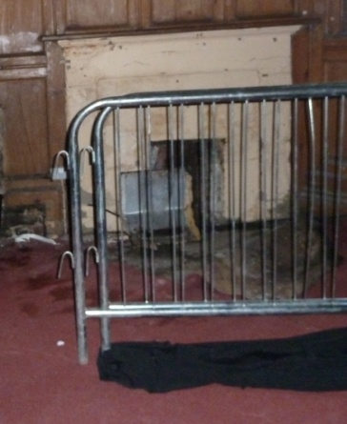
The Rectors vestry, looking so neat and tidy for the signing of the registers only a week or so ago, is now part of the building site and closed-off (for now) with restricted access only. We always knew it was damp in there – it is now a question of finding out how much repair work will be necessary to sort out problem areas.

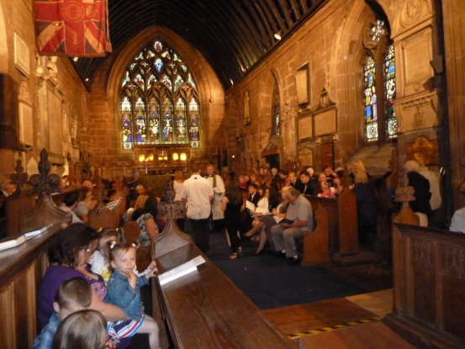
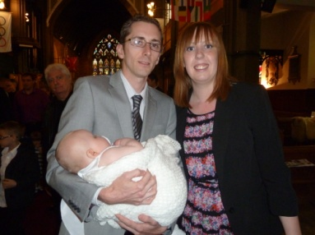
Life in the church has of course continued as near to normal as possible with a record number attending the baptism on Sunday last.

Baby Leah and her proud parents
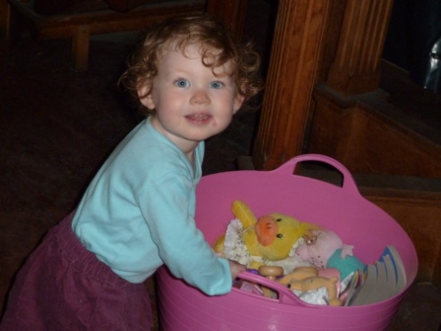
One of the congregation (our very own Opal) happy to view the toys in the play bin. Pity the floor was in need of a wash – sorry Gaby for the state of her tights by the time you went home.

