National Interpreting Agency 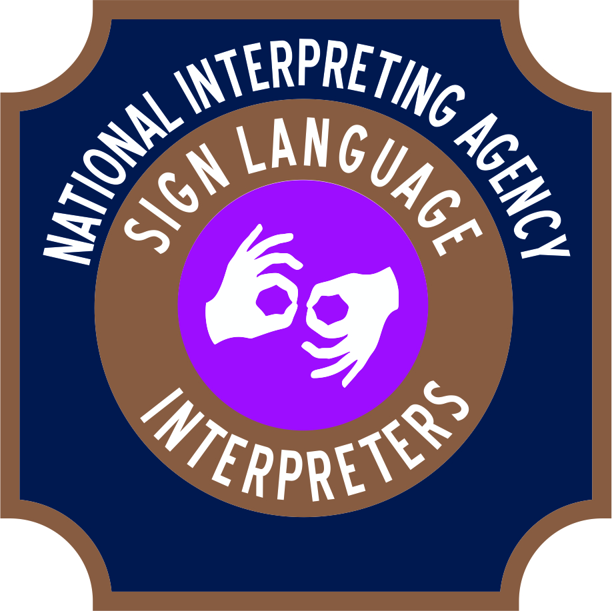
Gina D Asad
Executive Director
P.O. Box 35478
Cleveland, Ohio 44135
216-527-3400 office
216-527-4181 cell
330-975-4419 fax
N.Interpreting.A@aol.com
www.NationalInterpretingAgency.com

To Whom It May Concern:
Effective communication is a must as individuals go through their day-to-day life. In fact, communicating is so innate to the majority of us that it is something we tend to assume will occur for us. However, this is not the same reality for all individuals, which is the reason that my team at National Interpreting Agency (NIA) is dedicated to cultivating effective communication for those with specific hearing necessities.
We are interested in making sign language/ASL accessible to the general public and professionals that work with the public. In life, sometimes we may come in to contact with individuals who are deaf/hard-of-hearing that we may need to communicate with.
NIA provides interpreting services, with competitive and affordable costs, to any public or private event, including but not limited to:
- Fundraising and/or advertising functions
- Rallies
- Professional business meetings
- Lectures and/or workshops
- Sponsored events
NIA also offers basic sign language classes to instruct those businesses and individuals interested in learning basic signing skills to be able to communicate with individuals who are Deaf/Hard-of-Hearing until a professional interpreter can arrive to facilitate the communication at a professional level.
Most importantly, by offering interpreting and sign language classes, NIA is a full and proud supporter of the American with Disabilities Act (ADA), as we not only facilitate communication for those in need, but also make any special accommodations needed. NIA urges you to be supporters of the ADA by connecting with us to provide you with sign language services that will put you on the map of utilizing the services required to include all demographics of individuals in your audience of consumers.
Thank you,
Gina D Asad
Executive Director

