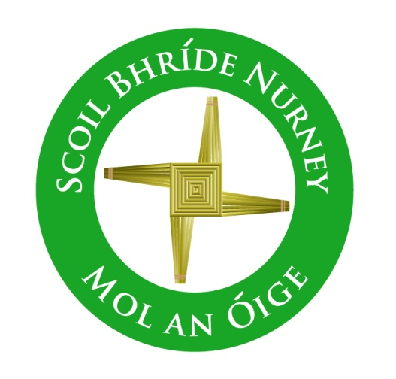
Droichead Induction Policy
2020+

Board of Management Scoil Bhríde Nurney
2020+

Scoil Bhríde

Droichead Induction Policy

Purpose
- To guide the whole school implementation of Droichead to support the induction of newly qualified teachers (NQTs)
- To identify the roles and clarify the responsibilities across the school community in support of Droichead
- To identify the protocols underpinning the Droichead process in the school
- To identify the documents in support of the process

Professional Support Team: Roles and Responsibilities
Professional Support Team (PST)
The Droichead process is an integrated professional induction framework for NQTs.
The main objective of the Droichead process is to support the professional learning of NQTs during the induction phase, thus laying the foundations for subsequent professional growth and learning for the next phase of their career.
Droichead: The Integrated Professional Induction Framework, Teaching Council, March 2017, p.3
The PST is a team of fully registered teachers, ideally with five years’ experience, including the principal, who work collaboratively to support and mentor the NQT during school-based induction, in the first stages of their professional journey. All PST members will have completed a programme of professional learning with NIPT, including mentor skill development. Schools may form a school PST or an inter-school PST or they may invite one external PST member to join the internal school staff.
Supporting a newly qualified teacher during Droichead is always a collaborative process, although the roles and responsibilities of PST members may vary in different school contexts, and are therefore agreed before the Droichead process commences.

- PST Roles

The dual role of the PST is to:
- guide and advise the NQT during school-based induction, in the first stages of their professional journey
- form a joint declaration with the NQT that they have participated in a quality teaching and learning process
Droichead: Policy Teaching Council, March 2017, p.3, 1.1.1.3

(b) PST Responsibilities
The responsibilities agreed by our PST are identified in a separate document.
Our PST’s responsibilities are neither exhaustive nor prescriptive and will be reviewed in light of experience. Responsibilities directly relating to support and mentoring relate to all team members while other responsibilities are designated to a named team member. We recognise that is also important that these agreed responsibilities are communicated to the NQT at the earliest opportunity.
In support of a NQT’s Droichead process, the PST will invite the wider school staff to provide opportunities for…
- Co-planning
- Co-teaching
- Sharing of resources
- Engaging in professional conversations
- Facilitating class observation
PST members
Name | Role | Trained (year)
Vincent Thorpe | PST member & Principal | 2020
Gillian Dunne | PST member | 2020
Eilis Reilly | PST member | 2020
 | PST member
 | PST member

NQT/s in the current school year
Name | TC Reg. No. | Class/es | Practice period | Assigned PST member  (if applicable)
John Stack |  | 3rd | 2019/2020 | VT, ER, GD

2. Protocols
This policy adheres to the protocols identified in the Droichead – The Integrated Induction Framework, Teaching Council, March 2017. This policy is specifically supported by the following sections:
- Professional conversations: p. 5
- Observation: p. 5
- Maintaining records of the Droichead process: p. 6
- Concluding the Droichead process: p. 7

3. Supporting documentation
This policy is part of a suite of documents to support Droichead in the school. These documents include:
- Droichead: The Integrated Induction Framework, Teaching Council, March 2017
- Teaching Council Standards (accompanied by our customised Indicators and Examples of School Context)
- PST Roles and responsibilities
- Droichead Outline drafted by the PST and finalised with NQT input
- Needs Analysis/Induction Plan – updated regularly in collaboration with NQT

Review
This policy will be subject to regular review in the light of ongoing experiences. The review of the policy will be led by the principal in collaboration with members of the PST.

Ratification of Droichead Induction Policy

This policy was adopted by the Board of Management on _________________

Signed: _________________________ Signed: __________________________
Chairperson of Board of Management Principal

Date: __________________________ Date: __________________________

Date of next review: __________________

