November 2020
With God, All Roads Lead to Victory!

Hello, Friends,

As we enter the month of November, many Americans will begin preparing for the next big holiday, which we know as Thanksgiving. (In the midst of this pandemic, we have a lot to be thankful for!) As we approach the end of 2020, I imagine people all over the world are mustering up a big “THANK YOU! THIS YEAR IS ALMOST OVER!!!”

I couldn’t help but chuckle when my friend posted this on her Facebook page:

This seems to be a popular sentiment, as 2020 has definitely been a year for the record books!

All jokes aside, though, let me ask you this:

What if 2021 was no better? Even more, what if 2021 turns out to be worse??!!

SHHHHH!!! Before you say anything, listen:

2020 did not catch God by surprise. 2021 – whatever is in store – will not catch God by surprise either. He knows the end from the beginning. And He does not do anything without first telling His servants, the prophets (Amos 3:7).

ASIDE: Has God been speaking to you through your man or woman of God? Have you been listening? Taking heed? Recognizing His authority and obeying the Word that He has spoken through those who have spiritual authority over you?

God does not do anything without first telling His prophets. Neither does He do anything without equipping His people for the situation. I Corinthians 10:13 tells us that He has already made a way of escape. He has already provided an answer, a solution, a way out, and a way in for every situation we will ever face. He will not allow us to be tested or tried beyond our ability.

Do you know what that means? That means we already have the victory! Even in the midst of this pandemic… even in the midst of the uncertainty of the future – victory belongs to us. With God, all roads lead to victory! He designed it that way!

The question becomes: How do we get there? I’m glad you asked! First, recognize the authority of the One Who designed the roads and give Him authority over your life. Then, receive His Word as Truth. Finally, operate in your “NOW faith.”

- Recognize the authority of the One Who designed the roads and give Him authority over your life.

When you give God supreme authority over your life, you will experience protection, safety, assurance, clarity, and confidence. When you get a bad report – whether it be a weather report, a medical report, a family report, a financial report – whatever kind of report it may be - you won’t don’t have to fear. Because God is the One you have given authority over your life, His report is the only report that matters. (I ask you today, Whose report will you believe? )

When you receive a report that is contrary to the Word of the Lord, you can ask, “WHO SAID?”

If God said it: YES, IT APPLIES TO YOU – give heed to it, do it, believe it, desire it, pursue it, receive it. If God did not say it: NO, IT DOESN’T APPLY TO YOU – don’t give heed to it, do it, believe it, desire it, pursue it, don’t receive it.

I love the example of the three Hebrew boys when they were threatened with the burning fiery furnace. King Nebuchadnezzar had built a golden image. All the people were commanded to bow down and worship the image when they heard the music. If they did not bow, they would be thrown into the burning fiery furnace. When Shadrach, Meschach, and Abed-nego did not bow, they were reported to the king. Their accusers said, “These men, O king, pay no attention to you; they do not serve your gods or worship the golden image which you have set up” (Dan 3:12, AMPC). They paid no attention to the king’s threat. Why? Because they revered God as the authority of their life (see Dan. 1).

When the king gave them a chance to reconsider, they said, “It is not necessary for us to answer you on this point. If our God Whom we serve is able to deliver us from the burning fiery furnace, He will deliver us out of your hand, O king. But if not, let it be known to you, O king, that we will not serve your gods or worship the golden image which you have set up!” (Dan 3:16-18, AMPC).

Oh, what confidence! They didn’t even flinch! And we know the rest of the story: They were tossed into the furnace. They were not harmed. Nebuchadnezzar saw that God was with them. He blessed the God of Shadrach, Meschach, and Abed-nego and issued a decree that anyone who spoke ill of their God would be killed. And if that wasn’t enough, he promoted Shadrach, Meschach, and Abed-nego. This is what happens when you make God the supreme authority over your life!

- Receive God’s Word as Truth.

When you have confidence in God’s authority, you also, by extension, have confidence in His Word. Having confidence in God’s Word means receiving His Word as Truth, knowing that He said what He meant, He meant what He said, and it will not fail. Jesus prayed for us in John 17:17, “Sanctify them through Thy truth: Thy Word is truth.” In the Greek (the original language of the New Testament), the word translated “truth” means “true to fact, reality, the opposite of illusion.” Receiving God’s Word as truth means acknowledging it as a reality (as opposed to merely an ideal) in your life.

Let’s practice. The following are familiar scriptures, but I want you to read them and on-purpose receive the Truth of these words. (That might mean you read them more than once or twice. ) Here we go!

- I can do all things through Christ which strengtheneth me (Phil. 4:13).
- Nay, in all these things [I am] more than [a conqueror] through Him that loved [me] (Rom 8:37).
- Jesus speaking: Behold, I give unto you power to tread on serpents and scorpions, and over all the power of the enemy: and nothing shall by any means hurt you (Luke 10:19)
- With [Jesus’] stripes [I am] healed (Is. 53:5).

Say these words aloud: Father, I give You supreme authority over my life, and I receive Your Word as Truth. I declare right now: Your Word is a reality in my life. Your Word is THE reality in my life. I live by every Word that proceeds from Your mouth, in Jesus’ Name. Amen.

- Operate in NOW faith.

However you define faith in your personal life, add the NOW factor to it. Get rid of the notion that whatever you are believing for will happen in the future or in the sweet bye-and-bye. Get rid of the notion that you are waiting on God to do it for you. Get rid of the notion that it has to take a long time for you to get it. Instead, renew your mind to the truth NOW FAITH IS… (Heb. 11:1).

Jesus said in John 8:58, “Before Abraham was, I AM.” My childhood pastor used to say, “God is quicker than quick and sooner than right now.” God is the eternal God. He is the Alpha and Omega, the beginning and the and the ending, Which is, and Which was, and Which is to come (Rev. 1:8). If He was, is, and is to come, guess what. That means He’s always NOW.

We who are born again Christians have this NOW God living on the inside of us. Furthermore, in Mark 11:22, Jesus tells us to “Have faith in God” or to have “the God-kind of faith.” We get a front-row seat to see the God-kind of faith in action in Genesis chapter 1. Time after time, God said. “Let there be…” and there was the immediate manifestation of what He had spoken. That’s NOW faith! That’s the God-kind of faith! Jesus wouldn’t tell us to have something if it wasn’t available to us. Because God is living inside of us, we can operate in Now faith, too!

Second Corinthians 5:7 tells us, “We walk by faith and not by sight.” Walk by your NOW faith – understanding that things change from the inside out. When God spoke, He wasn’t trying to get something that was outside of Himself. He spoke the image that was within. When He said, “Light be,” that image of light was already on the inside of Him. His words were the containers that held that image; when He spoke those words, He released the image into the atmosphere. That’s why when He said, “Light be,” light was.

Get rid of the notion that whatever you are believing for is coming from some outside source. Faith is not in the business of acquiring (i.e., getting something that we do not yet have ownership of). Rather, faith is in the business of retrieving that which is already ours because God has already provided it. This includes all spiritual blessings in heavenly places (Eph. 1:3) and all things that pertain to life and godliness (II Pet. 1:3-4).

Begin exercising your NOW faith.

Here, let’s practice. Say the following out loud:

- Behold, the kingdom of God is within [me] – NOW! (Luke 17:21)
- As [Jesus] is, so [am I] in this world – NOW! (I John 4:16)

- [I] shall say unto this mountain, Be thou removed, and be thou cast into the sea; and shall not doubt in [my] heart, but shall believe that those things which [I] saith shall come to pass; [I] shall have whatsoever [I] saith – NOW! (Mark 11:23)
- What things soever [I] desire, when [I] pray, [I] believe that [I] receive them, and [I] shall have them – NOW! (Mark 11:24)
- With God all things are possible – NOW! (Matt. 19:26)

As we wrap up 2020 and approach 2021 – don’t be in such a rush for this time to be over. Take no thought for the morrow: for the morrow shall take thought for the things of itself. Sufficient unto the day is the evil thereof (Matt. 6:34). Instead, live in the now. Operate in your NOW faith, knowing that you always have whatever you need when you need it because it is always NOW. The Kingdom of God is within you – NOW. You have all spiritual blessings in heavenly places and all things that pertain to life and godliness – NOW. Receive this as Truth, in Jesus’ Name.

Glory to God!

With God, all roads lead to victory. Give Him supreme authority over your life, receive His Word as Truth, and activate the NOW factor in your faith. If you do these three things, manifested victory will be your portion. “Light Be!” in Jesus’ Name.

As you rehearse the three steps outlined in this letter, answer these questions in the privacy of your own heart:

- Have I truly given God authority over my life? Am I experiencing the protection, safety, assurance, clarity, and confidence that come with giving God authority over my life? In what areas have I not given Him authority?

- Do I receive God’s Word as Truth? Do my actions show that I have received God’s Word as Truth? If yes, how? If no, what would my actions look like if I did receive His Word as Truth? What is hindering me from receiving His Word as Truth?

- How will I incorporate the NOW factor into my faith?

If you have been blessed by what you have just read, OR, if you have been challenged by what you just read - I would like to encourage you to give, or to “sow on it.” Name your seed in faith and expect to receive a harvest of it in your life. Just as you would plant corn seeds if you wanted to harvest corn, plant the seed you want to harvest. If you are believing God for your car note to be paid, name the seed “Car Note, “ sow it in faith, and expect to see the harvest of that seed (i.e., your car note being paid and something extra because the harvest is always greater than the seed). If you are believing for favor on your job, name the seed “Favor.” If you are believing for healing in your body or salvation for a loved one, name your seed accordingly - whatever you are believing God for. I stand in agreement with you that God will grant your request according to His will, in Jesus’ Name.

As you prepare to sow your next seed (sowing outlets are listed at the end of this letter), sow it in faith as demonstration that you believe you receive a harvest of this Word in your life. Be blessed knowing that I am praying for you and speaking PERFECT VISION to you, in Jesus’ Name.

Lovin’ you with the Love of the Lord,

Katherine

You may sow through the following outlets:

PayPal or Zelle: Godslovesong@outlook.com | *Cash App: $KIsFree (K Is Free – all one word)
*Website: https://www.godslovesongministries.com/giving-partnership

Special Announcement on Next Page

Hey! Does this remind you of anyone you know?
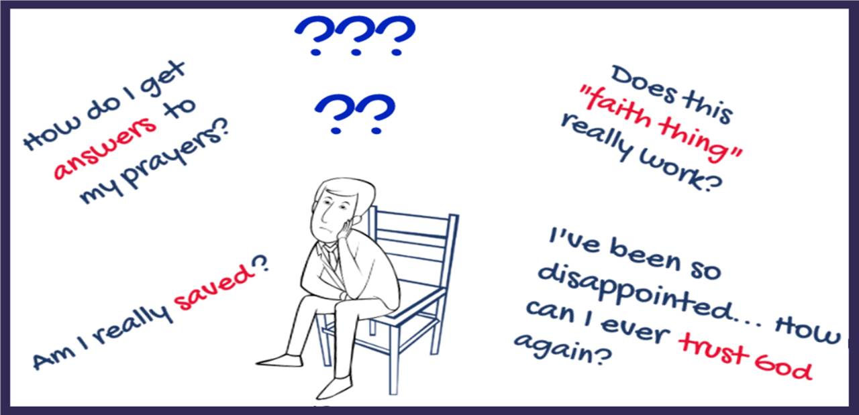

We can help!
Visit www.Discipleshipway.com to learn more!
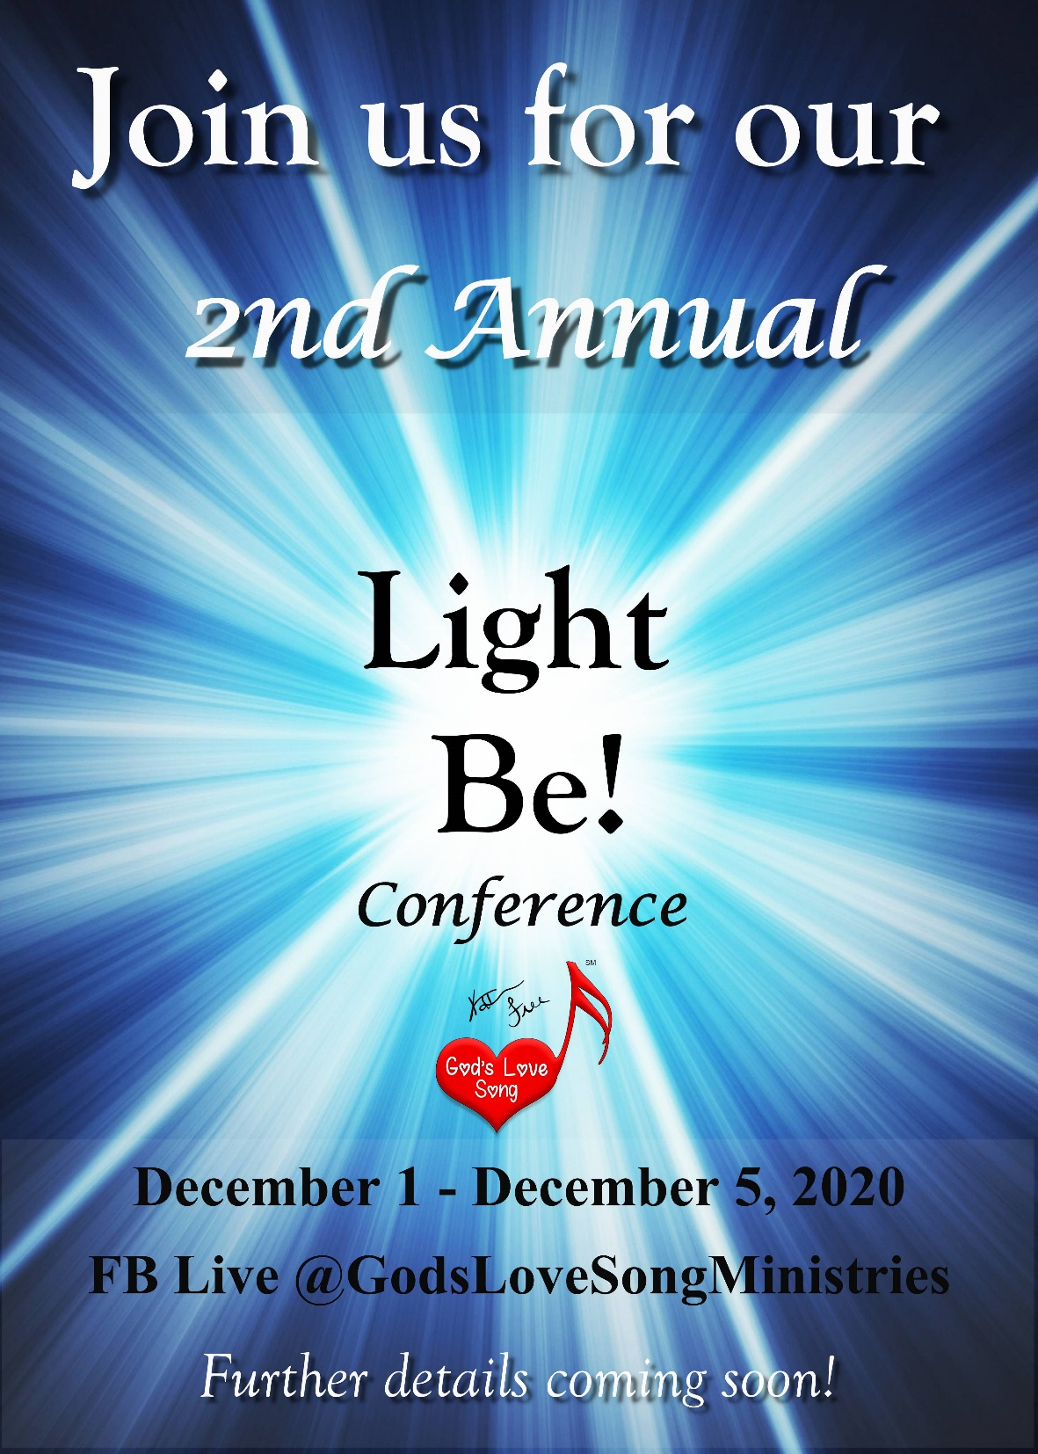

Tell your friends!!!

The reference in some Bibles translates “Have faith in God” as “Have the God-kind of faith."

