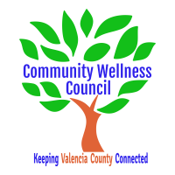
Board Meeting
September 4, 2019
1:00pm-3:00pm Wellness Center

1:00PM-1:15PM

- Call Meeting to Order
- Welcome Guests
- Agenda
- Consent Agenda
  - Minutes of 8/7/19
  - Treasurer Report
  - Coalition Reports
- Social Media/Website Report
- Consent Exemptions
Business
- Public Safety and Mental Health Discussion (Peggy) 1:15PM-1:30PM
- Coordinator’s Report (Noelle) 1:30PM-1:40PM
- Grant, Grant deliverables/Activities Update (Diana/Noelle) 1:40-1:50PM
- Financial Management Update/Monthly Match (Noelle) 1:50PM-2:00PM
- Anna Age 8 Taskforce updates 2:00PM-2:10PM
- KAH Training updates 2:10pm-2:25PM
- Collaborative CRUNCH update (Noelle/Diana) 2:25-2:35PM
- Review Timeline for upcoming planning for events (All) 2:35-2:40PM
- OSAP/Strategic Plan and Core Team Planning (Linda) 2:40-2:50PM
- MRGDA Update (Noelle/Diana) 2:50pm-2:55pm
- Review of Activities/Time Line/Action Items 2:55 PM-3:00PM

Additional Items of Discussion
- Adjourn

