The Narcissistic Abusive Relationship Cycle

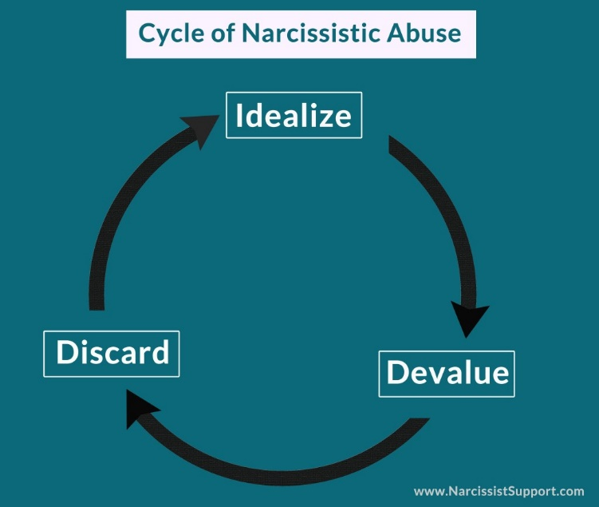
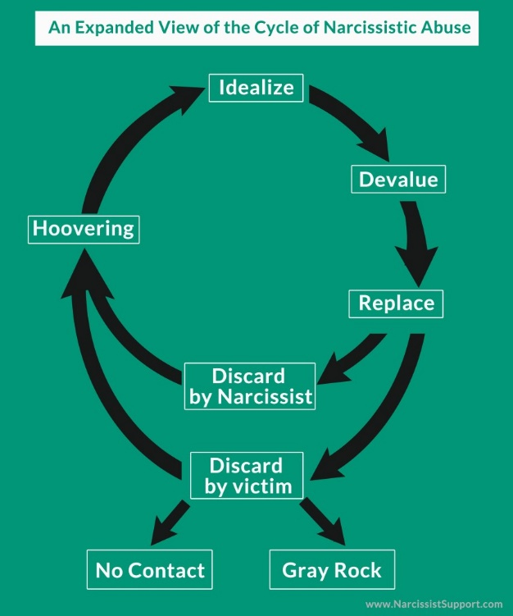

The Narcissistic Abusive Relationship has a very different cycle of abuse, so it typically confuses people because it does not look like the cycle of abuse that we often see circulating for domestic violence awareness. Even professionals are baffled when victims come in explaining the abuse they suffered because it does not look like a typical domestic violence situation. A lot of the manipulation tactics used by Narcissists are very covert and undetectable to anybody who is not familiar with Narcissism or Narcissistic Personality Disorder. Their tactics have been compared to those used on prisoners of war to break them down. Many victims of Narcissistic abuse end up suffering from PTSD, C-PTSD, Fibromyalgia, and many other debilitating health conditions. I found the following article and it explains the cycle of abuse for Narcissistic Abuse in great detail. It is a very good read and makes it easy to follow each stage associated with the cycle.

Remember, all Narcissists use the same cycle regardless of the relationship even though it may appear different and depending on the purpose you will serve in their twisted and distorted world. The Narcissist in your life could be a partner, family member, friend, co-worker, or boss. You will also find them in religious settings and organizations because this gives them the perfect opportunity to reinvent themselves and create new personas with zero questions asked (church, mosque, temples).

http://www.thriveafterabuse.com/cycle-of-a-narcissistic-relationship/

The Narcissistic Abusive Relationship has a very different cycle of abuse, so it typically confuses people because it does not look like the cycle of abuse that we often see circulating for domestic violence awareness. I found the following article and it explains the cycle of abuse for Narcissistic Abusive Relationships in great detail. It is a very good read and makes it easy to follow each stage associated with the cycle.

Idealize Stage 1: (when Narcissist and victim first begin a relationship)

Love bombing (Red Flag of a Narcissist #1)
Rushing Intimacy (Red Flag of a Narcissist #2)
Listening/Offering Emotional Support (Red Flag of a Narcissist #3)
Mirroring (Red Flag of a Narcissist #4)
Charming (Red Flag of a Narcissist #5)
Hyper-sexuality (Red Flag of a Narcissist #2)

Devalue Stage: (either to the victim’s face or behind their back–if this stage is done behind the victim’s back, they may not realize anything is wrong in their relationship until they are discarded.)
Walking on eggshells
Oftentimes bouts of Narcissistic Rage, which can include one or more types of abuse: verbal, physical, emotional, psychological, sexual, financial
Cheating
Lying
Parasitic existence (Narcissist begins to “mooch” off of and/or financially drain the victim)
Gas lighting
Victim begins to question their behavior (Is it them? Is it me? Am I the problem? Am I making too big of a deal of things?)

* Replace:

Identifies and lines up next source of Narcissistic supply (generally a new or former partner)
Silent treatment given to current partner
Behavior and stories make the current partner suspicious
Victim experiencing “Narc Speak”
Projection (accusing the current partner of cheating, lying, stealing, or behavior they aren’t doing)
Creation of flying monkeys by telling new source of supply lies and half-truths about the victim (aka smear campaign)
Narcissist doing “damage control” behind the scenes, trying to save their public image

(If Discarded by the Narcissist):

Generally very sudden, and without warning. “Light switch” like approach to both the relationship and the partner (I love you/you don’t exist)
Lack of closure
Continued (or start of) silent treatment
Narcissist’s Mask “slips” showing their lack of remorse and empathy

(If the Narcissist is Discarded by the Victim):

The victim ideally goes “No Contact”
The victim ideally goes “Gray Rock” if No Contact isn’t possible
(If the victim doesn’t realize their partner is a Narcissist, they will most likely continue this cycle until they can’t stand it anymore–at which point they generally go “no contact” or “gray rock.”
Idealize Stage 2: (Happens after the discard stage. The “make up” stage, where the Narcissist tries to “suck” the victim back into the relationship.)

Hoovering (Narcissists attempt to suck the victim back in)
Dosing (everything that is found in the stage 1 of idealization, but to a lesser degree–it’s just the needed “dose” to make the hoovering effective (aka suck the victim back in).

* Regardless of how (and who) ends the relationship, the following are often experienced:

Victim is often replaced within a very short time frame (less than a few weeks), and often in a very humiliating, degrading, and public way. Oftentimes the Narcissist take down all trace of the relationship with the old partner and quickly replace with the new parter–especially on social media. The pictures and portrayal of their life with the new partner is that of total happiness, which (intentionally) further serves to add hurt, heartache, and humiliation onto the victim

Victim is often fearful of the Narcissist after seeing their lack of empathy, regard, and remorse (even if the Narcissist has never had a history of violence or intimidating behavior)
Victim often experiences a wide variety of conflicting emotions towards their partner (fear, love, hate, rage, sadness, relief, etc.)
Victim often experiences intense emotional pain that can lead to night terrors, anxiety, panic attacks, bouts of unexplainable crying, depression, wanting to isolate, feelings of worthlessness, deeply damaged self-esteem, guilt, suicidal thoughts/feelings (can develop into PTSD)

Victim feels misunderstood by friends and family

Victims is confused by what happened, and their role in it–often feeling like they must be the problem, as their partner has moved on and seems so happy with someone else

Victim has a hard time explaining what was so wrong in the relationship, or why they feel so emotional (especially if they were the one to leave)

Friends, family, well-intentioned other people offer unhelpful advice such as “get over it”, or even urge the victim to give the Narcissist another chance, as they aren’t familiar with the dynamic of the relationship, or about the personality disorder, or otherwise view the victim’s relationship as simply a “bad” relationship (which it is so much more than that)

Victim suffers from really low self-esteem, shame, embarrassment, and feelings of being “ground down” (especially if there was a long devalue stage done to the victim directly)

Victim wants to isolate from others, and feels very alone

The Narcissist may attempt to get money from their victim either by draining their accounts, racking up credit card debt, etc.

*In more extreme situations the Narcissist may begin projecting/telling the victim that they wished they were dead, had dreams that they were dead, wants to kill them, etc. Oftentimes this talk is very specific (ex. “I had a dream last night that you died in a house fire.”), and should be taken as serious as a death threat–as it potentially is one.

The end of a Narcissistic (or any manipulative or abusive) relationship is often very traumatic. Please know that you are not alone, and that there is help out there. If you are feeling depressed, please seek help immediately as a discussion with your doctor about antidepressants and/or anti-anxiety medications might be worth exploring. Finding a good therapist that is familiar with the different types of abuse can also really help you heal. Many domestic violence centers offer free or low-cost therapy options. ~ Glad Tidings

