

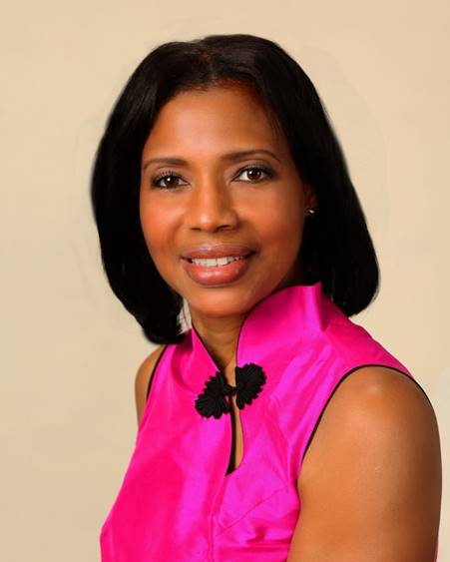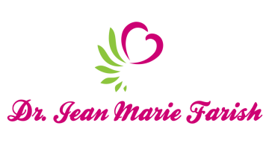

LOVE LIGHT NewsLetter

***I am excited to host my VoiceAmerica Empowerment Show-LOVE LIGHT with amazing Guests to cultivate a lifestyle of love and wholehearted connections through worthiness. My show is aligned with my mission to live an altruistic and heart centered life.***

**MEET LOVE LIGHT GUEST**

**MILLY DIERICX Diericx**

***Ph.D. in Thanatology; Masters in Erickson Psychotherapy and Author***

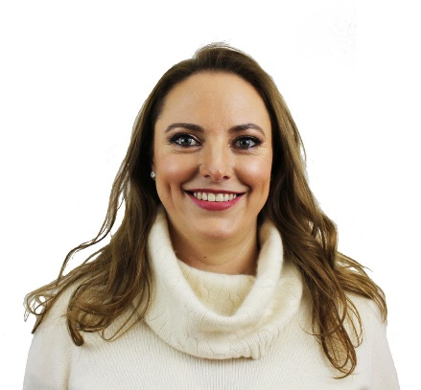

**May 22, 2020**

***“Raising Consciousness to the Vibration of Love”***

**ABOUT Milly Diericx**

**Milly has dedicated her life to healing herself and others. Her story begins with having lupus and facing the very real chance that she would die in a couple of days. The medical prognosis being so negative, she had two choices, either accept it and give away her power to others and live in fear, or do something about it. She decided to live her life on her own terms and seek ways to heal herself, and eventually, when this was accomplished, to help others do the same. In her journey to healing, she learned various techniques that brought her back to health, and now guide others through. However, if she had to boil down her recovery to a single thing, it would be that each one of us has the power to heal, that the body is designed to be healthy and well, all we need to do is give it the tools to do so. These techniques are just that, tools that help put the body back in balance, so that it can heal itself. The most powerful tool in this set is to achieve a change in consciousness, being aware of our own power, worth, and to love and accept ourselves unconditionally. Only from acceptance can we do something about our circumstances.**

[**info@millydiericx.com**](mailto:info@millydiericx.com)

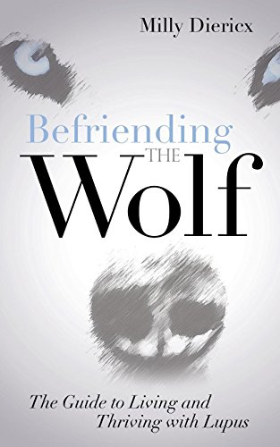

***“An empowered self is a loving self, and keep your love light shining.”***