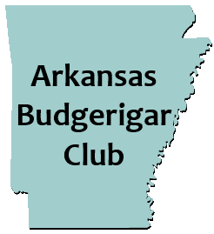
“MEMORIAL DAY”
WEEKEND DOUBLE SHOW!

May 27th, 2023 - Judge: Joshua Anthony
May 28th, 2023 - Judge: Mary Ann Silva

LOCATION: Tyndall Park Gene Moss building
ADDRESS: 913 E. Sevier St. Benton, AR 72015

All Divisions: Pairs, Rare, Junior, Novice, Intermediate, Champion
**“Natural Presentation” entries will be accepted**
One Day Entry Fee- $3 per bird ($30 max fee)
Two Day Entry Fee- $5 per bird ($50 max fee)

Friday- May 26, 2023
12:00pm- Show Hall opens for show setup/bird check in.
6:00 pm-Dinner (a la carte) at local restaurant.
Saturday- May 27, 2023
7:00 am- Show Hall opens
9:00 am- Bird check in and entries complete. Staging of birds.
10:00am- Judging begins
Lunch: provided by club. (Sides, desserts, drinks, etc. would be appreciated.)
6:00 pm-Dinner (a la carte) at local restaurant.
Sunday- May 28, 2023
7:00 am- Show Hall opens
8:00 am- Bird check in and entries complete. Staging of birds.
9:00am- Judging begins
Lunch: provided by club.
Bird Auction after lunch, followed by raffle item drawing (Donated birds and raffle items are greatly appreciated.)

Hotel: Best Western (Pet Friendly)
Address: 17036 I-30 Benton, Ar 72019
Phone #: 501-778-9695
*Mention Arkansas Budgie Club for special group rate*
$80.95 single room - $85.95 double room

For any other information contact: Bill McLean Jr. Ph #: 501-922-5656 Email: billmclean@att.net

