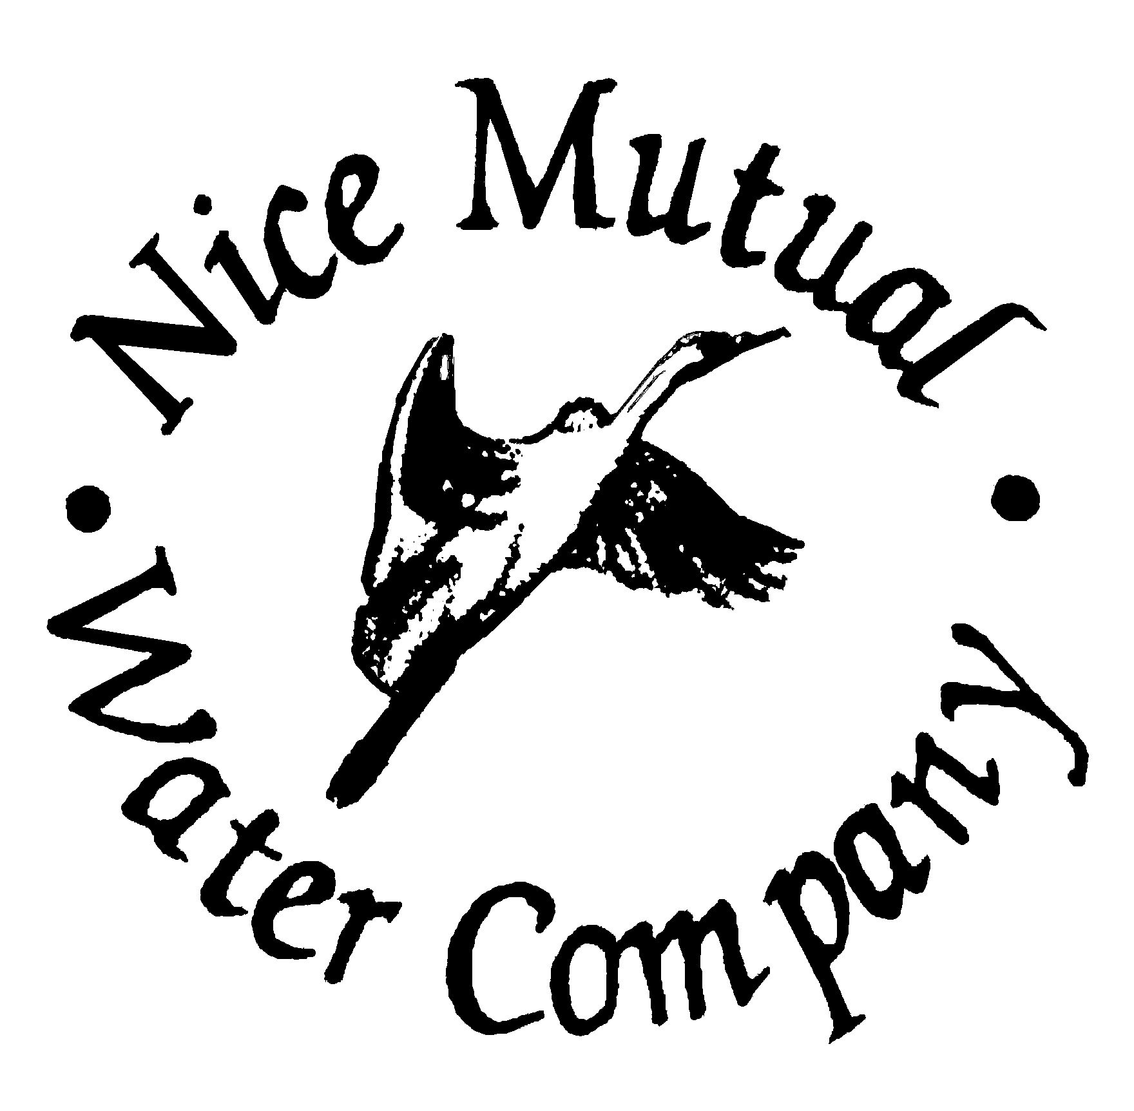

METER INSTALLATION FEES
1. Time and materials that are incurred by the Company on each meter set will be job costed out for each individual installation. The service connection fee paid is only for production capacity reserve that is allocated to each residential service.
2. The customer is required to have an approved contractor install their meter. They will be responsible for install costs, including County required fees. All work must be inspected by NMWC for quality and workmanship and approved before being accepted.
3. The new meter installation cost for parts and inspection is as follows:

Residential 3/4 x 5/8” Residential 1”

$ 1,150.00 Installation Cost $1,650.00 Installation Cost

Commercial 1”

$1,650.00 Installation Cost

4 The above terms are agreed and understood.

Printed Name: ____________________________
Signed: __________________________________
Date: ____________________

NICE MUTUAL WATER COMPANY
3246 LAKESHORE BLVD
P.O. BOX 578
NICE, CA 95464
(707) 274-1149

FEES FOR NICE MUTUAL WATER COMPANY:

RESIDENTIAL:
BALANCE DUE (IF ANY) $
CUSTOMER DEPOSIT 100.00
ACCOUNT SET UP FEE 125.00
STOCK TRANSFER FEE 25.00

COMMERCIAL:
BALANCE DUE (IF ANY) $
CUSTOMER DEPOSIT 200.00
ACCOUNT SET UP FEE 150.00
STOCK TRANSFER FEE 25.00

NEW SERVICE (IF AVAILABLE – PLEASE CALL)
5/8” X 3/4” METER $ 9,150.00
1” METER (RESIDENTIAL) 9,650.00
1” METER (COMMERCIAL ) 21,434.00
CUSTOMER DEPOSIT (R)100.00/(C)200.00
NEW ACCOUNT SET UP FEE (R)125.00/(C)150.00
NEW SHARE OF STOCK 25.00

Shareholder Application
NEW METER

Nice Mutual Water Company
3246 Lakeshore Blvd.-PO Box 578
Nice, CA 95464
PH. (707) 274-1149 FX. (707) 274-3345

CUSTOMER ___________________________________________
SERVICE ADDRESS___________________________________________
A.P. # ___________________________________________
MAILING ADDRESS___________________________________________
___________________________________________
CONTACT PHONE #___________________________________________
DRIVER’S LICENSE #__________________________________________

NEW CONNECTIONS: Please submit a drawing of where you would like the meter located. Nice Mutual Water Company will place the meter up to the property line. (Please indicate where on the actual property line.)

New Meter/Service Connection Fee $19,784.00

Installation Cost for 1” Meter $ 1,650.00

OTHER FEES DUE:
1 Year Refundable Deposit $ 200.00
(Deposit is applied to account if, no more than 2 late fees within a 12 month period)
Account Setup Fee $ 150.00
New Share of Stock $ 25.00
TOTAL $21,809.00

OFFICE Share of Stock #__________________
USE ONLY Date Turn on Requested _______/______/______

Customer Signature_____________________________Date____________

APPROVED LOCAL CONSTRUCTION COMPANIES

The following is a list of construction and excavating companies that handle water mains and service lines:

Rosco Corporation
7401 Lorene Rd
Redwood Valley, CA 95470
707-485-4320

Wipf Construction
1300 Hasting Road
P. O. Box 234
Ukiah, CA 95482
707-462-8741

Chernoh Excavating
14723 Catholic Church Road – Equipment Yard
Clearlake Oaks, CA 95423
P. O. 426
Lower Lake, CA 95457
707-995-1359 Office

Case Excavating
P. O. Box 2588
2735 Robin Lane
Clearlake, CA 95422
707-994-6815

Epidendio Construction
11325 Highway 29
Lower Lake, CA 95457
707-994-5100

Roto Rooter Construction
P. O. Box 1340
Kelseyville, CA 95451
707-994-9336

THIS SURVEY IS PART OF THE CROSS-CONNECTION CONTROL PROGRAM
REQUIRED BY THE CALIFORNIA ADMINISTRATIVE
CODE TITLE 17 – PUBLIC HEALTH

The Nice Mutual Water Company is required by the State of California to enforce the installation and maintenance of a backflow prevention device on any custom’s water system that has the potential of introducing any of the following substances into the public water system in case of pressure failure:
- Any water other than water from the public water system.
- Water from the public water system which has deteriorated in sanitary quality while on the customer’s premises.
- Any contaminated, or potentially contaminate water, including water from irrigation systems into which fertilizers, herbicides, or pesticides are, or can be introduced.
ANSWER YES OR NO TO EACH OF THE FOLLOWING QUESTIONS:
- Do you have an auxiliary water system using well, spring or lake water on your premises?____
- Do you have any form of cross-connection, either permanent or temporary, between an auxiliary water system or your plumbing that carries water provided by Nice Mutual Water Company? ____
- Do you have any type of irrigation system (sprinklers, drip systems, etc.) that includes a means of feeding fertilizer, herbicides or pesticides into the irrigation system? ____
- Do you have any other type of equipment or system on your premises where substances harmful to health (including water from the public water supply which has deteriorated in sanitary quality while on your premises) are handled in a manner that could permit entry into the public water system in the event of a pressure failure in public water supply system? ____

Under penalties of perjury, I declare that all of the above information is true, correct and complete.
Customer Name: _________________________________________________

Service Address: _________________________________________________

Mailing Address: ________________________________________________

Signature: ____________________________ Date: ____________________

THIS SURVEY MUST BE COMPLETED AND RETURNED BEFORE A NEW SHARE WILL BE ISSUED. PLEASE MAIL IT TO:
THE NICE MUTUAL WATER COMPANY, P. O. BOX 578, NICE, CALIFORNIA 95464
You will be notified by Certified Mail if you must install a backflow prevention device, or if an inspection of your premises is required. The notice will be accompanied by information on the installation and testing of backflow prevention devices and the date by which your installation and testing must be completed.
FAILURE TO RETURN THIS FORM WILL RESULT IN YOUR WATER CONNECTION BEING CLASSIFIED AS REQUIRING AN APPROVED BACKFLOW PREVENTION DEVICE, AND YOU WILL BE SO NOTIFIED.
IF YOU ARE NOTIFIED THAT YOU MUST HAVE A BACKFLOW PREVENTION DEVICE, FAILURE TO INSTALL A DEVICE WILL RESULT IN YOUR WATER SYSTEM BEING DISCONNECTED FROM THE PUBLIC WATER SUPPLY. NICE MUTUAL WATER COMPANY IS NOT GIVEN ANY ALTERNATIVE TO THIS ACTION BY TITLE 17 OF THE CALIFORNIA PUBLIC HEALTH ADMINISTRATIVE CODE.
NEW METER HOOKUPS EFFECTIVE DECEMBER 16, 2014
RESOLUTION #150317

As of December 16, 2014: If a party buys a share, installation of water service must be completed within 180 days and the monthly base rate will be paid every month whether or not water service is used. The monthly base rate will be charged starting 30 days after purchasing the share.

Policy:
For a Meter to be hooked up and a share issued, all fees must be paid in full. Partial payments are not allowed unless approved by the Board of Directors. Payment plans are not our policy.

RESOLUTION #150317 RESCINDS RESOLUTION #141216

