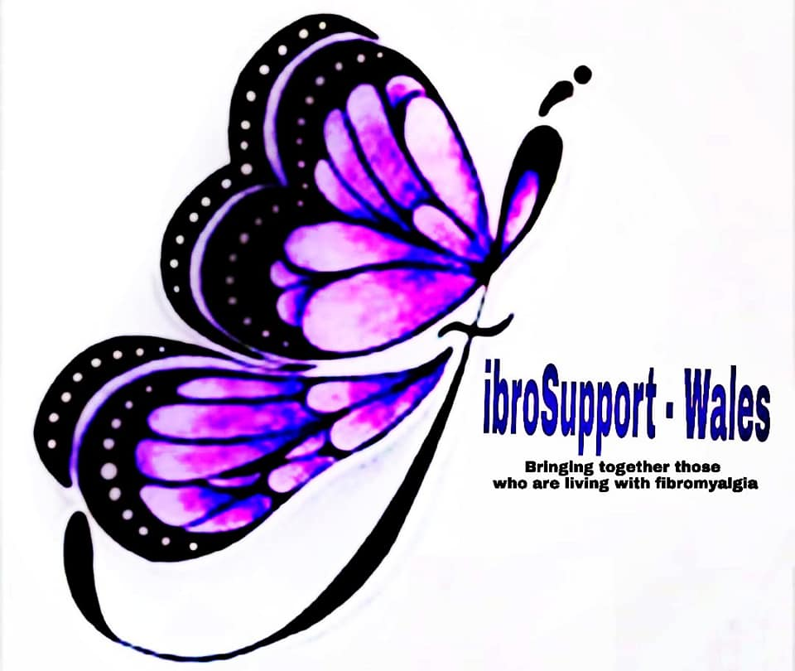

Equal Opportunities Policy

Purpose and Scope
The purpose of this Equal Opportunities Policy is to communicate our commitment to equality of opportunity in employment, with the aims of ensuring that all employees and volunteers are treated fairly and equally, and supporting the FibroSupport - Wales objective of providing a working environment that is free from all forms of discrimination.

The policy applies to all staff within the FibroSupport- Wales, including employees and other workers, such as agency workers, temporary workers and contractors. All staff are expected to put this policy into practice.

A copy of this policy will be distributed to all employees, volunteers and will be made available to other workers on their engagement.

Any questions about the policy should be directed to Steffan McMahon.

FibroSupport - Wales comittee has been consulted and has agreed the contents of this policy.

This policy does not form part of employees’ contracts of employment and FibroSupport - Wales may amend it at any time.

The policy is regularly reviewed at least once every twelve months and may be amended at any time.

Policy Statement
FibroSupport - Wales supports equality and diversity for all team members, trustees and volunteers during employment. The policy will be afforded to individuals fairly and irrespective of age, disability, gender, gender reassignment, marital or civil partnership status, pregnancy or maternity, race including colour, ethnic or national origins and nationality, religion or belief or sexual orientation.

We aim to create a working environment that is free from discrimination and harassment in any form, in which all trustees, volunteers, customers and suppliers are treated with dignity and respect.

FibroSupport - Wales will not unlawfully discriminate in the arrangements we make for new volunteers or committee members. All decisions will be made fairly and objectively.

We aim, as far as reasonably practicable, to ensure that all our working practices are applied fairly and consistently and, where necessary, we will take reasonable steps to avoid or overcome any particular disadvantage these may cause and to promote equality.

Specific Responsibilities
FibroSupport - Wales has overall responsibility for the effective operation of this policy and for ensuring compliance with the Equality Act 2010 and associated legislation and for observing relevant Codes of Practice.

Our HR department is responsible for monitoring and reviewing the policy and for ensuring that all employment-related policies, procedures and practices adhere to this policy.

All staff have a responsibility not to discriminate or harass other staff members, volunteers, clients and to report any such behaviour of which they become aware to Steffan McMahon [Chair Person].

Our trustees are responsible for implementing the Equal Opportunities Policy and must apply the policy as part of their day-to-day management of the Company. All trustees will receive specific training in this policy.

Forms of discrimination
The following are forms of discrimination that this policy aims to avoid:

* Direct Discrimination occurs when a person is treated less favourably because of a protected characteristic that they either have or are thought to have. Direct discrimination can also occur by way of association, which is when a person is treated less favourably because, for example, their spouse or partner or other relative has the protected characteristic.

* Indirect Discrimination occurs when a provision, criterion or practice is applied equally to everyone, but has a disproportionately adverse effect on people who share a particular protected characteristic. A person with the protected characteristic who is disadvantaged in that way has the right to complain. To be justified the provision, criterion, or practice must be necessary for legitimate business reasons in circumstances where less discriminatory alternatives are not reasonably available.

Victimisation occurs where someone is treated unfavourably because he/she has raised a complaint under this policy or taken legal action, in relation to any alleged act of unlawful discrimination, against FibroSupport - Wales or because he/she has supported someone else in doing this.

Harassment is unwanted conduct that violates an individual’s dignity or creates an intimidating, hostile, degrading, humiliating or offensive environment. Harassment can take many different forms and may involve inappropriate actions, behaviour, comments, emails or physical contact that causes offence or are objectionable.

Harassment may involve a single incident or persistent behaviour that extends over a period of time and can occur even if someone did not mean to cause offence. It also means that a person can be subjected to harassment by behaviour that is not aimed at them directly but which they nonetheless find unpleasant.

Harassment is always unacceptable and where it relates to a protected characteristic it will amount to an unlawful act of discrimination.

Discrimination arising from Disability - In addition to the above, it is unlawful to treat a person unfavourably because of something that is the result, effect or outcome of their disability, unless the treatment is necessary and can be objectively justified.

Furthermore, FibroSupport - Wales have a duty to make reasonable adjustments to ensure that disabled staff, volunteers, trustees or other workers are not substantially disadvantaged.

Creating equal opportunities in the workplace
There are a number of ways in which FibroSupport - Wales aims to ensure equal opportunities in the workplace, including:

Recruitment and selection
Recruitment and selection procedures will be free from bias or discrimination. Recruitment procedures will be conducted objectively and will be based upon specific and reasonable job-related criteria. Decisions regarding an individual’s suitability for a particular role will be based on aptitude and ability.

We will consider making appropriate reasonable adjustments to the recruitment process to ensure that disabled applicants are not substantially disadvantaged.

Career development and training
All trustees and volunteers will be given an appropriate induction to enable them to fulfil the responsibilities of their role.

All trustees and volunteers will be encouraged to develop their full potential and we will not unreasonably deny any trustee or volunteer access to training or other career development opportunities.

Terms and conditions
Our terms and conditions of service will be applied fairly and benefits and facilities will be made available to all staff who should have access to them, as appropriate.

FibroSupport - Wales will consider making appropriate reasonable adjustments to the working environment or any work arrangements that would alleviate any substantial disadvantage these cause disabled staff.

We will aim as far as reasonably practicable to accommodate the requirements of different religions and cultures and will consider requests from employees to vary or change their working hours to enable them to care for a dependant

Working environment
All individuals have a right to be treated with dignity and respect and FibroSupport - Wales takes reasonable steps to protect any member of our team from discrimination, bullying or harassment and, in the event of a complaint, we will take appropriate action to prevent, as far as possible, a further occurrence.

All members of the team are encouraged to report any incidents of inappropriate or unacceptable behaviour at work or that occurs during the course of employment, on or off premises, including at work social events or at formal or informal events involving our team, customers or other work-related contacts.

Equal Opportunities Monitoring
FibroSupport - Wales will monitor the effectiveness of this policy to ensure it is achieving its objectives.

As part of this process we monitor:
• the composition of trustees and volunteers
• access to training, promotion and other opportunities and benefits
• the impact of our employment policies, including use of the disciplinary and grievance procedure
• dismissals and other terminations

Information collected for monitoring purposes will be treated as confidential and will not be used for any other purpose.

Raising a complaint of discrimination
If you believe you have been discriminated against, you should raise the matter with a team management member.

Any trustee or volunteer who is found to have committed an act of discrimination, or breached this policy in any other way, will be subject to action under the Disciplinary Procedure, up to and including dismissal.

Non–employees will be subject to appropriate formal action that may, depending on the circumstances, involve terminating any contract or agreement.

FibroSupport - Wales will also take seriously any malicious or, in its opinion, unwarranted allegations of discrimination and will take appropriate action, disciplinary or otherwise, where necessary.

