

The Pony Express

Breaking Free TRC Newsletter Winter 2014

In this issue you will find:
Main Article Center Announcements
Linda’s Lines Student Highlight - Katie
Open Positions Volunteer Highlight-Randi
Volunteers Needed Equine Highlight-Gabe
Fundraisers Schedule

Breaking Free will start 2014 in a new Indoor Arena
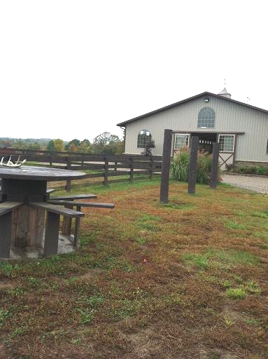
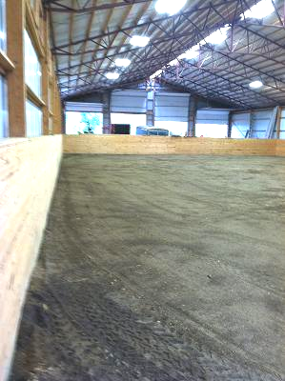
Amazing things happen when you put a child on a horse, physical and emotional limitations no longer matter and the smiles are priceless as friendships develop.

Breaking Free Therapeutic Riding Center is excited to announce the opening of our new indoor facility thanks to the generous help of the Chaco Foundation who have opened their indoor arena and stables on Zanesville’s east side for Breaking Free to use. Along with this new indoor facility, Breaking Free will also maintain their outdoor arena and camp facility in Norwich. This facility will be enjoyed by groups wishing to have a day camp experience with horses throughout the summer.

Here at Breaking Free, volunteers can become a part of the special bonds that develop on a horse, as a child gains confidence, independence, muscle control and skill. The horse quickly becomes a companion and a friend, and therapy takes on a whole new meaning.

Breaking Free gained a Premier Accredited Center certification recently by completing and passing the requirements and high quality standards of accreditation by PATH (Professional Association of Therapeutic Horsemanship International). We currently have 2 PATH Registered Instructors on staff with a third in training. These instructors lead the volunteers in helping participants in programs from therapeutic riding to Horsemanship 101. This year we will be adding special day camps, basic able bodied riding lessons, and in the works a veteran’s program. If you know someone between the ages of 3 and 25 who may benefit from this program, please pass on our information.

We always appreciate donations from the community and businesses, so if you have anything you think we may be able to use in our programs please contact us. We are also in need of good, trustworthy horses or mules, especially larger sized and in good health. All donations are tax deductible.

We invite anyone who has an interest in horses, in children, or in any aspect of volunteering to join us here at Breaking Free TRC and become a part of our life-changing programs and see for yourself what happens when a child meets a horse.

Linda’s Lines
Hello to our ever growing Breaking Free Family,
It has been a while since we have seen many of our wonderful students and giving volunteers out here at the center and it has been a very long, hard winter for us and the horses who have spent the majority of the winter inside their cozy stalls. I want to give a big thank you to those volunteers who were able and continue to take care of the horses. I don’t think we could have done it without you.

As we are preparing for a new and exciting year ahead we want everyone to know that it’s going to take many volunteers to help the participants receive their therapies. We will be having all therapeutic riding at the new Zanesville location and the MVESC and new day camps at the center in Norwich. I hope that each of our past volunteers and participants are looking forward to the use of the beautiful new facilities. I have had many phone calls over the past month from past participant’s parents who are so excited for their child to ride again.
The Chaco Foundation has a wonderful facility for us and has gone even further by adding a restroom and kitchenette along with a comfortable viewing area for parents to watch their children. I have no doubt we will see lots of big smiled and shouts of “yippy” from the kids.

Please check the website and your emails as we will be getting started soon. The horses will make the new facility their home in May and we will need many volunteers as they will need continued care. If you would like to be involved, we will also start working and training more horses for the program. Participants will arrive at the end of May to begin the first of three sessions for the year.
Let’s go have some Fun!
God Bless
Linda Lake, Center Director

Fundraisers
Golf Outing – This years annual golf outing will be held July 19 at Fuller’s Fairway in Zanesville. It will be here before we know it. If any volunteers or parents are interested in helping with any aspects of the outing (soliciting, planning, preperation, ect) please let us know we can use all the help we can get.

Center Announcements

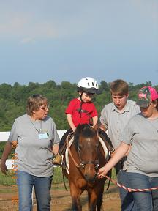
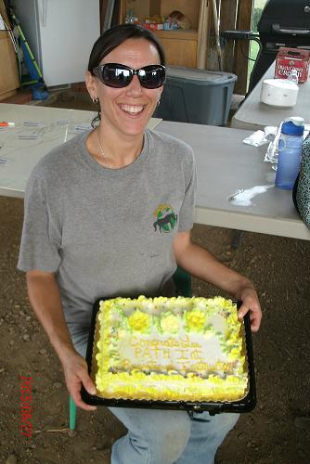
Open Positions (the following positions are open at the center, please contact the office to let us know if you are interested)
Activities Coordinator – 1 or 2 volunteers to set up and implement the warm up activities for students 15 minutes prior to their lessons. Tuesday & Thursdays

Public Relations - in charge of newspaper articles, press releases, public awareness

Fundraising Director – we are in need of an enthusiastic, driven individual to take on fundraising to continue the centers mission

Thank you to Mark and Heather Jackson for their dedication and service to the center and its board for the past several years. Mark and Heather have put a lot of time and effort into creating the activities for students, helping with all our special events, fundraisers and special projects around the center. We are sad to see them leave the board and Activities Directors positions but understand their busy schedule and are glad that they are staying on as volunteers. Mark and Heather thank you for all you have done to help advance Breaking Free.

Thank you to all the winter feeders who have been braving the weather to help feed the horses at the center. We and the horses defiantly appreciate all the work you put in during the off season and know that we could not do it without you.
*We still have days open that we could use a volunteer or two to help with feeding. Let the office know if you are interested.

Instructor IT – Meg Shaw will be joining the lessons as an instructor-in-training this upcoming session. Any other volunteers interested in the instructor certification process should let the office know they are interested.

Student Highlight – Katie

In her fourth year with Breaking Free, Katie found a new equine pal to hang with…a big goofy mule named Jeremiah.

Katie loves riding Jeremiah and likes to laugh at his massive mule ears. He likes to challenge her with his stubbornness, but if anyone can get him to move it will be Katie.
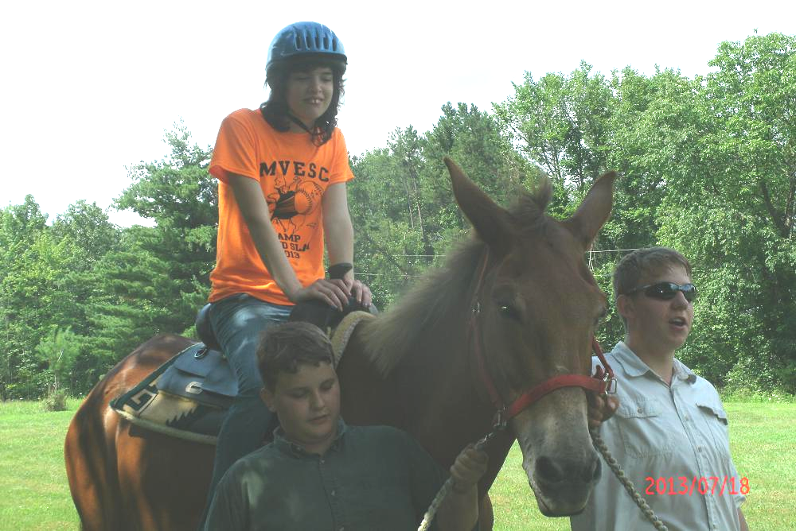
During the off season, Katie visited the center and called down to Jeremiah in the pasture, no sooner had she stopped calling and Jeremiah was bounding up the hill to see his buddy.

Katie has a way of brightening everyone’s day as she always has a smile and hug for everyone she meets.

Volunteer Highlight – Randi

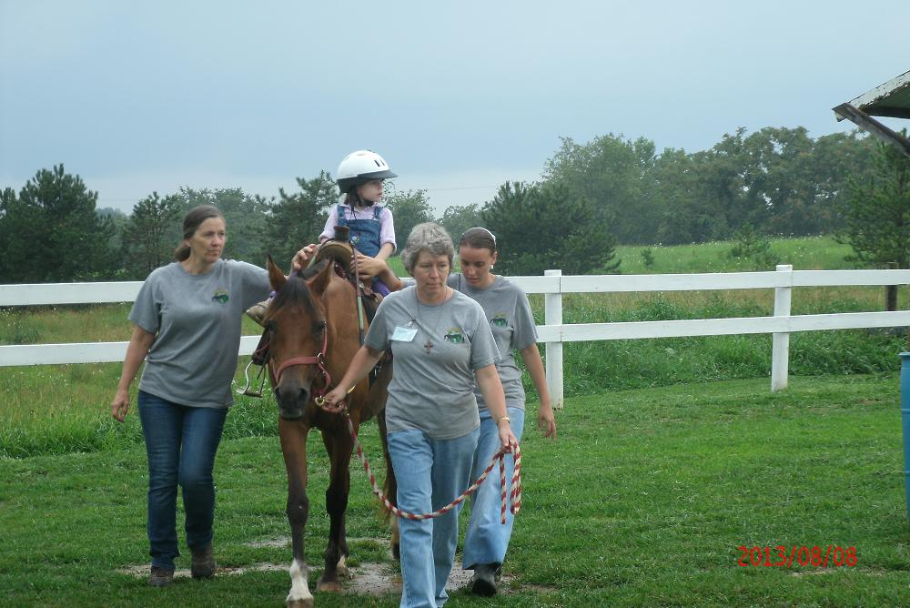
Randi Bates has been an active volunteer with Breaking Free for 5 years and a board member since 2010.

Working primarily as a horse leader, she also helps with sidewalking and special events. When Randi started with Breaking Free, she brought along her Arabian horse Fyre who served as an excellent equine partner until her retirement last year. She is also a very talented artist who has captured some of our horses on canvas that hang in the main office.

Equine Highlight – Gabe

Gabe is a new horse to the center this past year and was broke into the new arena this winter. He is an even paced, slow-going quarter horse gelding. We look forward to using Gabe this year with our teen participants.

.

Remember to check the website often for updates www.breakingfreeriding.org
Also be sure to “Like” us on Facebook

2014 Master Schedule (changes and additional details to follow)
May
- Open House (4-7pm)
- Avondale Youth (11am-12pm)
- Past Volunteer Training/Orientation
15 Past Volunteer Training/Orientation
17 New Volunteer Training Part 1
18 New Volunteer Training Part 2
24 Avondale Youth (11am-12pm)
27 Session 1 Tuesdays Begin
29 Session 1 Thursdays Begin
June
7 New Volunteer Training
7 Volunteer Riding (9:30-10:30am)
7 Avondale Youth (11am-12pm)
21 Volunteer Riding (9:30-10:30am)
21 Avondale Youth (11am-12pm)
July
8 Session 1 Tuesdays Ends
10 Session 2 Thursdays Ends
12 New Volunteer Training
12 Volunteer Riding (9:30-10:30am)
12 Avondale Youth (11am-12pm)
15-17 Day Camps
17 MVESC Day Camp
19 Golf Scramble
22 Session 2 Tuesdays Begins
24 Session 2 Thursdays Begins
26 Volunteer Riding (9:30-10:30am)
26 Avondale Youth (11am-12pm)
August
9 New Volunteer Training
9 Volunteer Riding (9:30-10:30am)
9 Avondale Youth (11am-12pm)
23 Volunteer Riding (9:30-10:30am)
23 Avondale Youth (11am-12pm)
September
2 Session 2 Tuesdays End
3 Session 2 Thursdays End
6 New Volunteer Training
6 Volunteer Riding (9:30-10:30am)
6 Avondale Youth (11am-12pm)
9-11 Day Camps
16 Session 2 Tuesdays Begins
18 Session 2 Thursdays Begins
20 Volunteer Riding (9:30-10:30am)
20 Avondale Youth (11am-12pm)
October
4 New Volunteer Training
4 Volunteer Riding (9:30-10:30am)
4 Avondale Youth (11am-12pm)
18 Volunteer Riding (9:30-10:30am)
18 Avondale Youth (11am-12pm)
28 Session 3 Tuesdays End
30 Session 4 Thursdays End
November
1 Volunteer Riding (9:30-10:30am)
1 Avondale Youth (11am-12pm)
8 Veterans Parade Zanesville
9 Breaking Free Weiner Roast/Awards Banquet
15 Volunteer Riding (9:30-10:30am)
15 Avondale Youth (11am-12pm)
December
1 Christmas Parade New Concord

