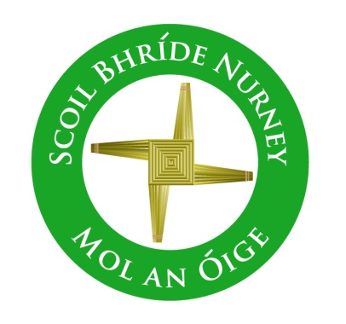
Scoil Bhríde,
Nurney,
Principal – Vinny Thorpe
Dep. Principal – Catherine Owens

County Kildare.
Te/Fax: (045)526767
Email: sbnurney@gmail.com
www.nurneyns.com
Roll no: 16345A

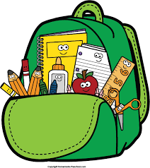
6th Class 2021 – 2022
Book List

- To aid with the cost of school books there is a Book Rental Scheme in operation in our school. Please check our school website www.nurneyns.com on how to pay the annual membership and sign up to this cost saving scheme each year. If however you decide not to pay the annual membership and sign up to this cost saving scheme, listed below is the 6th class school books you will need to purchase for your child for this school year.
- New Wave Mental Maths 6th Class (Prim-Ed)
- Starlight Combined Reading and Skills Book 6th Class (Folens)
- Busy at Maths 6 (Fallons)
- Seo Leat 6 (Fallons)
- Seo Leat Reader 6 (Fallons)
- Small World History 6 (Fallons)
- Small World Geography and Science 6 (Fallons)
- ‘Grow in Love’ text book 6th class (veritas)

Please label all of your child’s belongings, stationery, uniform and tracksuit tops, coats etc.

PLEASE NOTE: ‘Book rental’ books will only be ordered for and issued to your child if you choose to fully fill in the Book Rental Membership Form and return it to the school office with your full Book Rental Payment.

Thank you for your co-operation and looking forward to a great year ahead!

___________________
Class Teacher

