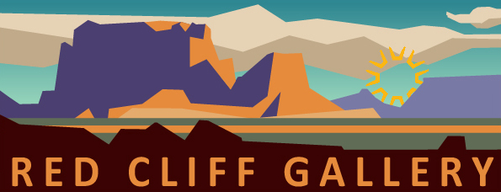 1/21/2021

2021 Show Schedule
For The Red Cliff Gallery

- December 14, 2020-January 18, 2021 (5 weeks) – SUAG Solo Artist Show, works by Carol Bold and Rebekah Tucker

- January 20-February 19 (4 weeks) – SUAG Solo Artist Show, works by Alicia Lockwood

- March 1-26 (4 weeks) – DSU Senior Exhibition (2 Students)

- April 6-30 (4 weeks) – Washington County School District Art Show

- May 7-June 4 (4 weeks) – SUAG “Portals and Pathways”

- June 18-July 29 (6 weeks) – SUAG “Only Abstraction”

- Sept 10-Oct 7 (4 weeks) – SUAG “Fall Splendor”

- Nov 12-Dec 16 (5 weeks) – SUAG “Gift of Art”

www.redcliffgallerysuag.com
www.southernutahartguild.com

