DERMATITIS OR ECZEMA

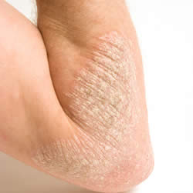
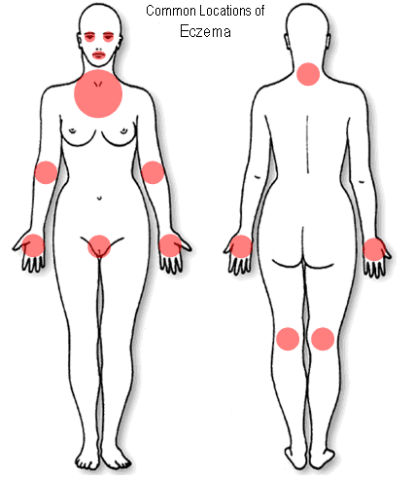

Dermatitis is an inflammation of the skin that produces scaling, flaking, thickening, colour changes, and, often itching.

Eczema is a term sometimes used interchangeably with dermatitis, although some authorities define it as a specific type of dermatitis distinguished by the present of fluid-filled blisters that weep, ooze, and crust over.

There are several types of Dermatitis/Eczema:

- Allergic or Contact Dermatitis:
  - Many cases of dermatitis are the result of allergies. This type of condition is called allergic or contact dermatitis.
  - It may be caused by contact with perfumes, cosmetics, rubber, medicated creams and ointments, plants such as poison ivy, and/ or metals or metal alloys such as gold, silver, and nickel found in jewelry or zippers.
  - Some people with dermatitis are sensitive to sunlight. Whatever the irritant, if the skin remains in constant contact with it, the dermatitis is likely to spread and become more severe.
  - Stress, especially chronic tension, can cause or exacerbate dermatitis.

- Atopic Dermatitis:
  - Is a hereditary form of the condition that usually becomes apparent in infancy.
  - It typically appears on the face, in the bends of the elbows, and behind the knees. Often, other family members have histories of allergies or asthma.

- Nummular (“coin-shaped”) Dermatitis:
  - is a chronic condition in which round lesions appear on the limbs.
  - It may be caused by an allergy to nickel, and is often associated with dry skin.

- Dermatitis herpetiformis:
  - is a very itchy type of dermatitis associated with intestinal and immune disorders.
  - This form of dermatitis may be triggered by the consumption of dairy products and/or gluten.

- Seborrhea:
  - is a form of dermatitis that most commonly affects the scalp and/or face.

Recommendations:
Include a soy smoothie in your food intake every day (a guaranteed source of all of the essential amino acids … essential for healthy skin.

STEP 1: Follow the following for two weeks. Then add Step 2.
- Alfalfa
  - to purify the blood
  - to provide minerals for healing
  - 3 with each meal
- Essential Fatty Acids
  - ESSENTIAL for healing the skin
  - 1 GLA with each meal … AND … 2 OmegaGuard with each meal
- Vitamin E
  - essential for healing
  - promotes circulation & better oxygenation for healing
  - 1 400 I.U. capsule per day
- NOTE: Eat lots of RAW (not roasted) nut and seeds

STEP 2
- Vita Lea … Multiple Vitamin/Mineral (including zinc)
  - essential to balance the body chemistry
  - zinc is essential for healing
  - 2 per day
- B Complex
  - deficiency is linked to root cause of eczemas
  - l with each meal
- Optiflora (Pre- and Probiotics)
  - increase bowel microflora healing
  - l probiotic per day … 1/8th teaspoon of prebiotic per day
- Vitamin D3
  - Essential for healthy skin
  - 2000 I.U. over & above what is in the multiple vitamin

STEP 3
- Do a Health Appraisal with your consultant after 8 weeks (two weeks on Step 1 ….. six weeks on Step l & 2)
- Investigate allergies with an Elisa Allergy Test – avoid foods that show up as culprits.
- Do a Parasite Cleanse

