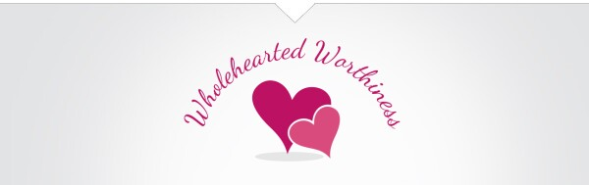
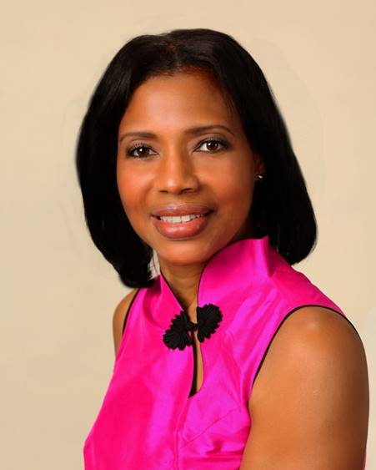
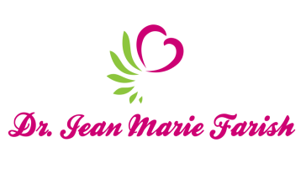

LOVE LIGHT NewsLetter

I am excited to host my VoiceAmerica Empowerment Show-LOVE LIGHT with amazing Guests to cultivate a lifestyle of love and wholehearted connections through worthiness. My show is aligned with my mission to live an altruistic and heart centered life.

MEET GUEST
Sondra Redmont, Administrator
UMMC Office of Well-Being

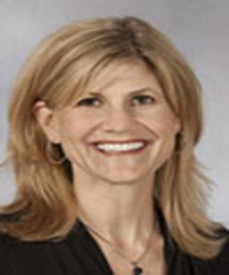
March 20, 2020

“Healing Arts and Empowering Health Care Workers”

ABOUT Sondra Redmont

Sondra Redmont, LCSW, NBC-HWC is a licensed clinical social worker and administrator. After 20 years of clinical practice, Ms. Redmont experienced burnout. In 2015, she joined the UMMC Department of Preventive Medicine beginning the journey into wellness. Everyday Wellness, the workplace wellness program was established to provide health programming for UMMC employees. In July 2018 the Office of Well-Being was established, for which Ms. Redmont became the Administrator. The Office’s mission to create a UMMC community where all members feel valued and experience wellbeing.

Ms. Redmont has been involved in projects to enhance the employee experience including the deployment of the Well-Being Index to establish a baseline measure of the distress in the UMMC community; organized the Caring for a Caregiver peer responder program to provide support to our providers who experience adverse patient events; and organized a taskforce to address workplace violence in the clinical settings. Through these projects and just a smile, Ms. Redmont believes that connectedness is one of the keys to creating a culture of well-being.

“An empowered self is a loving self and keep your love light shining”

