Carol & Nik White
The Old Vicarage, Station Road
Lowestoft. Suffolk
NR32 4QF
(01502) 450059
www.carolandnik.com

24th January 2020

Hey guys,

Happy Newsletter Day! (I just made that up!) As it now feels like we’re up to the 78th of January we thought we would send you a little newsletter to finish the month off on a high.

Payments

We would like to gently remind you all that our invoices are due on the 1st of each month, there have been way too many payments coming in late over the last few months and as childminding is our only source of household income it’s really important that we get paid on time. We always send the invoices out in plenty of time for the payment to be scheduled for the right day.

Illness

We know that it has been a really awful winter for bugs and sickness but it is really important that we stick to the 48 hour policy for any child that has had sickness and/or diarrhea in order to prevent the bugs from spreading.
We’ve added a quick reference guide at the end of this newsletter for whether your child is well enough to attend because as you all know we go out almost every day and we should not have to be administering medicine just to get an unwell child through to the end of the day.

Holidays

Quite a few people have been asking for our holiday dates for the coming year and although we do know when our main holiday will be we are just waiting to hear back from others to make a final decision. We have put the dates for our main holiday below and will let you all know in plenty of time when the remaining time will be taken.
If you have any holidays or time off planned for this year please let us know as soon as possible as it makes organizing outings and activities a lot easier.

Fees

I think we have told most of you of the impending fee change but we thought that we would put it down in writing for you. As of April 2020 we will be increasing our hourly rate from £4.25 to £4.50; this is the first time we have increased our prices since September 2017.

We are really looking forward to the coming months, hopefully the weather will start to warm up a bit soon and all of the groups and activities that we go to will re-start (they all seem to be having a bit of an extended Christmas break this month!). We’ve had great fun recently getting to know our new little ones and can’t wait to show them some more fun outings and activities.

Much Love

Carol & Nik

Term Dates (for Early Years Funded Children)

Spring Term Begins – Monday 6th January
Spring Half Term – Monday 17th February to Friday 21st February
Last Day of Spring Term – Friday 3rd April

First Day of Summer Term – Monday 20th April

Holiday Dates

Monday 21st September – Monday 5th October (Inclusive)

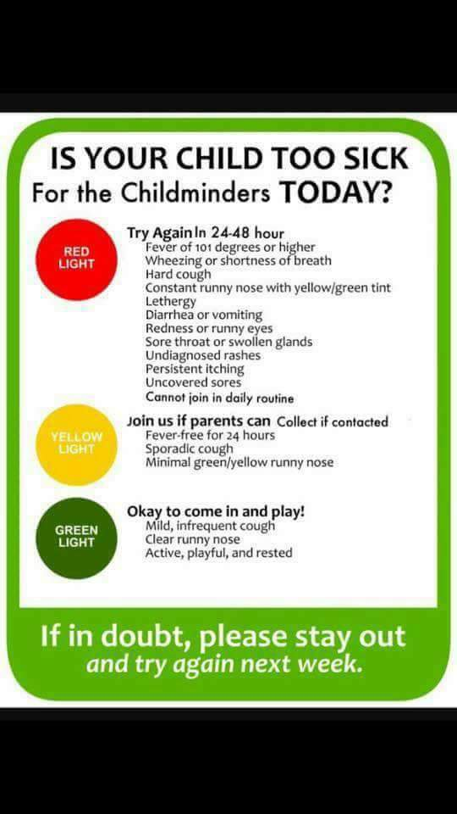
We will let you know the rest of our dates as soon as we have confirmed them.

