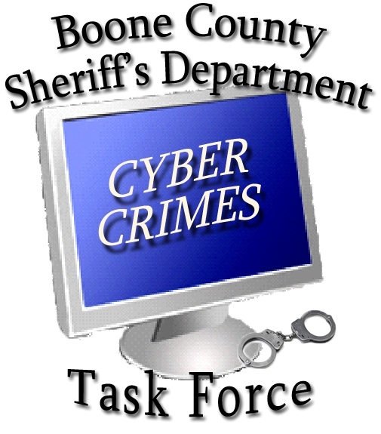

BOONE COUNTY SHERIFF’S DEPARTMENT
CYBER CRIMES TASK FORCE
2121 County Road | Columbia, Missouri 65202
(573) 442-4302 | cybercrimes@boonecountymo.org
www.bcsdcybercrimes.com

PERMISSION TO ACCESS ELECTRONIC ACCOUNTS

I, _________________________, voluntarily give my permission to the Boone County Sheriff’s Department Cyber Crimes Task Force Task Force or other designated investigators to access the accounts listed below for the purpose of their investigation. This includes any documents, images, videos, chat logs, communications, or other electronically stored data, both opened and unopened, contained within these accounts.

I further authorize Task Force investigators to copy any and all data currently held within these accounts, to utilize these accounts as needed for investigative purposes, and to change my passwords during the course of their investigation. I am giving this permission freely and voluntarily with the understanding I have the right to refuse to give my permission.

I am giving this authorization for the following accounts:

Account Username or Email Password

__________________ _____________________________ __________________________

__________________ _____________________________ __________________________

__________________ _____________________________ __________________________

__________________ _____________________________ __________________________

__________________ _____________________________ __________________________

__________________ _____________________________ __________________________

__________________ _____________________________ __________________________

__________________________ ____________________
Account Holder Date/Time

__________________________ ____________________
Parent or Guardian Date/Time

