Sinus Problems
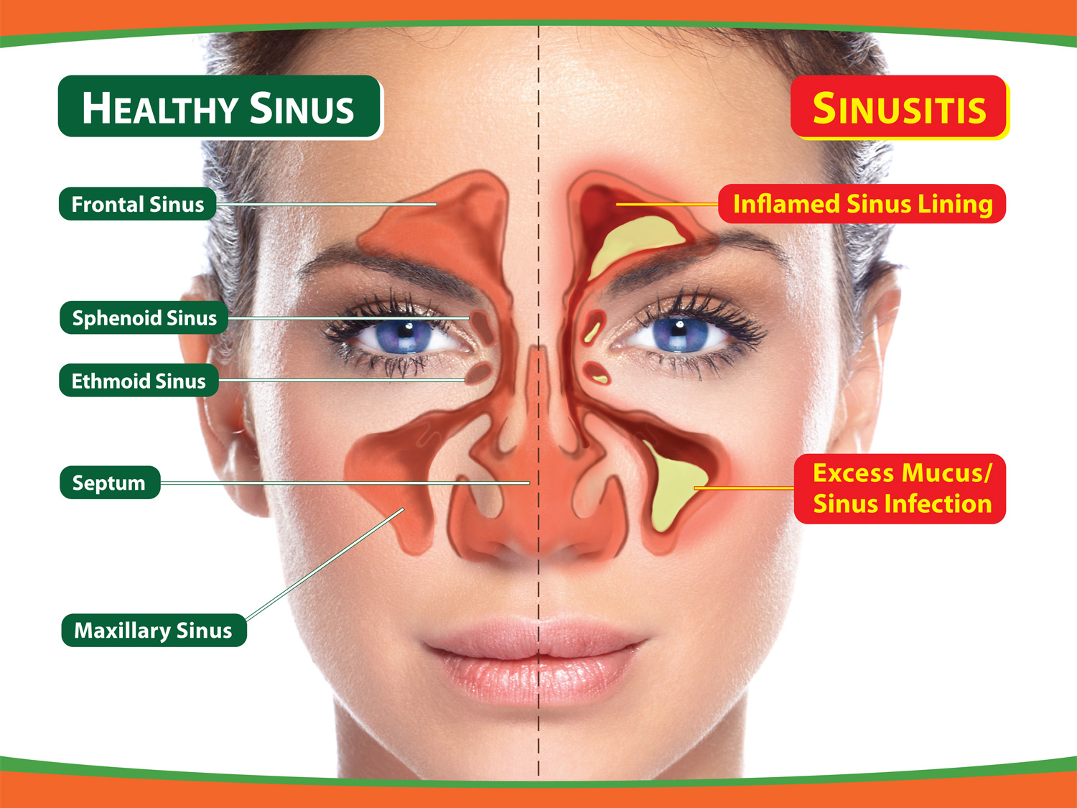

Symptoms:
- Area around eyes tender / eyes may hurt
- Gums and teeth may hurt
- Postnasal drip – mucous in throat

Causes:
- Usually related to allergies
- Can be too dry / too moist for mucous membranes
- Sinuses don’t drain / infections in sinuses

What to do:
- Avoid mucous causing foods (dairy / wheat overload?)
- Have Elisa RAST food allergy tests done to determine your genetic and acquired allergies
- Use supplements & herbs of benefit (see below)
- Reflexology –
  - massage both sides of the big toe on both feet
  - massage the bottom of each of the other four toes on both feet
- Rub Mentholated Skin Cream into sinus area
- Room humidifiers / plants / boil water to make room air more moist
- Use hot, wet packs
- If chronic acute, do daily sinus irrigation (see below)

Herbs & Supplements (Shaklee Supplements recommended)
- Step 1:
  - Alfalfa – anti-inflammatory / also helps to thin mucous
  - NutriFeron – supports the immune system
- Step 2:
  - Vitamin C including bioflavinoids – anti-inflammatory (anti-infections)
  - Garlic – anti-bacterial (cold-processed garlic better than eating raw garlic
- Step 3:
  - Vita Lea – multiple vitamin/mineral supplement
  - Soy Protein – ALL 9 essential amino acids to build up the immune system
  - Zinc – anti-infection
- Step 4:
  - Shaklee DR – nature’s antibiotic (use on a rotation basis only …. 3 per day - 4 days on / 3 days off – until problems are gone)
  - CarotoMax – nourishes mucosal lining

Sinus Irrigation:
Mix: ½ cup warm water; ½ teaspoon salt; 1/8 teaspoon baking soda
Suck solution up into a small bulb syringe and put head over sink and squirt up into nasal passages. Breathe in at the same time. Do one nostril at a time, closing off other nostril with finger. Then let it drain out. Do daily or 2-3 times daily if necessary. Helps to activate drainage.

