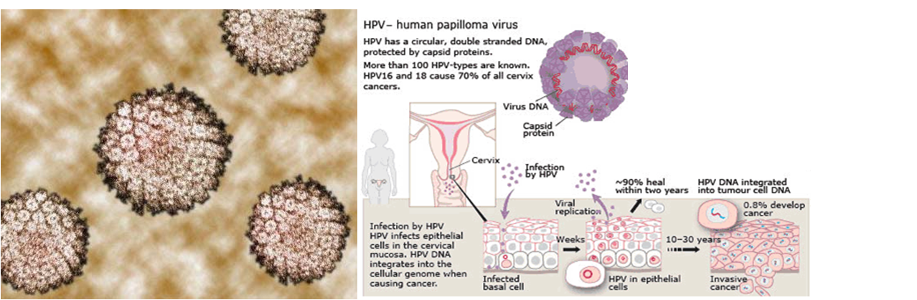

Human Papilloma Virus – HPV
- is a DNA virus from the papillomavirus family that is capable of infecting humans.
- There are at least 100 different types.
- About 30 types of HPV are spread through sexual contact, making it one of the most common sexually transmitted diseases (STDs).
- While the majority of the known types of HPV cause no symptoms in most people, some types can cause warts (verrucae), while others lead to cancers of the cervix, vulva, vagina, penis, oropharynx and anus. (HPV 16 and 18 infections are strongly associated with an increased odds ratio of developing oropharyngeal (throat) cancer.)
- Like all papillomaviruses, HPVs establish productive infections only in mucous membranes (mucous membranes are the moist, inner lining of some organs and body cavities, such as the nose, mouth, lungs, and stomach).
- Recently, HPV has been linked with an increased risk of cardiovascular disease.

Causes of HPV Infection
- HPV enters the body, usually through a break in the skin, and then infects the cells in the layers of the skin. The virus then replicates or multiplies in the body. The time between first contracting HPV and the appearance of lesions can be weeks to months or even years. Many people don't even know they are infected with HPV.

- HPV is transmitted by skin-to-skin contact. HPV infections that cause skin warts (e.g., plantar or common warts) can be acquired through a cut, but the risk of transmission is low. Walking barefoot in public areas such as the gym or pool can be a risk for infection with the types of HPV that cause plantar warts.

- HPV infections that cause genital warts are very contagious and are usually contracted through sexual activity with an infected person. This includes kissing or touching the skin of the infected areas (e.g., scrotum, vagina, vulva, anus) and having intercourse. Although HPV is more likely to be transmitted when lesions or warts are visible, transmission is possible even without the presence of visible warts.

- A mother with a genital HPV infection may also transmit the virus to the infant during labour.
The risk factors for HPV infection include:
- Age: Children and young adults are most at risk for developing common warts and flat warts. Genital HPV infections commonly occur in teenagers and young adults who have a compromised immune system or eat poorly.
- number of sexual partners: The higher the number of sexual partners, the greater the risk of genital HPV infection.
- immune system: People who have a compromised immune system (e.g., HIV or AIDS, organ transplant recipient, or who are taking medication that suppresses the immune system) are at an increased risk of genital HPV infection.

When someone is infected with HPV, the condition that results will depend a lot on which type of HPV virus is transmitted and the location of transmission. Some diseases that HPV can cause include:
- Warts, including common warts (verrucae vulgaris), plantar warts (verrucae plantaris), and flat warts (verrucae plana)
- Genital warts (known medically as condylomata acuminata or venereal warts)
- Precancerous lesions, including on the cervix (high-grade dysplasia and low-grade dysplasia)
- Cervical cancer
- Other precancerous lesions or cancer, including on the penis, anus, vagina, and vulva
- Laryngeal papillomas, which are noncancerous tumors on the larynx (voice box), vocal cords, or the air passages leading from the nose into the lungs (respiratory tract).

In more developed countries, cervical screening using a Papanicolaou (Pap) test or liquid-based cytology is used to detect abnormal cells that may develop into cancer. If abnormal cells are found, women are invited to have:
- a colposcopy ...during a colposcopic inspection, biopsies can be taken and abnormal areas can be removed with a procedure, typically with a cauterizing loop or by freezing (cryotherapy). Treating abnormal cells in this way can prevent them from developing into cervical cancer.

However, removal of the cancer cells does not address the CAUSE!
If you develop Cervical Dysplasia caused by HPV ...
- Douche before bed:
  - use a microflora douche (crush 2 Shaklee Bifidus in 1 cup purified water and douche)
  - if inflammation or infection, douche before bed two nights in a row with:
¼ cup hydrogen peroxide to 2 cups water
- Supplements:
  - Shaklee NutriFeron – 2 per day
  - Shaklee Vita Lea – 3 per day
  - Soy Protein – 3 tablespoons … OR … 1 serving of Shaklee Cinch Shake
  - B Complex (maintain yellow urine 24 hours per day) … at least 3 per day
  - CarotoMax (achieve “peachy” palms quickly & maintain) … start out with at least 2+ per day … after cells have gone back to normal, maintain with a minimum of 1 per day.
  - Vitamin E (at least 400 I.U.) – 1+ per day
  - Vitamin C (at least 1500+ mg) – 3+ per day
  - Zinc (at least 30 mg) – 2 per day
  - Garlic – 3 per day
  - OmegaGuard – 3 per day
  - Optiflora - 1 per day
  - IF you have tested positive to the HPV virus … take 3 Shaklee DR 4 days of every week for 8 weeks

- Detoxify
  - Shaklee DTX – 1 to 3 per day (to help the liver get rid of toxins & to protect the liver)
  - Herb-Lax - 1+ per day (whatever is required to maintain 2 to 3 bowel movements per day)
  - Drink ½ oz of water per every 10 pounds of body weight
  - Eat high fibre foods

- Use Natural Bioidentical Progesterone Cream …
  - if you are experiencing typical PMS symptoms (emotional sensitivity, bloating or tender breasts 5 to 10 days before the menstrual cycle starts) … use 1/8th teaspoon of 3% progesterone from ovulation for 12 days twice per day
  - if menopausal & beyond and your blood or saliva hormone testing shows you are low in progesterone … use 1/8th teaspoon of 3% progesterone three weeks of the month twice per day.

- Avoid:
  - unopposed estrogen supplementation
  - birth control pills
  - spermicides (used in diaphragm jelly & on condoms)
  - commercial douches
  - tampons
  - unloving, traumatic sex

- Change your diet: eliminate caffeine, alcohol, sugar & fried foods - eat lots of raw fruits, vegetables, whole grains, nuts, seeds, beans, & legumes

7. Reduce Stress (Stress Relief Complex highly recommended)

