December 1, 2021
11:30am – 12:00pm CT
Business Meeting Agenda
Meeting called to order at 11:45pm CT

We did have a quorum.

REPORTS:
President: Rod Burnett – no report

Vice President: Bonnie Thomann – no changes to bylaws

Treasurer: Freda Selk (treasure and membership reports) – see attached report.
52 members with a few new members.
- Barb Grabenbauer will sit for CTR exam in March 2022, working in Waterloo.
- Heba Elmanawy with U of Iowa and has a research background.
- Stephanie Medina with St. Luke’s in Cedar Rapids passed CTR in November 2021. Donald Ruse also a new member.
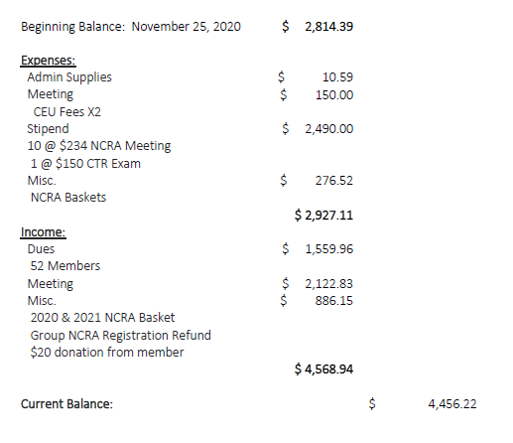

Lori moved to approve, Kathy Churchill seconded, was approved.

Secretary: Jean Malo Roberts
Two NCRA CE applications completed.
14 board meetings this year, many were to plan this workshop.

Library: Bobbi Matt
Minimal information in the library currently.

OLD BUSINESS:
2020 Business Minutes – Wanda motion to approve, Bonnie seconded, and they were approved as written.

- CTR Exam partial reimbursement
  - Up to $150 reimbursed directly to ICRA member
  - Must be an ICRA member for 2 years before taking the exam
  - Must have passed in 2020/2021
  - Email your CTR information to Freda or Rod for consideration for reimbursement

NEW BUSINESS:

- New CTRs
  - Tara Hernandez (Iowa State Cancer Registry) passed in Nov 2021
  - Stephanie Medina passed in Nov 2020
  - Gwen Durham passed in March 2021

- Nominating Committee volunteers for 2022 elections
  - 3 members needed for the committee
  - Let one of the current boards know if you are interested
  - President, Vice-President, Treasurer(includes membership), Secretary positions will need to be filled
    - Must be a member in good standing for 1 year to serve on the board

- Program Chair and volunteers for 2022 Educational Workshop
  - Virtual or in-person is an option
  - Let one of the current board members know if you are interested

- Library additions recommended
  - Cancer Registry Management Principles and Practice 4th Edition https://www.ncra-usa.org/About/Store/Store-Professional-Resources/BKctl/ViewDetails/SKU/NCRCRMTXBK4ED
    - Will need to investigate how to manage the electronic book and if it can be checked out and checked back in.
    - Will need to review the options and what can be added and available.
  - 2022 CTR exams are recommending use of 3rd edition.
    - Kim has a 3rd edition she will give to library after taking the test in March 2022
  - Request for links for all the websites, manuals and resources for cancer registry resources was requested.
    - Maintenance would be needed because links break

- Dues due Jan 31, 2022. Delinquent if not received by March 31, 2022. Dues are $30.00 annually.

ADJOURN Freda motioned to adjourn, Beth seconded, meeting adjourned at 12:18pm CT.

