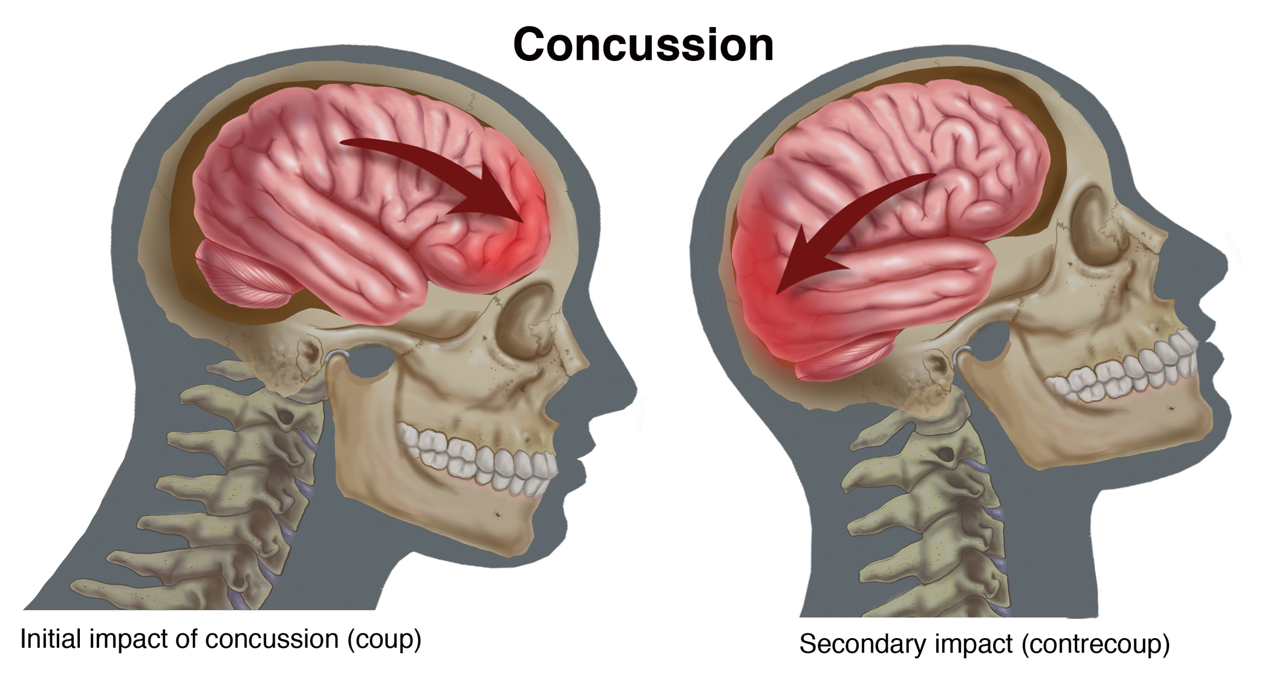
Concussion:

A concussion is like a bruise that results from your brain colliding with your skull. Anyone who has had a blow to the head should consider himself at risk, most especially if there was even a momentary loss of consciousness. Other signs of concussion: Headache, nausea, difficulty concentrating and/or short-term memory loss. One or more of these symptoms should trigger a call to your doctor, who will determine if further testing is required.
Natural health can offer natural ways to help the tissues heal after a concussion.
- Protein: include a higher-than-usual amount of protein in the diet … which should be continued for two weeks

- “Stimulus Deprivation” for a week is recommended, especially in the case of a severe concussion (basically, total brain rest — no computer, no music, not even lying on the couch and watching TV) in order to recover fully)

- Load up on antioxidants. Eat a healthy diet with abundant protein (as mentioned above) and also eat lots of blueberries during the two weeks following the injury. The reason: Blueberries contain potent flavonoid antioxidants that help to strengthen blood vessel walls, including in the brain. Supplement the fruit’s antioxidants by taking 3,000 mg a day of vitamin C, which also helps reduce the oxidative stress in the brain associated with head trauma.

- Reduce Oxidative Stress: Resveratrol and other polyphenols are clinically proven to reduce oxidative stress in the brain associated with head trauma. (Shaklee Vivix is recommended.)

- Drink fluids. Make sure the body is well-hydrated, as that allows the brain to heal more quickly. How much to drink: ½ oz of water per pound of body weight daily. Adding an electrolyte drink to your water will help to speed up healing.

- Mineral intake: A smorgasbord of minerals reduces inflammation and promotes healing. (Shaklee Alfalfa tablets are highly recommended.)

- B Complex: is food to the central nervous system. Whenever there is stress in the body due to an injury, the need for B Complex increases.

- Take arnica (Arnica montana). You are probably familiar with arnica cream, made from a plant that has served medicinal purposes for more than 500 years and used for sore muscles, sprains and bruises. But arnica also comes in the form of homeopathic pellets, which help to expedite healing of bruised brain tissue, (Place three homeopathic arnica 30c pellets under your tongue within 15 minutes of the trauma or as soon as you can get them. Continue this dosage every hour for the rest of the day, reducing frequency on the second, third and fourth days to three doses — one in the morning, one at lunch and one in the evening.

- Increase fish oils — fast. While the general recommendation for most people is to take one to two grams daily of high-potency fish oil. Some Naturopath doctors recommend it is a good idea for people who have suffered head injuries to take up to four grams as quickly as possible after the injury and to continue taking four grams once daily at least seven days afterward. This can assist in healing concussion, decrease brain inflammation and with it the fogginess, memory loss and headaches that are often a part of concussion. Note: If there is evidence of continuing bleeding in your brain after the concussion, you should not take the fish oils until the bleeding stops.

- Increase blood flow to the brain: Ginkgo Biloba and Vitamin E support more optimal blood flow. Note: If there is evidence of continuing bleeding in your brain after the concussion, you should not take these supplements until the bleeding stops.

Danger Zone:
It is important to realize that the danger zone following a concussion can last up to 48 hours, with the first 24 hours being the most critical. The danger is that bleeding will occur in the brain (especially likely if a person is taking an anticoagulant medication such as warfarin) or that a blood clot can form. The following symptoms should be seen as a medical emergency, warranting a call to 9-1-1 and a visit to the emergency department of the nearest hospital:
- A headache that gets continually worse
- Vomiting
- Slurred speech
- One pupil larger than the other or other visual disturbances
- Change in sleeping pattern — such as sleeping more than normal
- Seizure
- Confusion and restlessness
- Amnesia
Luckily, severe problems are quite rare. Most concussions are much less threatening, and most people can heal safely and completely at home by following these wise, helpful instructions.

