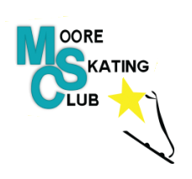
Moore Skating Club
Return to Skating Framework
2020-21

Rationale:
The safety of the Moore Skating Club’s Skaters, Coaches, Officials, Board Members, Volunteers and Families are our highest priority. We are working with Skate Ontario, the Township of St. Clair, and Lambton Public Health, to ensure that we make a smooth transition as we return to Skating, while making the best of and planning for what is likely to be a season unlike any that we have ever seen.

Disclaimer:
The information in this document is not intended or implied to be a substitute for professional medical advice, diagnosis, or treatment. The Moore Skating Club and its Board of Directors and staff make no representation and assume no responsibility in respect of their information concerning COVID-19 as the circumstances are constantly changing, and any information on COVID-19 should be obtained from the local Public Health Authority.

Updates:
As new information becomes available from all parties involved, this document will be updated and posted on our website for review. Each time this document is updated, Moore Skating Club members and Facility Operators for the 2020-2021 season will receive an email with a link to the revised copy. Anything revised from the previous copy will be printed in red text.

Lambton Public Health Checklist:

- Moore Skating Club will continue to be in contact with Mooretown Sports Complex to ensure compliance with facility-specific guidelines and requirements. The link to these guidelines will be posted on our website. http://www.stclairtownshipcommunityservices.ca/sites/default/files/brochures/MSC%20-%20Return%20to%20Play%20-%20Phased%20Approach.pdf\

- The Moore Skating Club has consulted the relevant sport or physical activity guidance documents, including those from public health, the provincial government, and provincial or national sport organization (see list below).
  - Skate Ontario Return to Play Protocols https://skateontario.org/wp-content/uploads/2020/08/Return-to-Play-Protocols-Skate-Ontario-4.1.pdf
  - Lambton Public Health Return to Play https://lambtonpublichealth.ca/wp-content/uploads/2020/08/Return-to-Organized-Sport-and-Recreation-Plan-Template.pdf
  - Mooretown Sports Complex Return to Play - Phased Approach http://www.stclairtownshipcommunityservices.ca/sites/default/files/brochures/MSC%20-%20Return%20to%20Play%20-%20Phased%20Approach.pdf

- The return to sport or recreation plan has been developed and shared with participants through the following accessible communication channels:
  - https://mooreskatingclub.ca/
  - https://www.facebook.com/Moore-Skate-Club-116399035730741
  - Email updates will be sent to all participants.

- The following people (“COVID-19 Oversight Group”)have been designated to oversee activities ensuring public health guidelines are followed:
  - Cherie Gaulton, President
  - Caley Evans, Secretary
  - MacKenzie Kada, Test Chair

- Guidelines have been communicated with facility operators, coaches, volunteers, participants, and family members. They will continue to be communicated by the above noted means as updates become available.

Group Size

- Group Size and format will be regulated by Skate Ontario https://skateontario.org/wp-content/uploads/2020/08/Return-to-Play-Protocols-Skate-Ontario-4.1.pdf
- Please note that the numbers below reflect the most recent Return to Play protocol from Skate Ontario, however while preparing for registration we were operating under the previous Return to Play protocols which called for a maximum of 15 skaters on the ice (maximum of 20 with coaches). The most up to date group sizes will be reflected in the registration for the next session.
- STARSkate will have a maximum of 20 individuals on the ice. This number includes skaters and coaches. Any individuals in excess of 20 must be off the ice (i.e. coaches, officials, music players etc.) and must follow all physical distancing requirements unless they are from the same household or social circle. There must be a minimum of one coach on the ice for each session.
- CanPowerSkate will have a maximum number of 30 skaters on the ice, maximum number of individuals including program assistants and coaches is 38.
- CanSkate will have a maximum of 36 skaters, maximum of 45 individuals including program assistants and coaches. Skaters must be working on Stage 2 or equivalent in order to participate in this session. Stage 1 skaters can participate in the session if they can get up on their own and manoeuvre without hands-on assistance.
- There will be no Private Lessons at this time due to ice rental availability.

Screening for COVID-19

- Before entering the facility, each participant will be greeted by 1 or 2 designated COVID-19 screeners. They will ask the participant the questions on the Skate Ontario Questionnaire and complete the session log. The session logs will be maintained by the Club secretary and stored in the Booster Box between sessions.
- Each screener will be required to wear a cloth face covering and there will be hand sanitizer provided for use.
- The following process has been implemented under the recommendation of Skate Ontario:
Completion of Skate Ontario COVID-19 Waiver
All individuals participating in club/skating school must complete the Skate Ontario Acknowledgment, Release, Indemnity and Assumption of Risk regarding COVID-19 (“COVID-19 Waiver”). Failure to do so means that that individual must not participate in club/skating school activities. Any individual participating in club or skating school activities is required to complete a COVID-19 Waiver, or have a signed COVID-19 Waiver on-file with Skate Ontario:
• Skaters
• Coaches

• Staff
• Board Members
• Volunteers
• Officials (please note: this will be kept on file with Skate Ontario)

An individual becomes unwell with symptoms of COVID-19
- If an individual becomes unwell with symptoms of COVID-19, or if someone is aware of an individual that becomes unwell with symptoms of COVID-19, that individual must immediately stop participation in club or skating school activities.
- The individual will be isolated from all others in a well-ventilated area, or outside and provided with a non-medical face mask if one is available.
- The individual shall be sent home and instructed to follow public health guidelines regarding self-isolation and testing.
- The Moore Sports Complex will be informed in order to determine if any areas need to be closed off and/or require additional cleaning/disinfecting.
- A member of the COVID-19 Oversight Group should be informed of the situation and will contact the individual or their parent/guardian to determine next steps to be taken.

An individual is tested for COVID-19
- Any individual that is part of a club or skating school that has been tested for COVID-19 must not participate in club or skating school activities while waiting for the results of the test.
- The club/skating school will work with public health to consult the Session Participation tracking sheets to inform other club/skating school members who might have been in close contact with the individual. Close contact is defined as being within 2m for a period lasting more than 15 minutes, without appropriate or consistent use of PPE (i.e. healthcare workers).
- The club/skating school will work with public health to consult the Session Participation tracking sheets to inform other club/skating school members who might have been in close contact with the individual. Close contact is defined as being within 2m for a period lasting more than 15 minutes, without appropriate or consistent use of PPE (i.e. healthcare workers).
- Any club/skating school members who were in close contact with the individual should not participate in club/skating school activities and should follow public health guidelines until the diagnosis of COVID-19 is ruled out by health professionals

An individual tests positive for COVID-19
- If an individual tests positive for COVID-19, they should inform a member of the club/skating school COVID-19 Oversight Group.
- The COVID-19 Oversight Group will work where requested with the facility and public health officials to assist in contact tracing. The Session Participation tracking sheets may

be used to assist public health officials in informing other club/skating school members who may have been in close contact with the individual.
- Any club/skating school members who were in close contact with the individual should not participate in club/skating school activities for 14 days and should follow public health guidelines regarding self-isolation and testing.
- Moore Skating Club will inform all club/skating school members of a positive COVID-19 result within the club/skating school setting.
- Moore Skating Club will inform and work with the facility in the case of a positive COVID-19 result and determine if any additional cleaning/disinfecting should be performed as per the facility’s guidelines.
- Moore Skating Club will inform Skate Ontario of a positive COVID-19 diagnosis by e-mailing: clubsupportservices@skateontario.org

Return to club/skating activities following illness
- If no test was performed, or the COVID-19 test was negative, the individual may only return to club/skating school activities once they no longer have any symptoms of COVID-19 for at least 24 hours.

Return to club/skating activities following COVID-19
- Following a positive COVID-19 test, an individual must follow all public health guidelines regarding return to activities.

Modification/restriction/postponing or canceling of club/skating school activities
- Based on the evolving COVID-19 pandemic, Moore Skating Club must be prepared to follow public health, municipal/provincial government and sport recommendations regarding modifying/restricting/postponing or canceling activities.
- If cancellation/modifications are required of any activity members will be informed via email as well as the information posted on the website and Facebook page.
- Any modifications and restrictions will remain in place until advised that it is safe to resume activities by public health, government or sport officials

Public Health Guidelines
Moore Skating Club members should follow all public health guidelines regarding COVID-19. These may include:
- Any club/skating school members who themselves have travelled outside of Canada, or has someone in their household who has travelled outside Canada must self-isolate and not participate in club/skating school activities for 14 days, unless the individual has a Government of Canada Travel Exemption.
- Any individual who has been exposed to someone with a confirmed case of COVID-19 should self-isolate and is not permitted to participate in club/skating school activities for

- 14 days, unless they engaged in consistent and appropriate use of PPE (i.e. healthcare workers).
- Any individual with symptoms of COVID-19 is not permitted to take part in club or skating school activities.
- Any individual who has someone in their household showing symptoms of COVID-19, should not participate in club/skating school activities.

Ensuring Physical Distancing

- Skaters in each session will need to show up to enter the facility in their skating attire (including hockey gear for Power Skating sessions) a maximum of 15 minutes prior to the scheduled start time. Only one other individual (parent and/or guardian) may accompany the participant. Participants can get ready at home or in the parking lot of the facility, prior to this 15 minutes.
- Skaters may be permitted to get skates on and off in designated dressing rooms. The number of participants in each room will be 7 individuals to maintain social distance requirements.
- Designated dressing rooms will be open 15 minutes prior to the start of the session and for 10 minutes after the end of the session. The COVID-19 screener will assign participants to a dressing room after they complete the screening when entering the facility.
- Only one parent and/or guardian will be permitted to attend with each participant. This is to maintain the facilities maximum occupancy rules. The parent/guardian must adhere to arena policy in all respects to COVID-19 protocol. Physical Distancing, wearing of masks and PPE, following flow arrows and respecting designated entry and exit doors among all other policies in force.
- On ice, the players will be required to maintain social distance within the rules established by the local health unit and Skate Ontario. All activities will be designed to maintain this. Coaches will also maintain 6 feet apart when communicating and instructing participants.
- On-ice activities must be approved by Skate Ontario.
- Skaters must follow physical distancing protocols and remain at least 2m apart from any other individual while waiting to enter and exit the ice. Individuals from the same household or social circle are not required to follow physical distancing requirements.
- https://www.publichealthontario.ca/-/media/documents/ncov/factsheet/factsheet-covid-19-guide-physical-distancing.pdf?la=en

Equipment and Personal Items

- Personal items like skating bags should be left in the relevant individual’s vehicle if available (in a safe and secure location) and where possible, not be brought into the arena.
- Skaters and coaches may carry their own water bottle, tissue box etc. into the arena.
- Skaters must use individual water bottles, tissue boxes etc. during training sessions. No sharing of these items is permitted. Skaters must have their own closed containers (i.e. Ziploc bag) for disposing of used personal items such as tissues. These must be disposed of at home or in a lidded garbage container in the facility.
- Any winter gloves that are worn should be washed daily

Face Coverings and Face Masks

- Mask/face coverings to be worn while in the facility.
- Coaches are recommended to wear a non-medical face mask while coaching. Any winter gloves that are worn should be washed daily.
- Skaters are NOT required to wear a non-medical face mask while skating. Any winter gloves that are worn should be washed daily
- https://www.publichealthontario.ca/-/media/documents/ncov/factsheet/factsheet-covid-19-how-to-wear-mask.pdf?la=en

Hand hygiene and Other Public Health Measures

- All participant’s and guardians entering the building must sanitize their hands prior to entry to the facility. Hand Sanitizer will be available via the COVID-19 attendant when entering the building.
- Participants must refrain from cheering or yelling of any kind to reduce the potential for droplets.
- https://www.publichealthontario.ca/-/media/documents/ncov/factsheet/factsheet-covid-19-hand-hygiene.pdf?la=en

Appendix A: Health Screening Questionnaire
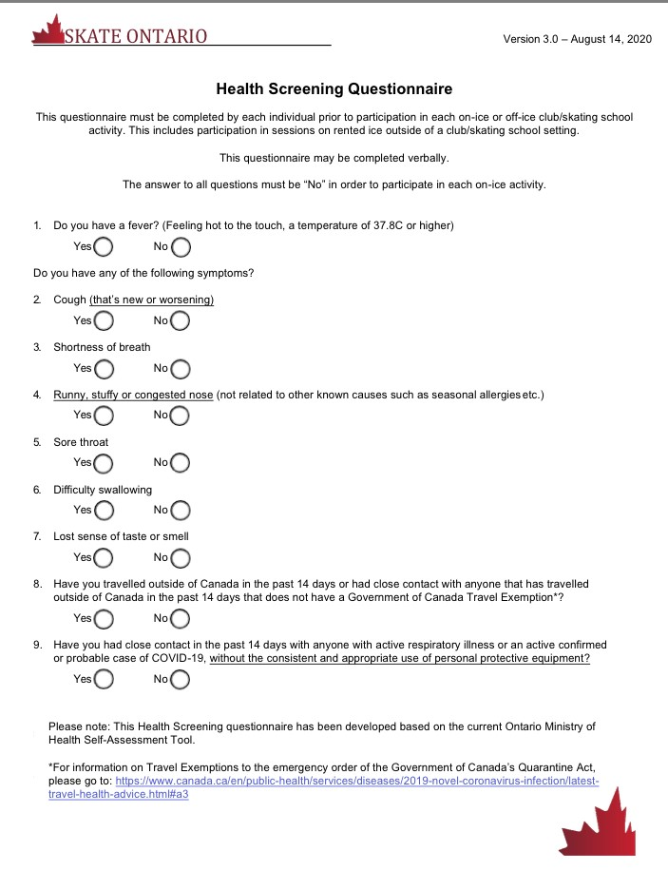

Appendix B: Session Participation Log 1
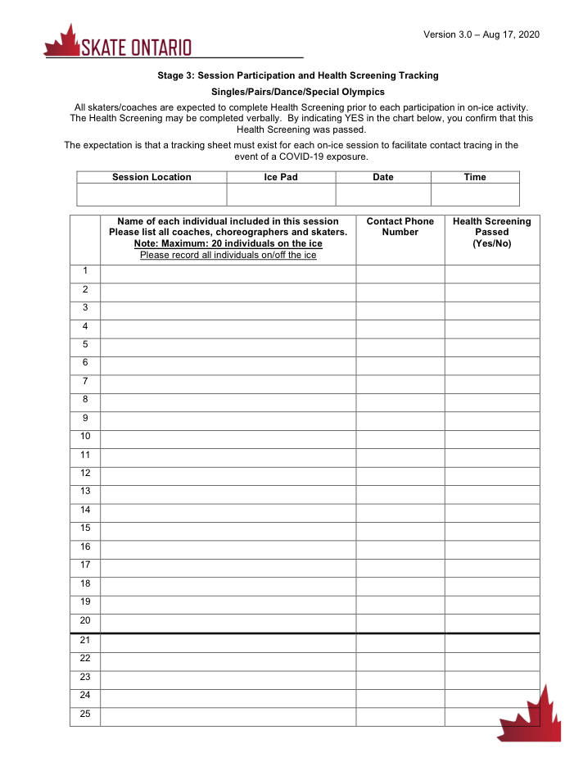

Appendix C: Session Participation Log 2
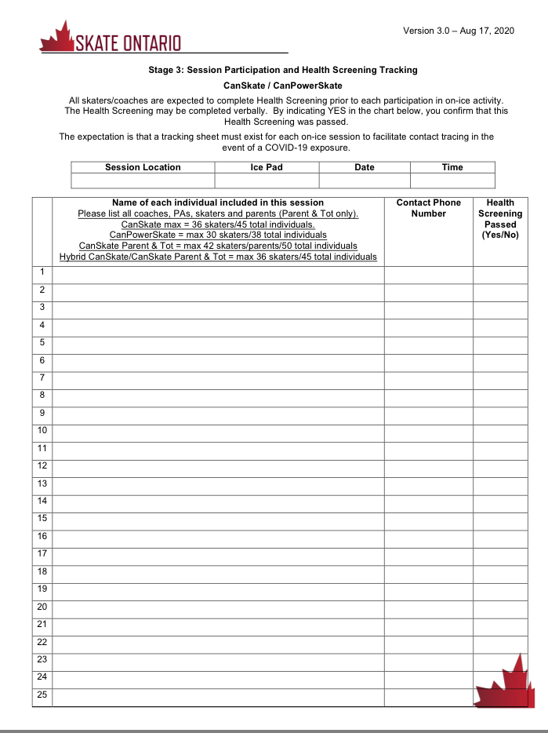

Appendix D: Participation Waiver
