New Jersey Family Career and Community Leaders of America
2016 Joseph Polyak Memorial
Leadership Award Application

Application Due by: April 15, 2016
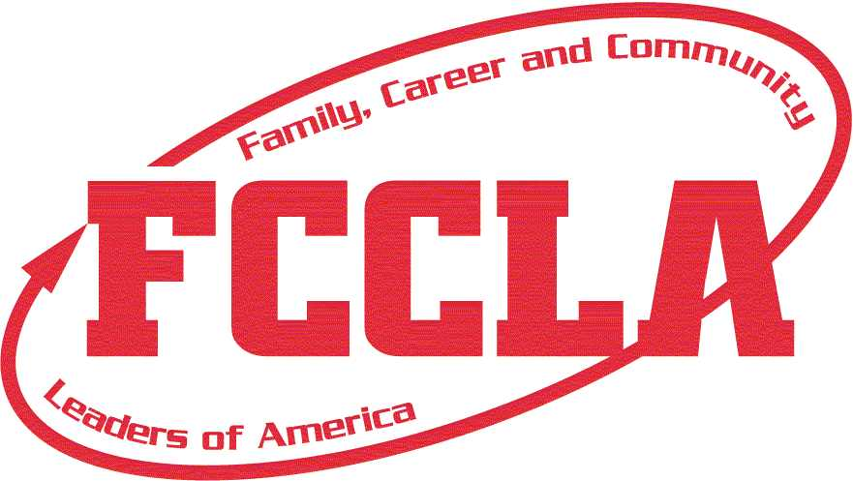

Joseph Polyak

This scholarship is in memory of and tribute to the father of former FHA/FCCLA NJ State President and FCCLA National President, Jeffrey Polyak because Mr. Polyak’s involvement with NJ FCCLA extended far beyond being a supportive parent. He served as a volunteer, fundraiser, and consultant for our state association, always advocating the mission of FCCLA as he developed and supported many of the technological advances that changed the face of NJ FCCLA. He never accepted praise as he led from behind the scenes computing competitive event scores and preparing slides to recognize students at annual NJ State Leadership Conferences.
Mr. Polyak believed in the power of students to impact the world. He believed that leaders came in all sizes and shapes and never discounted the potential of the silent student. He believed that leadership was active not passive and that to be effective, leaders had to work hard, put potential into action, and lead by example. Not only did he believe in this philosophy of leadership, he lived it.

The Joseph Polyak Leadership Award Guidelines

Each year, one deserving student leader will be awarded a $500 stipend to be used towards the costs associated with attending the FCCLA National Leadership Conference (NLC). The stipend will be sent to the student upon return from the NLC and completion of the criteria outlined below. To be eligible the student MUST:

- be an active FCCLA member for the 2015-2016 school year.
- be either a state officer, a student who is participating in a competitive event or a member attending whose participation is integral to the FCCLA NLC team.
- submit an application with an official school transcript and required essay,
two written letters of reference (one from his/her NJ FCCLA Chapter Adviser and one from a peer).
- agree to represent NJ in a professional and appropriate manner, following all rules and regulations of the National Leadership Conference
- agree to send the Polyak family an Acknowledgement Letter* (plus a copy to NJ FCCLA State Headquarters)

* Acknowledgement Letter
Within 30 days of returning from the FCCLA National Leadership Conference, the recipient must send a letter to the Polyak family that describes:
  - The student’s experience at the FCCLA National Leadership Conference
  - One personal development idea that he/she will implement
  - How he/she will continue his/her involvement in FCCLA
  - How, in the spirit of the scholarship, he/she will pay it forward
  - A picture of the student at the FCCLA National Conference
NOTE: There is no limit to the number of eligible members that may apply from a chapter or school.
New Jersey Family, Career and Community Leaders of America
2016 Joseph Polyak Memorial
Leadership Award Application
Application Due by: April 15, 2016

Name _____________________________________________________________________________
Address_______________________________City/State/Zip______________________________

Home Phone ____________________ E-Mail ___________________________________________ .
School ________________________________ Chapter Name _____________________________
Chapter Adviser ____________________________________________________________________
Grades involved as a FCCLA member
6th 7th 8th 9th 10th 11th 12th

List leadership activities:

List community service activities:

List local, regional, state, North-Atlantic region, cluster, and/or national FCCLA participation (including offices and awards):

List school activities:

Additional honors and awards:

Check grades in which you were enrolled in a Family and Consumer Sciences Course:
6th 7th 8th 9th 10th 11th 12th

List Courses taken in Family and Consumer Sciences ______________________________________________________________________________________________________________________________________________________________________________________
Required Essay
Submit a 300 – 500 word typewritten essay that addresses the following:
- Why you are applying for this scholarship?
- How do you expect this experience to impact your leadership potential and shape you as an individual?
- What will your role be at the FCCLA National Conference?

Additional Support Materials
This scholarship requires recommendations from a chapter adviser and a peer. Attach both to this application.

Enclose a copy of your high school transcript.

I verify that the above information is true.

Signature of Applicant Date

Signature of Chapter Adviser Date

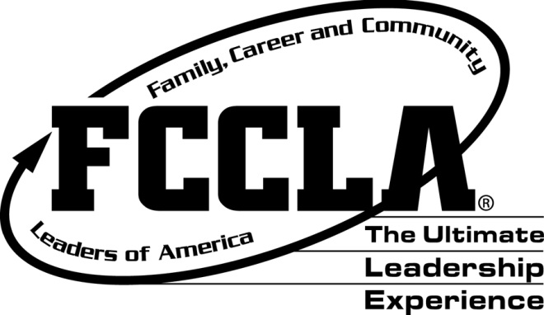
Return completed application to:
New Jersey FCCLA State Office
c/o Patricia DiGioia-Laird
NJ FCCLA State Adviser
855 Grove Avenue
Edison, New Jersey 08820-2201

Application Due by: April 15, 2016

