New Jersey
Family, Career and Community Leaders of America
2023 Distinguished Service Award

Application Due by: March 1, 2023

Purpose
To recognize significant contributions made to Family, Career, and Community Leaders of America and/or Family and Consumer Sciences in the way of service, guidance, and dedication. The nominee’s career should be directly linked to the profession of Family and Consumer Sciences Education.

Name of Nominee:

____________________________________________________________________________________
Nominee Title:

____________________________________________________________________________________
Nominee Address:
____________________________________________________________________________________

City: ______________________________________ State: ______________ Zip: ______________

Telephone (Home)_____________________________ (Work)______________________________

Employer:
____________________________________________________________________________________

Employer Address:
____________________________________________________________________________________

City: ______________________________________ State: ______________ Zip: ______________

Signature of Nominee's Supervisor: _________________________________________________

Please attach an additional sheet of paper to list/describe the following:
- Professional Association memberships (5)
- Offices held in the above professional associations. (5)
- Describe outstanding service to New Jersey FCCLA. (30)
- Leadership positions/responsibilities held in the state/national organization. (10)
- Projects/programs implemented for the state/national organization. (15)
- Publications authored that relate to the purpose/mission of the organization. (10)
- Materials/plans developed to assist present or future educators that integrate FCCLA and Family and Consumer Sciences on the local or state levels. (10)
- Significant research conducted that relates to New Jersey FCCLA. (10)
- Other significant contributions to New Jersey FCCLA. (5)

This official nomination form must be completed and returned to state headquarters, and postmarked no later than March 1, 2023. This form must be accompanied by support information. Candidates may be contacted and interviewed by the Program Committee by telephone.

I agree to have my name placed in nomination for the New Jersey FCCLA Distinguished Service Award.

____________________________________________________________________________________
Signature Date

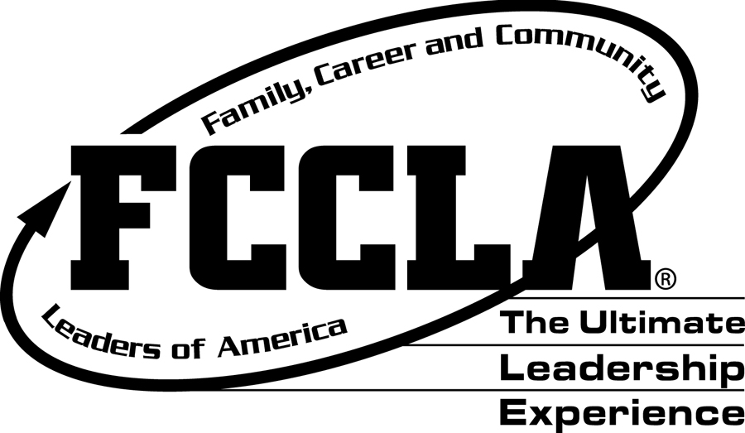
Return Complete Application to:
New Jersey FCCLA State Office
c/o Patricia DiGioia-Laird
NJ FCCLA State Adviser
855 Grove Ave.
Edison, NJ 08820

Application Due by: March 1, 2023

