Liver – Fatty Liver Protocol
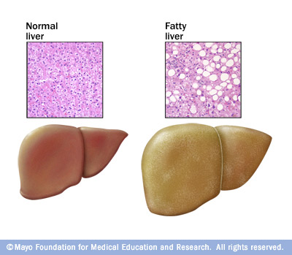
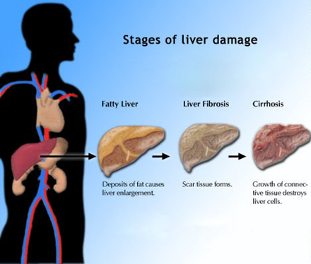

Causes of a Fatty Liver:

Poor food choices

Excessive use of alcohol

Exposure to toxins

Insulin resistance

Side effects from drugs

Natural Health Recommendations:

- Lecithin – optimal amounts to emulsify fat

- Do “The Rejuvenating Body Cleanse”

- DTX – at least 2 per day after the cleanse for 4 months

- Alfalfa – optimal amounts to cleanse the blood and alkalize the body

- Turmeric – 1 teaspoon per day

- Optimally healthy diet

- If blood sugar is a problem, use Glucose Regulation Complex (or the Shaklee 180 Metabolic Boost as your daily multiple vitamin/mineral)

- OmegaGuard (Omega 3 Complex) – to reduce your risk of blood clots

NOTE: There are other supplements of benefit ... if you wish to be more proactive, talk to your health consultant

