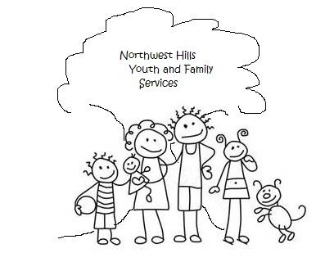
20 Main Street, #8 Phone: (203) 415-8066 Fax: (860) 799-4156
Oakville, CT 06779 www.Norhtwesthillsysb.com Maryann.cheney@nwhyfs.org

Northwest Hills Youth and Family Services, Inc.

CONSENT FOR TELEHEALTH TREATMENT

I hereby consent to engage in telehealth services with Northwest Hills Youth and Family and any
member of its clinical or administrative staff. I understand that telehealth includes
delivery of mental health therapy sessions, diagnosis, consultation, treatment, and
transfer of clinical data using interactive audio, video and/or data communication of my
mental health information.
I have the right to withhold or withdraw consent at any time without affecting my right to
future care or treatment.

Client Name (printed): ___________________________________________

Client Signature: ______________________________________ Date:_____________________

Name of Parent/Legal Guardian (printed):___________________________________________

Parent/Legal Guardian Signature:_______________________________Date:_______________

Therapist Name (printed): ____________________________________

Therapist Signature: __________________________________________Date:_______________

