Budgerigar Association of America

Club Affiliation Application

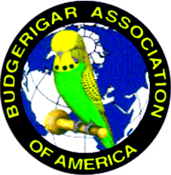
Please Print All Information

NAME OF CLUB:

Type of Club (ie, All Bird Club, Budgie Club, etc):

Contact Name:

Address:

City: State: Zip Code:

Email Address:

Phone No #1: Phone No #2

Proof of Insurance Sent To:

This is for AFFILIATION only!
Show information must be sent in at least 4 months prior to your show on a PATRONAGE FORM.

Affiliation Dues are $175.00 per year and due on January 1st.
This includes insurance, four medals, CC Awards, and a BAA Journal subscription.

A second affiliation option is available for clubs that are not planning a show for the year. The affiliation fee is $25 and will not include insurance, medals or CC awards.

Additional medals may be purchased for $17.50 each.
Additional CCs may be purchased for $20.00 per set.
Make checks payable to B.A.A. Send Application & payment to:

^{Steve Higgins}
^{16058 County Road 355}
^{Terrell, TX 75161}
⁷¹³⁻⁸¹⁹⁻⁸⁷⁶⁹
E-mail- higgins3023@yahoo.com

