Understanding the Key Hormones involved in the Menstrual Cycle
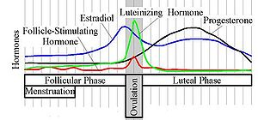
- Luteinizing Hormone from the Pituitary
- Follicle-Stimulating Hormone from the Pituitary
- Estradiol from the ripening eggs in the ovaries
- Progesterone from the ripening eggs in the ovaries

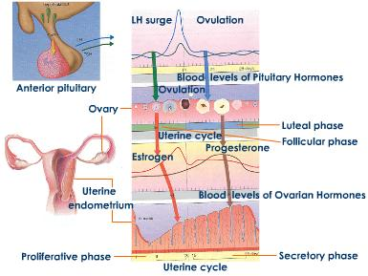
In response to the rise and fall of hormones the uterine endometrium will respond by proliferating the tissue to prepare for possible conception each month. If conception does not happen, then the tissue is shed, and the cycle repeats itself.
Estrogen causes the tissue to proliferate. Progesterone causes it to become dense and hang on to the uterine wall until about day 26-27 when the progesterone drops suddenly (which tells the uterus to shed the tissue, and the shedding begins the menstrual cycle on day 1, and should last approximately 3-4 days.

If the follicles in the ovaries do not produce enough progesterone, the level of progesterone during the luteal phase will be deficient (allowing estrogen to be dominant). This will causes the typical estrogen dominant symptoms of PMS 5 to 7 days before the period starts ... tender breasts, emotional sensitivity, bloating, and some women experience a cyclical headache), and often causes heavier, longer periods
During peri-menopause, progesterone deficiency is often more pronounced, causing longer cycles, heavier bleeding, clots, etc. This is when D&Cs and many hysterectomies are recommended (but it does not address the cause ... which is a progesterone deficiency). The surgery removes the “evidence” of the problem, but it does not correct the cause of the problem.
If the cause is not addressed (progesterone deficiency), then the woman can go into menopause with a higher risk of osteoporosis, cancer, insomnia, depression, etc.
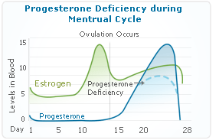

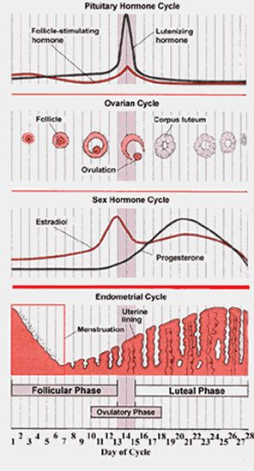

Progesterone Deficiency Causes
- Xenoestrogen Exposure … toxins that interfere with the production of progesterone
- Xenoestrogen exposure during embryo phase of life
- Nutrient deficiencies (B Complex, GLA, Soy Protein)
- Stress (high adrenaline and cortisol production uses up the nutrients essential to manufacture progesterone
- Interference from synthetic pharmaceutical progestins (such as Depo Provera, Prometrium, Megestrol, etc.)
- Impaired liver function
- Excessive calorie, sugar and refined starch intake

Problems caused by Low Progesterone:
- Insomnia & fatigue
- Increased risk of endometrial, breast & ovarian cancer
- insomnia and fatigue
- low blood flow to skin
- hot flashes and high blood pressure
- fibroids in uterus
- cysts in the ... thyroid, breasts, ovaries
- blood clots
- weight gain
- fluid retention
- hypothyroid symptoms
- low sex drive
- thin dry skin
- depression
- brain malfunction (epilepsy)
- glaucoma and other eye challenges

* cysts … thyroid, breasts, ovaries
* blood clots
* weight gain / fluid retention
* hypothyroid symptoms
* low sex drive
* thin, dry skin
* depression & brain malfunction (epilepsy)
* glaucoma & other eye problems

Many women wisely choose to use a natural, transdermal, progesterone cream to support the levels of progesterone in their blood, and also to reduce their risk of the symptoms of progesterone deficiency (a 3% cream is the average strength ... which means 1/8th of a teaspoon is equivalent to approximately 10 mg of progesterone).
NOTE: It is imperative to understand the “balance” of hormones. Too much or too little will create “imbalance”. Therefore, any women who chooses to use natural progesterone cream MUST wisely have her levels checked at least every 12 to 18 months to be personally responsible for her health
When to use progesterone cream:
- Menstruating Women (use for 12 days only, following the natural pattern of progesterone production in your cycle)
<<<<<<<<<<<<<< 12 days >>>>>>>>>>>> (start at ovulation)
________________________________________________________________________________
1 14 28 (Days of the Month)
- Menopausal & Beyond (do not use the first week of the month ... use the rest of the month)
XXXXXXXXXXXXXXX <<<<<<<<<<<<<<<<<<<<<<<<<<<< progesterone >>>>>>>>>>>>>>>>>>>>>>>>>>>>
_____________________________________________________________________________________
1 7 30 (Days of the Month)

