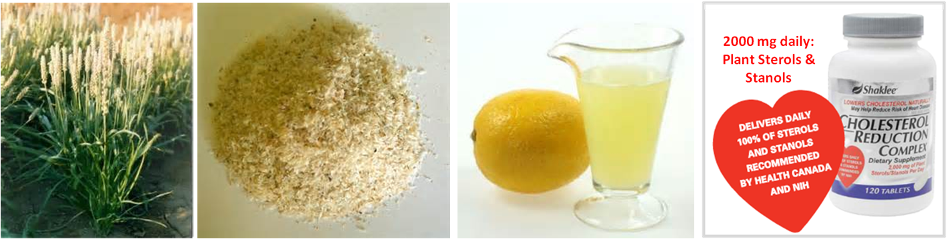

A Drug-Free Approach to Maintain Good Cholesterol Levels
Step 1: Lots of Fibre in your Diet ... Drink one fibre drink in the morning and one at night - see recipe provided below.
Step 2: Take 2000 mg Plant Sterols & Stanols DAILY ... Shaklee Cholesterol Reduction Complex
Step 3: Lifestyle: a) Exercise; b) Quit Smoking
Step 4: Diet: Eat a healthy diet. Cut out trans fats (margarines, fried foods, etc.) Include Omega 3 fatty acid rich foods (such as chia seed, flaxseed, raw nuts). We recommend optimizing your Omega 3 intake by taking OmegaGuard (Omega 3 complex supplement from Shaklee).
Step 5: Take 1 to 3 teaspoons of turmeric every day ... can be stirred into an ounce or two of prune or
tomato juice and swallowed in a quick gulp.

Fibre Drink:
- 2 cups of water
- 2 tablespoons of fibre: choose from psyllium / ground chia seed / Shaklee Fibre Plan (U.S. Product)
- 2 tablespoons lemon juice (supports a healthier liver, which is involved in cholesterol management)
- 1 pinch of cayenne pepper (excellent for heart health)
- (optional: sweeten with 1 to 3 teaspoons of pure maple syrup)
Mix together well and drink immediately. (The psyllium thickens quickly.) It is imperative to have enough water because psyllium absorbs 10x its weight in water. If you do not have enough fluid, you can become constipated by all of the fibre.

Plant Sterols and Stanols (Shaklee Cholesterol Reduction Complex)
- Have been clinically proven in over 80 studies to lower LDL (bad) cholesterol
- 2 tablets – 2x per day of Shaklee Cholesterol Reduction Complex, taken before meals provides2000 mg of plant sterols and stanols (to get an equivalent amount, you would have to eat 59 oranges ... OR ... 47 ½ cucumbers
- Sterols and stanols work in the intestinal tract, blocking the cholesterol from going into the bloodstream.

Fibre Drink that Helps lower Cholesterol ... and many other benefits
Psyllium
- Psyllium is a soluble fiber used primarily as a gentle bulk forming product.
- It comes from a shrub like herb called Plantago ovata that grows worldwide but is most common in India.
- Each plant can produce up to 15,000 tiny, gel coated seeds, from which psyllium husk is derived.
- When psyllium husk comes in contact with water, it swells and forms a gelatin like mass that helps transport waste through the intestinal tract.
- In food manufacturing, blond psyllium is used as a thickener or stabilizer in some frozen dairy desserts.
Physical benefits:
- The soluble fiber found in psyllium husks can help lower cholesterol.
- Psyllium can help relieve both constipation and diarrhea, and is used to treat irritable bowel syndrome, hemorrhoids, and other intestinal problems.
- Psyllium has also been used to help regulate blood sugar levels in people with diabetes.
- Increased fiber intake may reduce risk of colon cancer.
- As a weight loss aid, take it at least 30 minutes before meals.
Cautions:
- It is IMPERATIVE that you have enough fluid with psyllium, because it absorbs at least 10x its weight in water
- Psyllium supplements may reduce or delay the absorption of certain medications. As a rule, you should not take psyllium supplements at the same time as other medications. Take psyllium at least 1 hour before or 2 - 4 hours after taking other medications.
- A potential side effect from any fibre product is gas and bloating. If you are experiencing this side effect, reduce the amount of fibre you are using ... or switch to ground chia seed instead.

