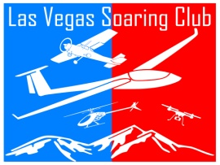

**Las Vegas Soaring Club**

**Membership Meeting**

**June 10, 2023**

**MINUTES OF RECORD**

The second quarter Membership Meeting was called to order at 9:05am by the LVSC Flying Field President Al Badoux and VP David Knapp. A Quorum of 21 were in attendance. *This must be 10% of the general membership OR 14 members.*

**OLD NEWS:**

**Instructional Pilots:** In order to keep up with the influx of new members, and remain within AMA standards, the Board had asked David Knapp and Daniel Valdes to become AMA approved Instructional Pilots. These pilots will help new pilots, and members regardless of age, to inspect the aircraft prior to flight and review basic flying field etiquette. More below.

**Finances (Barry):** A second quarter spread sheet was generated by Barry Mattison and shared with the Members. As of today’s, date we have $5368.17 in the LVSC Account. Al Badoux proposed a motion to approve the budget which was approved by Ed Jennings.

**Field Improvement:** Last quarter we discussed having green Astro turf placed between the taxi ways in an effort to reduce kicked up dirt and enhance the appearance of the field. The Board recently voted not to move forward on this project as it may create more issues than solve.

**NEW NEWS:**

**Membership Update (Al) :** As of June 01, 2023, we have 133 active members. In the past 90 days we have added 14 new members. According to Group Works, we have 126 members of which 75 have signed in the past 30 days and 19 never signed in.. Projecting current future membership with full renewals, we can expect to see 4 renewals in July, 11 in August, 6 in Sept and 4 in October amounting to approx. $600.00 of future income.

**Jr Pilot Program:** Our very own AMA District 10 Assistant VP, Barry Mattison, has been instrumental in the introduction and roll out of this program. At this time, we have four new Jr Pilots. (Chad, Temper, Ethel & James Jr). These pilots have had their aircraft inspected prior to flight, verbally tested on basic safety and flying etiquette, and demonstrated their ability to fly their aircraft. If you have watched any of these Jr. pilots, you know they are doing acrobatic manuvers and are safe pilots – this is a direct result of having a positive maiden, encouragement and support from the club. As our club becomes more well-known thanks to walk in visitors and the social media platforms, and our membership grows, we must take pride in the fact that we are fully within the “AMA standards” and each of you have contributed to the success of LVSC one way or another.

**Board Member Voting:** The Board, which consists of seven positions, have annual term limits. These terms generally are from July 01 to June 30. Currently our Board consists of six positions, we have eliminated the “Communications Coordinator” due to lack of activity/need. Our Treasurer, Barry Mattison, will develop an on line voting method for all members to submit a candidate or elect themselves for any position. Votes will be tabulated no later than June 30, 2023. Special Note: All current Board members have told me they are willing to stay on another year to serve the club.

**Spectator Fence:** The Board has requested that this project be re-visited to examine methods to reduce the cost to where the club can afford installing it. This spectator fence would be behind the spools and be designed to keep nonmembers from approaching the spools. Other clubs have had issues with theft. Once the Board has reached a reasonable cost, it will be presented to you the members for a vote. A suggesting was made to ask members for donations to this project. A few members stated they had connections and if supplied with the dimensions would ask for bids – the plans were posted on Groupworks.

**Work Party:** Our Facilities Manager, Neil Welch, has sent out a request for a small work crew to help trim back weeds, rack dirt and tidy up the runway area before the heats arrive. We’ve had wonderful success from members stepping up for 30-60 minutes to accomplish this and keep our field clean. The date for this project is Saturday June 17, 2023 between 8am and 10am. A secondary memo was sent out on Groupworks with updated date/time.

**Spool Reminder:** Our wooden spools are growing tired. We recently re-carpeted each but now need everyone’s help in making sure we do not break or bend them by sitting on the actual spool. I’ve seen kids and adults using them to sit. Some of our chairs are growing tired as well so I would like to ask each member to “be on the lookout” for any patio chairs or stools that are in fair condition and can be donated and used at the field.

**Swap Meet:** May 20, 2023 at Willie McCool in NLV. The event hosted three clubs was fun to meet new friends and club officials.. Al has posted the event on Groupworks on May 01 and May 15, 2023. Many items donated by Bill Richardson will be for sale and proceeds go directly to the LVSC account.. A total of $27.00 donated to the club.

**Safety & Caution Paint:** I am glad to report we now have our paint can inventory re-stocked and the red safety line should be once again visible..

**Bike Path Update:** Our last in person project update was on July 23, 2022 with Mr. Josh Travers. Starting February 2023 I have campaigned to reach the “in charge” person of this project and learned they have had 4-5 project managers come and go. On June 06, 2023 I finally spoke to Tira Faiivae who is the Red Rock / Sloan Project Manager with BLM. Tira was friendly and agreed to send me the following updates.

**BLM Vs Driveway:** See attached Diagram – note “Pave Existing gravel road”.. on desktop “BLM vs gate

**Local Hospital Plaque:** I think it would be beneficial to have a small plaque attached to the bulleting board that provides the address of the closest ER/Hospital in addition to our relative location for 911 calls. Perhaps give our location such as ¼ mile past the Gun Club (12201 W. Charleston Blvd) Lat: N36.1498 Long: W115.3653. Al Badoux proposed a vote which was seconded. Barry Mattison will work on producing a framed style plaque.

**FAA Altitude Waiver (Info):** Some of you may be aware that the Bennet Field RC Club has been granted an altitude waiver of approx. 2000 feet. So why not us? Simple, we are not within Class B airspace. This is a requirement of the FAA, not AMA. Our altitude max remains at 400 feet.

**Use of Field (Info):** Special Tactics & Solutions have asked to use our field on June 23, 2023 to host a training event from 1pm to 3pm. Reminders will be posted on Groupworks both 7 and 3 days prior to the event. I will be present to secure the field from members and obtain the proper use of field documents. Rob will be donating the half day fee of $100.00.

**Radio ID:** According to recent reports, the deadline for RID is his September 2023. Our club has submitted documents, and been approved, to be a FRIA (FAA Recognized Identification Area) field. We have not yet received verified documentation (yet) as the FAA is apparently overwhelmed with requests. This means after the Sept 2023 deadline, any member may fly any aircraft within our field’s boundaries without a Radio ID unit. Special circumstances are attached to drone operators flying Part 107.

**BBQ Fun Fly:** As summer approaches, so will nice weather and what better way to enjoy the day than have a BBQ and fly. On Saturday June 24, 2023 LVSC will host a Fun Fly BBQ. Our very best outdoor chef, John Surrency, will be cooking and serving Hamburgers, Hot Dogs, chips and sodas will be served around 10am till gone. A member also volunteered to bring his slow cooker down and cook up some ribs!! We do eat well at LVSC.. Reminders will be posted on Groupworks so please mark your calendars to attend and do some flying.

**AMA Health Insurance:** A member made an inquiry pertaining to the AMA insurance. AMA doesn’t provide any life insurance benefits; however, there is a $10,000 death benefit that is part of the AD&D (medical) insurance benefits provided to AMA members. In order for this particular benefit to be considered, the death would have to be related to modeling activities.

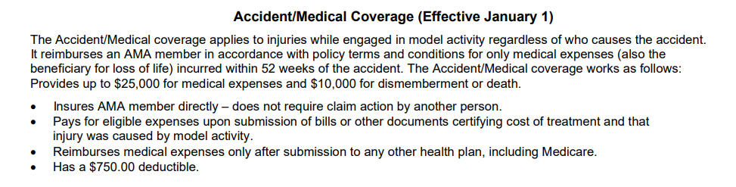

F**light-line Safety:** Based on collected comments, and a few complaints, we need to review the importance not to fly drones or mini aircraft from the spools, nor do any cross runway take offs from the taxi area. It happens and all Board members have to reminded to approach anyone seen doing this and remind them of the rule. This is all about your safety..

**Flight Time Courtesy:** I’ve been approached by a few members saying they are, not comfortable, or are intimidated flying with 2-3 planes in the air and become frustrated when a member lands, tosses in a new battery, with 7 more on deck and goes back up. Please respect air time so that others may enjoy the air space as well.

**Use of Runway by Helicopters & 3D Helis:** We have a dedicated Heli Pad which admittedly has some build in problems – mostly crossing the runway at the west end creating traffic for fixed wings on approach. As a general rule, most every pilot graciously allows heli pilots to utilize the full runway for a quick 5-minute flight. Heli pilots utilizing the heli pad should avoid flying over the runway. 3D Heli pilots should please respect that this type of flying may cause stress to other pilots in the air.

**Open Forum:**

At 10:00am motion to adjourn the meeting was made by Al Badoux and seconded by Ed Jennings.