Signs are EVERYWHERE🦋🦋🦋🦋🦋

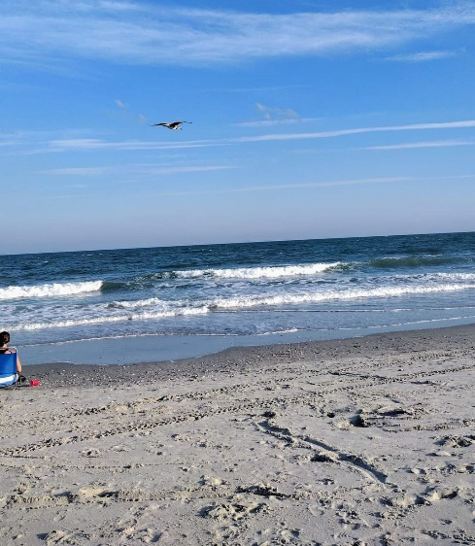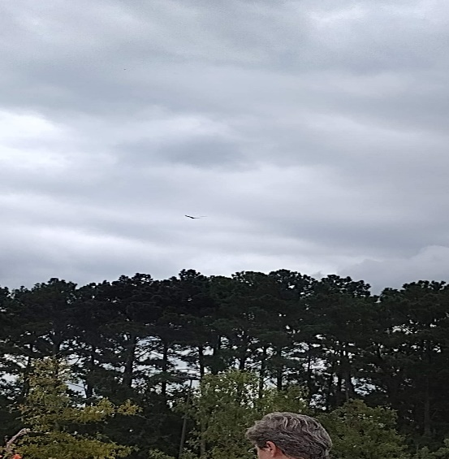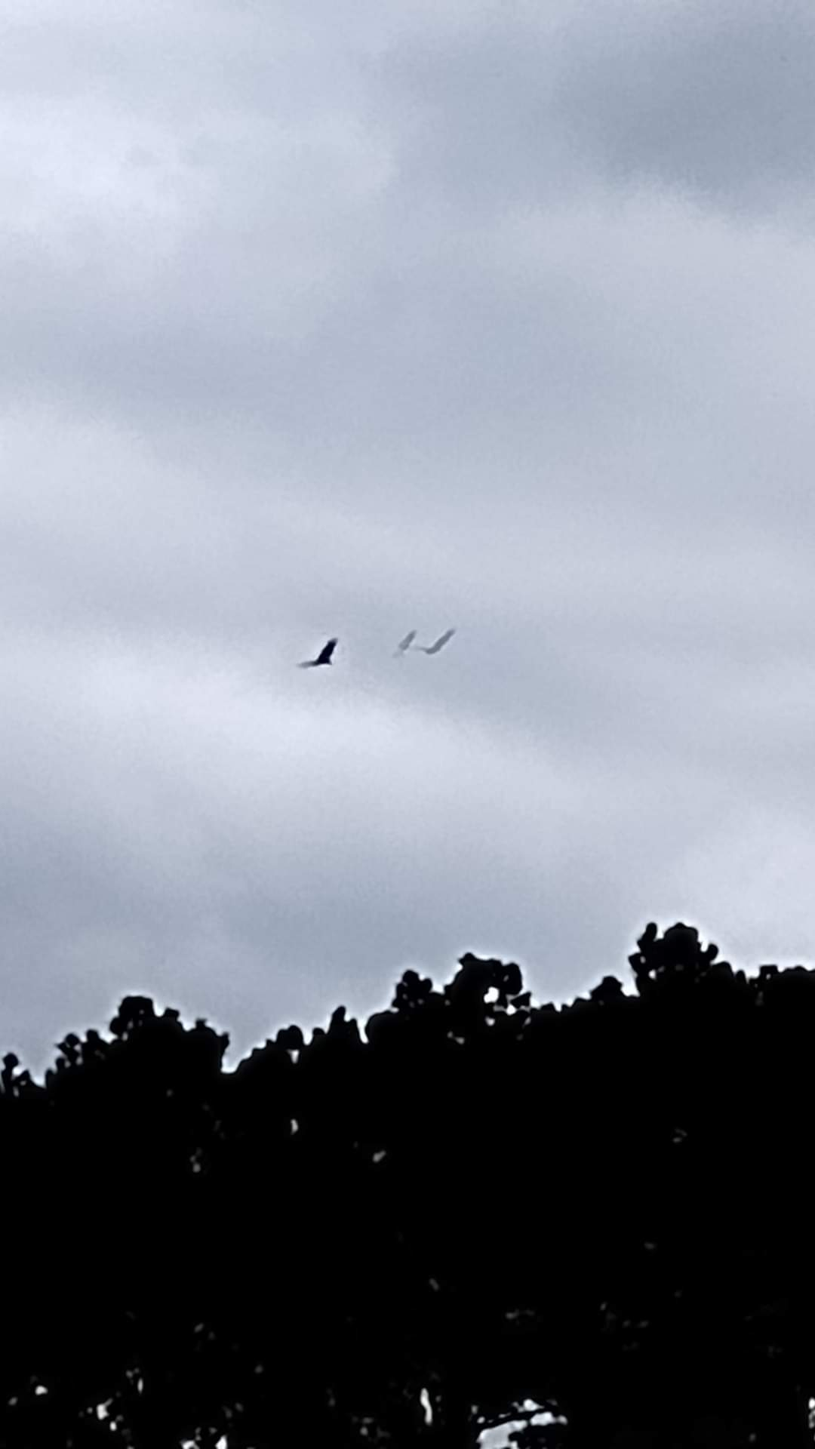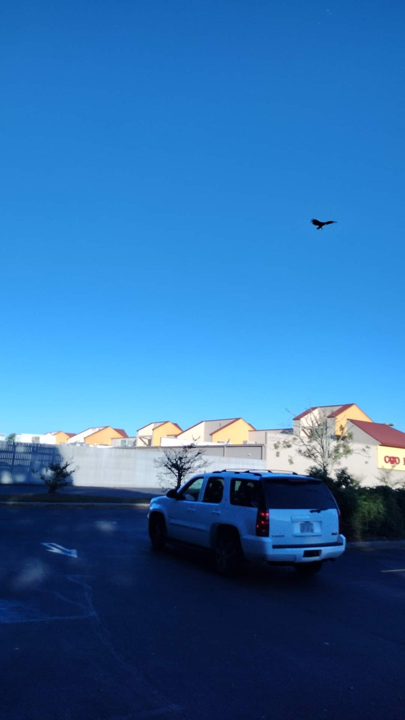

When you are arriving in a new territory or taking on new assignments allowing God to guide your steps, sometimes you are unsure if you are in the right place, at the right time. Well, no matter where I go, or what I am doing in the Kingdom, God has a bird or group of birds, fly high in the sky so, I can see them. HE always makes sure that I see the birds(s) no matter what. If I happen to not see or miss the bird(s), they will fly low right in front of my car or where I am standing to let me know I am on the right track. Once I see those birds I am ready for whatever task is given to me, because I know God is walking with me. God gives everybody little signs here and there. Sometimes, maybe we just think it’s a coincidence or we take it with a grain of salt, but there are answers in the signs that God sends.

For example, my husband sees numbers as his sign (11:11, 12:02, 1111, 2222), or I have a friend and the color yellow is her sign. I have another friend and his sign is red cardinals. There are so many signs that God will place in front of you for reassurance, but you really have to be paying attention to notice. Could it be bees, butterflies, squirrels, the sun shining on you wherever you go, leaves, and the list goes on. It’s funny because my 25 year old son used to get annoyed hearing about and seeing my bird..LOL…but guess what now that he has stepped into his kingdom role, birds follow him everywhere and he takes the time to notice. This gives him constant reassurance on his assignments that he is in the right place at the right time. I have friends that have told me the same thing is happening to them, now that I told them about the birds. What is your sign? What do you see everyday in your travels reminding you that God is with you?

