One Step Cassette Style FSH Urine Test

INTRODUCTION

One Step Cassette Style FSH Urine Test is a test kit for the determination of FSH (human Follicular Stimulating Hormone) concentration in urine specimens. Test results are read visually without any instrument.
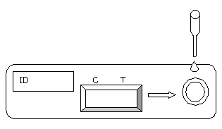

TEST PROCEDURE

- Test device, patients’ samples and controls should be brought to room temperature (18-30°C) prior to testing.

- Remove the test device from its protective pouch (bring the device to room temperature before opening the pouch to avoid condensation of moisture on the membrane). Label the device with patient or control identifications.

- Draw approximately 0.2ml sample. Dispense entire contents into the sample well. Alternatively hold the pipette in a straight position, not at an angle. Dispense 4 drops (approximately 0.2ml) of the specimen or control into the sample well. For each sample or control, use a separate pipette and device.

- Wait for colored bands to appear. Depending on the concentration of FSH in the test specimen, strong positive results may be observed in as short as 40 seconds. To confirm negative results, the complete reaction time (10 minutes) is required. Do not read results after 30 minutes.

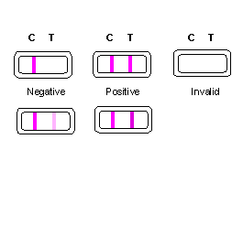INTERPRETATION OF RESULTS

- Negative: Only one colored band appears on the control (C) region. Or two colored bands appear, but the test (T) band is lighter than the control band. The FSH concentration of the sample is below 25 mIU/ml.

- Positive: If two color bands are visible and the test (T) band is equal to or darker than the control (C) band. The FSH is present in the sample at or above 25 mIU/ml.

- Invalid: No visible band at all. A total absence of color in both regions is an indication of procedure error and/or that test reagent deterioration has occurred. Repeat test with a new test kit.

STORAGE AND STABILITY
The test kits can be stored at room temperature (18 to 30°C) in the sealed pouch to the date of expiration. The test kits should be kept away from direct sunlight, moisture and heat.

PRECAUTION
- For in vitro diagnostic use only.
- Do not use test kit beyond expiry date.
- The test device should not be reused.

