6 6 6, the Three Beasts,
and the Anti-Trinity

Revelation 13:1 And I saw a beast rising out of the sea, with ten horns and seven heads, with ten diadems on its horns and blasphemous names on its heads.
² And the beast that I saw was like a leopard; its feet were like a bear's, and its mouth was like a lion's mouth. And to it the dragon gave his power and his throne and great authority.
³ One of its heads seemed to have a mortal wound, but its mortal wound was healed, and the whole earth marveled as they followed the beast.
⁴ And they worshiped the dragon, for he had given his authority to the beast, and they worshiped the beast, saying, "Who is like the beast, and who can fight against it?"
⁵ And the beast was given a mouth uttering haughty and blasphemous words, and it was allowed to exercise authority for forty-two months.
⁶ It opened its mouth to utter blasphemies against God, blaspheming his name and his dwelling, that is, those who dwell in heaven.
⁷ Also it was allowed to make war on the saints and to conquer them. And authority was given it over every tribe and people and language and nation,
⁸ and all who dwell on earth will worship it, everyone whose name has not been written before the foundation of the world in the book of life of the Lamb who was slain.
⁹ If anyone has an ear, let him hear:
¹⁰ If anyone is to be taken captive, to captivity he goes; if anyone is to be slain with the sword, with the sword must he be slain. Here is a call for the endurance and faith of the saints.
¹¹ Then I saw another beast rising out of the earth. It had two horns like a lamb and it spoke like a dragon.
¹² It exercises all the authority of the first beast in its presence, and makes the earth and its inhabitants worship the first beast, whose mortal wound was healed.
¹³ It performs great signs, even making fire come down from heaven to earth in front of people,
¹⁴ and by the signs that it is allowed to work in the presence of the beast it deceives those who dwell on earth, telling them to make an image for the beast that was wounded by the sword and yet lived.
¹⁵ And it was allowed to give breath to the image of the beast, so that the image of the beast might even speak and might cause those who would not worship the image of the beast to be slain.
¹⁶ Also it causes all, both small and great, both rich and poor, both free and slave, to be marked on the right hand or the forehead,
¹⁷ so that no one can buy or sell unless he has the mark, that is, the name of the beast or the number of its name.
¹⁸ This calls for wisdom: let the one who has understanding calculate the number of the beast, for it is the number of a man, and his number is 666.

(Rev 13:1-18)

That Number!

666. That’s probably not a great start for a sermon. Nor is it probably the best number to have all your seminary papers mailed to. But I did, because when I arrived long ago at the office where they were assigning Post Office boxes to students, I was told there weren’t many left. The lady sheepishly asked if I wanted #666, but understood that I would probably say no, because the last three students did. I thought to myself, given all the speculation and superstition around it, could there be a greater piece of irony than to have your sem-box be #666? So, I eagerly accepted it, just like I’m quite fine beginning a sermon with this number.
666 might be the most infamous number in all the world. From the ancient Bible where it originates, to 21st century pop-culture, and everything in between, it is famous, figured, fixated upon, and feared. A fixture of books and songs (too many to count), movies (at least 20 have “666” in the title and that says nothing about movies that deal with it in the plot), corporate logos (see below), a brand-new Nike shoe, the covid vaccine (in more ways than one), the list is almost endless, thus giving it perpetual fame.

Logos (Supposedly) with “666”
 | 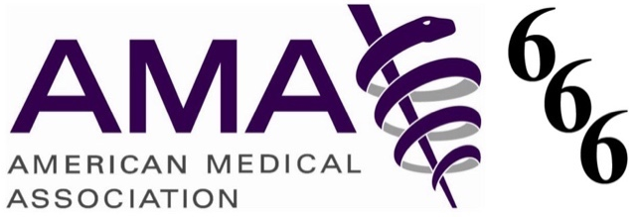
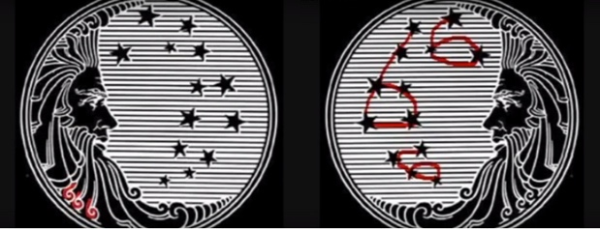  Procter and Gamble | 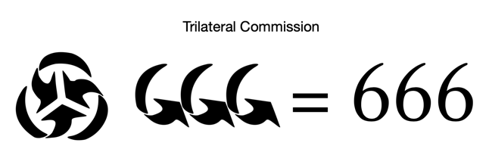
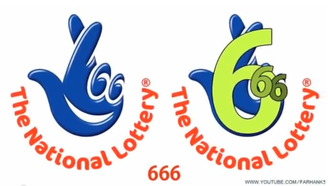 | Flag of Ottawa, Ontario
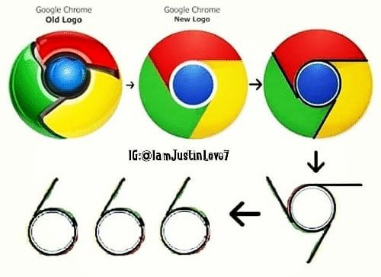
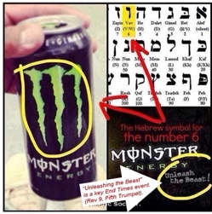 | 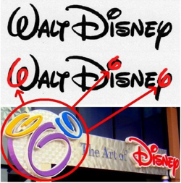  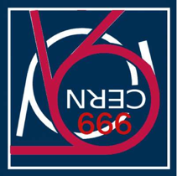

The number is usually associated with the so-called “Antichrist,” the last-days “man of sin” or “son of perdition” that the Bible discusses (2Thess 2:2). It’s fascinating how many individuals have been said to be this Antichrist as people supposedly took seriously John’s instruction to “calculate the number” (Rev 13:18). Ranging anywhere from the completely silly like figuring up the number of letters in a name like Ronald Wilson Reagan (three names with six letters each) to the contextually possible idea gematria (where each Greek or Hebrew letter is assigned a numerical value), to people who are in other ways connected to the number, Nero, Constantine, many Popes (and also the papacy itself), Napoleon, Hitler, Kennedy, Obama, Kissinger, Gorbachev (he had that mark on his forehead), Bill Gates, and so many more are said to be the Antichrist.
Christian theologians aren’t the only ones who try to figure the number. In scientific and esoteric circles, 666 is shown (like other numbers in Revelation) to be deeply related to the earth and therefore to man, because earth is our home and six is man’s number (created on the sixth day). For example, in one blogger’s search of NASA’s data and “maths,” he rather creatively found 33 statistics, some of which are not quite accurate, others which are very accurate which link the number to the earth and home of man. Think of the force of gravity on earth at 666 Newtons, the speed of sound at 666 knots per second, the Arctic and Antarctic Circles at exactly 66.6º latitude, the Tropic of Cancer at 66.6º from the North Pole, and likewise the Tropic of Capricorn to the South Pole, the earth’s average orbital speed around the sun at 66,600 MPH, the angle between the North Pole and the plane on which the earth travels around the sun is 66.6º, and you start to get the picture.
If it hasn’t already been seen, fixation on the number can be demonstrated in so many ways. Here’s a crazy 666 list related to the “pandemic.” Throughout 2020 and into 2021, you could go to Google (itself attached symbolically some say to the number, see logos above), and discover that nearly any state you put in had announced that 666 new cases of COVID-10 had been confirmed very recently. It no longer works like it once did, but you can still find some of them as reported in MSM news agencies. The word “corona” is 6 letters long and when you place a numerical value to each English letter (A=1, B=2, C=3, etc.) you get 66; hence 6, 66. The US Patent that Microsoft took out on a cryptocurrency system that would track all your activities is WO/2020/060606. And, a bill was introduced by the House called HR 6666 in conjunction with it called the Trace Act. None of this is to comment on who might be more fixated on the number—those looking into it, those perpetrating it, or both.
One that combines all these together is the element krypton—the 36th element of the periodic table and fictional home of Superman. 36 is the only number whose sum of all the integers (1 + 2 + 3 + … 36) equals 666. Long before Superman arrived on the comic scene, many were even calling Antichrist “Superman.”
Probably the worst of the things associated with 666 is fear. Fear is the great plague of this last year and these discussions often only play into it. Fear ranges from the superstitious to outright phobias. When Ronald Reagan (who was a candidate for the Antichrist, see above) moved in 1989, a year after he left office, their new home in Bel-Air had its address—666 St. Cloud Road. Nancy had it changed to 668. In New Mexico they changed Route 666 to Route 491 because, as the spokesperson for the change stated, “The devil’s out here, and we say goodbye and good riddance.” Or think of those students in my conservative Evangelical seminary who wouldn’t take P.O. #666. Would you have? Why, there’s even a phobia called hexakosioihexekontahexaphobia—the fear of 666.

Revelation 13 in Context

All of this is a hopefully light-hearted way of bringing up a very important and not at all light-hearted chapter of Revelation. Revelation 13 begins with a beast and ends with the number 666. It is a fascinating if not also deeply complex and disturbing part of the book. We’ve seen some of the fascination. Nearly all its material is disturbing because of how it moves us to really thinking long and hard about what has been rightly called a kind of anti-Trinity presented in it. That idea is extremely important in rightly understanding the number, and we will say much more about it as we move along.
But I want us to try to make sense of where this chapter is positioned in the book first. The complexity here is rather astounding, and I won’t talk about all of it here. But some of it is necessary. On one hand, Rev 13 starts to move us into the second half of the book. But it does so not as two disconnected halves, but more like an unfolded step ladder where, after going all the way to the top rung, you step over and begin climbing back down. This is because of the chiastic nature of the book, where everything hinges on that center. Understanding this will help us not only in coming parallel sections with things we’ve already seen, but in contrasting sections. So for example, in ch. 13, 666 parallels 1260 days of prophesying (11:3), the beast healed of the deadly wound parallels the resurrection of the saints (11:9-11), and both in mockery and sacrilege against the parallel.
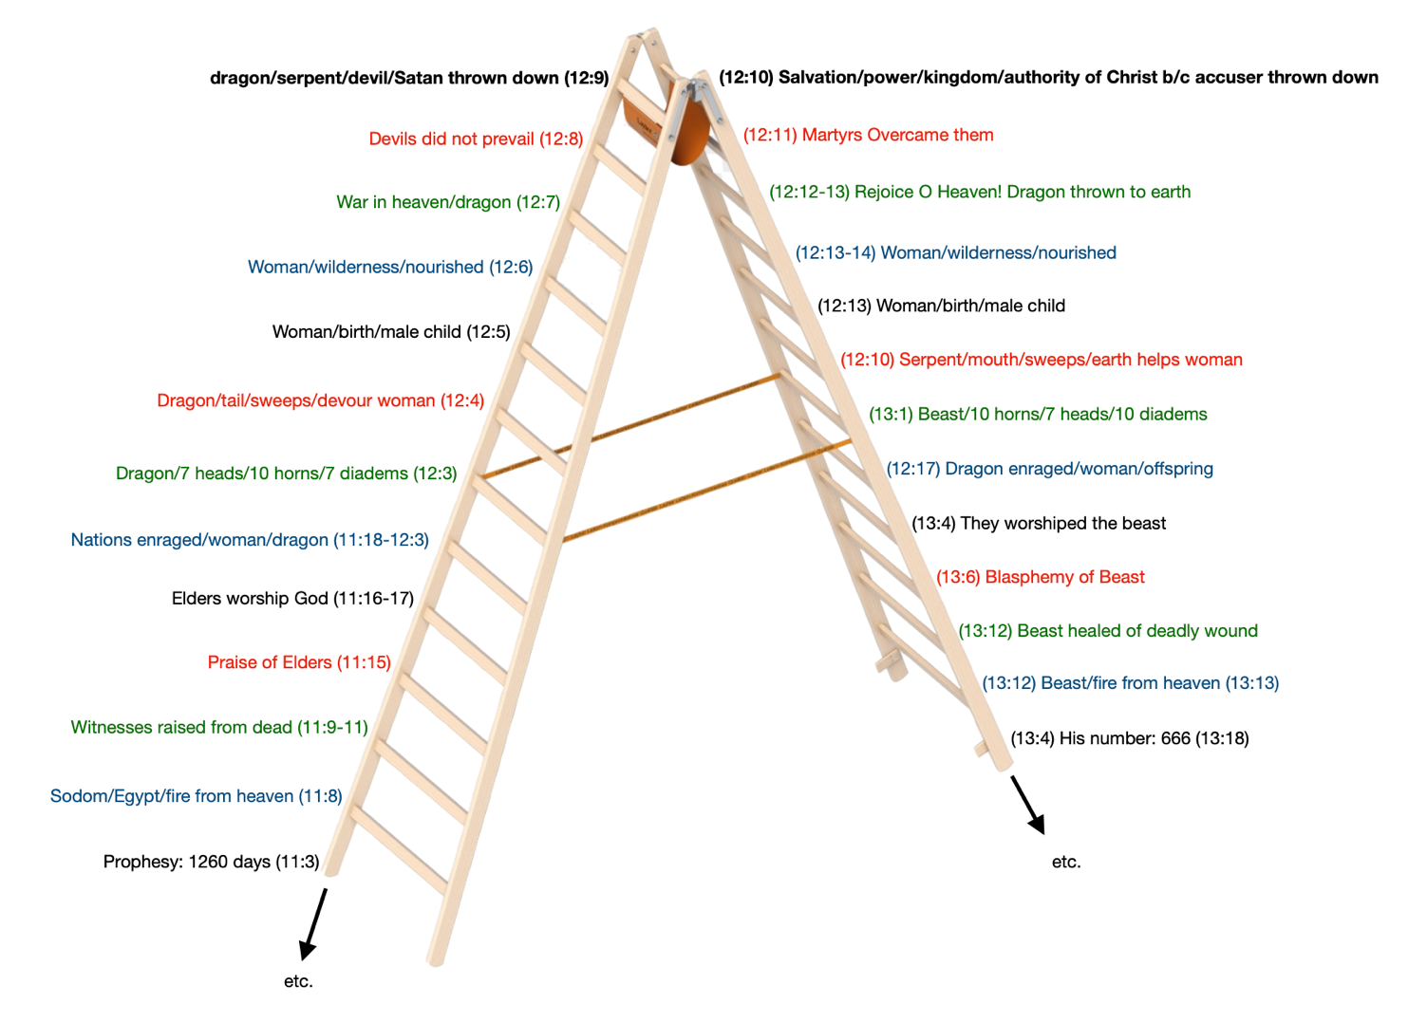
Ch. 13
Yet, because of the spiraling nature of the seven cycles, our step ladder is like two mirrored circular staircases, with repeating themes not only directly across from the adjacent step, but also above and below it in the spiral. A reason this is important is because it will help us make sense of how the second half of the book also folds in on itself, somewhere between chs. 14 and 16. This gets perhaps infinitely complicated and demonstrates the omniscient mind of God. But more practically, this will have implications for how we interpret some important things like Armageddon or the 1000-year millennium later in the book. If, for example, ch. 12 mirrors ch. 20, then they would be talking about the same thing and one could help interpret the other (on this chiasm, see below).

- Dragon (12:3)
- Sea-Beast (13:1)
- Earth-Beast = False Prophet (13:11)
- Babylon (14:8)
- Beast-Worshipers (14:9)
E¹. Beast-Worshipers (16:2)
D¹. Babylon (16:19)
C¹. Earth-Beast = False Prophet (19:20)
B¹. Sea-Beast (19:20)
A¹. Dragon (20:2)

As far as the seven cycles go, Rev 13 falls right in the middle of the fourth (chs. 12-14). So in one sense, this makes it the middle of a middle (1.2.3.4.5.6.7. cycles and 12.13.14. chs.). That would seem to make it important.
As far as the chapter itself goes, one way to look at it is to separate it into two halves. We are introduced in Rev 13:1 to “a beast rising out of the sea…” Vs. 11 begins the parallel. “I saw another beast” but this one was “rising out of the earth.” So, we have two beasts. Like the previous chapters, this is still being told in story form. As with the woman and dragon and child, so also here. John is using ancient stories and repurposing them for the last days. In this case, he is drawing especially upon the OT creatures of Leviathan (sea monster) and Behemoth (land monster), both discussed as mighty and terrible creatures in Job. I won’t say more about it because of last week, but don’t forget to let the story work on you as you read it.
These two beasts mirror one another. John “sees” both. Both ascend. Both have horns. Both are related to the dragon. Both relate to a wound that is healed. Both are worshiped. Both amaze. Both make war. Of all the direct parallels, the only one that seems confusing is the last. The 666 is parallel to the people of the earth worshiping the first beast. This will become important for identifying the nature of the number.

Sea beast | Land beast
I saw (καὶ εἶδον), 13:1 | I saw (καὶ εἶδον), 13:11
Beast ascending (θηρίον ἀναβαῖνον), 13:1 | Beast ascending (ἄλλο θηρίον ἀναβαῖνον), 13:11
10 Horns and 7 heads, 13:1 | 2 Horns, 13:11
Dragon’s gifts, 13:2 | Speaks like a dragon, 13:11
Authority of dragon, 13:2, 4 | Authority of first beast, 13:12
Wound healed, 13:3 | Wounded one, 13:12, 14
Worship the dragon, 13:4 | Worship the first beast, 13:12
Amazes land (ἐθαυμάσθη), 13:3 | Deceives land-dwellers with signs, 13:13–14a
Makes war with saints, 13:7 | Kills those who do not worship image, 13:15
Land-dwellers worship him, 13:8 | Mark on forehead to buy and sell, 13:16

Separating the chapter this way still leaves two verses unaccounted. Thus, it creates a simple A-B-B-A structure with vv. 9-10 at the center, and this center is a call to the saints to endure through faith so that they will not suffer the fate of those taken and killed by the beast(s). This is also terribly important for interpreting the number.

- Sea-Beast (13:1-8)
- Those taken captive who die (13:9-10)
B¹. The saints must endure through faith (13:9-10)
A¹. Land-Beast (13:11-18)

These are the simplest and most important ways to understand Rev 13, but it gets highly more complex as more and more structures are woven into the two beasts and that which connects them. What we need to do next is look at each beast. As we do, we will try to identify who they are. Also, as we go, we will be looking at a third beast who lurks like a phantom menace throughout the chapter. All of this is necessary to finally come to a conclusion on what this 666 thing is all about and, more to the point, what it is that we must take away from our reading of Revelation 13.

The Great Sea-Beast

John looked and saw a beast rising out of the sea (Rev 13:1). Where is John? Obviously, he has come back down to earth in his vision, as the woman has just fled into the wilderness and been saved from the Dragon who now stands on the sands of the sea, ready to make war on the rest of her offspring, that is, the church.
It now describes what this beast looks like (13:1b). He has ten horns, seven heads, and ten diadems on its horns. He is a hydra, like Leviathan, the dragon before him. In fact, the two are described nearly the same way (see 12:3). Both have ten horns. Both have seven heads. The only difference here is that order is reversed. The main difference overall is that this beast has ten diadems on its horns whereas the dragon had seven diadems on its heads. What’s going on here?
First, the heads describe the creature. Both are of the same supernatural nature—sea monsters. The diadems show you how they are different. To have the diadem on the head is to crown the entity itself. But a horn is that which comes out of the head. It is not the head. It is the symbol of power. In Daniel, which is where the main imagery is taken (compare with Dan 7:4-7), a horn refers to a human kingdom and/or its king (see Dan 7:24; 8:21-22). So the dragon, which is Satan, has his head crowned, but the sea-beast has the horns, the earthly power, crowned. Therefore, this beast must be some kind of human counterpart that is closely emulating the supernatural Dragon.
This is further understood from vs. 2. “And the beast that I saw was like a leopard; its feet were like a bear’s, and its mouth was like a lion’s mouth. And to it the dragon gave his power and his throne and great authority.” Here is how the four beasts with seven heads are described in Daniel 7. “The first was like a lion … and the mind of a man was given to it … a second one, like a bear … another, like a leopard … and the beast had four heads, and dominion was given to it.” That’s six of our seven heads and all three of our animals are the same. All that’s left is this unidentified terrifying and dreadful and strong seventh beast of Daniel, though that is the one with ten horns (Dan 7:7). Might John’s second yet-to-come beast have anything to do with this missing creature?
At any rate, what we see next is that “the dragon gave his power and his throne and great authority” to this monstrous sea-beast. Note the language. This is the same kind of language we have seen of Jesus who has received these very things in heaven from his Father. In fact, it is what is said in the center of the book when Jesus gets it because of his work on the cross (Rev 12:10). That’s deliberate. That’s important.
Vs. 3 is the center of a smaller structure and as such it helps explains the worship of the beast that appears after it.

- The beast’s description (horns/heads/diadems) (13:1-2a)
- The dragon gave him power, a throne, and great authority (13:2)
- The mortally wounded head is healed and (13:3)
C¹. All marveled and followed the beast Prophet (13:3b)
B¹. They worshiped the dragon who gave the beast authority (13:4a)
A¹. They worshiped the beast, saying “Who is like the beast?” (13:4b)

One of its heads had a mortal wound. That is, the head died. But it was healed, and the entire earth marveled as they followed the beast. This marveling and following is explained in two ways (vs. 4): 1. “They worshiped the dragon because he had given his authority to the beast.” 2. “They worshiped the beast, saying, ‘Who is like the beast, and who can fight against it?’” You hear again how similar the dragon and the beast are and how they echo things we have heard before about Jesus and his Father.
Let’s unpack what we are seeing. Growing up, I was taught that this mortal wound was the death of the Antichrist half-way through the Great Tribulation. But three days later, he would be resurrected, emulating Jesus’ own death and resurrection and that’s why he was able to deceive the whole world. The world all thought this great guy who had brought peace to Israel and a rebuilt temple must be the Messiah. How deceived they were!
But where do they get Antichrist? Aren’t we talking about the beast? Here we need to go back to Daniel. It is very clear, working through the various visions of Daniel, that he sees four empires that come in succession in world history. Identifying them is not easy, though the first everyone agrees is Babylon. Most take the others as being the Media-Persian empire of Darius (the Mede) and Cyrus (the Persian), Greece (with the four generals of alexander), and Rome.
Throughout the OT, evil Gentile kingdoms and rulers are represented as sea-monsters. Egypt is the Leviathan (Ps 74:13-14; Ezek 32:2). Nebuchadnezzar is a sea monster swallowing Jerusalem (Jer 51:34-35). Some suggest the great fish of Jonah represents the Assyrian empire centered in Nineveh, which will swallow up and spit out the people of Israel. The point is, the beast is Gentile kingdoms and nations (many heads). Since John is paralleling Daniel, this first sea-monster is the same history of the world. It is past (for us), not future.
But as futurists with at least the last of Daniel’s beasts, Dispensationalists will say, “[this dead-head] represents both the revived Roman Empire, and its Imperial Head the Antichrist.” A revived Roman Empire aside, many non-Dispensationalists have also seen a king as representing his kingdom. Daniel does in places too (Dan 8:21). As such, it is easy to think of Rome and Nero who died in 68 AD but around whom a myth grew up that he had not really died and would soon return to wreak vengeance. It seems to me one could probably think of a thousand other examples, which follow the overall pattern set by the Romans in 70 AD. So it isn’t illegitimate to see some kind of antichrist figure in this head mortally wounded.
But what have we just been talking about in Revelation? Has it not been the birth, death, resurrection, and ascension of Jesus Christ? And did we not see the dragon coming after him as a child but failing? Did we not then see him kicked out of heaven after the ascension? And did we not see him return with great vengeance to strike against the rest of the woman’s offspring? And is not the world immediately ascribing to this beast the same thing ascribed to Jesus? Beale gives what I think is the obvious meaning.

The wound comes from God, because the Greek word for “wound” (plēgē) is … translated “plague” eleven times elsewhere in Revelation, always signifying something of divine origin. This wound on the beast’s head is none other than that inflicted by Christ at His resurrection and is the fulfillment of Gen. 3:15: “He shall crush [or bruise] you on the head … [but the wound] seems to have been healed, because the enemy is able to continue his activity. It is fatal because, from the resurrection on, Satan’s power was fatally restricted and his days numbered. The temporary healing represents the fact that God allows the enemy to continue to use his agents [after the resurrection] … while safeguarding the spiritual security of His people.”

I am constantly asked how can Satan have been defeated and yet still be around? Rev 12-13 are the answer. He is a hydra. He has many heads. He uses many kingdoms. He has many generals. It is the already-defeat of the dragon that can’t help but be transferred to whatever human inspired evil comes after him. The human and supernatural entities are nearly indistinguishable. Both are fallen foes, but both are worshiped because the beast appears to have been raised each time a new head (kingdom/king) is reared up. But he has not, not like Jesus. This beast’s slain head is a mockery of the Lamb of God who was “standing as slain” in Rev 5:6. Even though later in the book the same thing is identified as a resurrection (17:8), this is not like Christ’s resurrection which ends in eternal life, but one “which will end in eternal destruction.” That’s what people are worshiping. A doomed, defeated monster. Beale continues,

Mention of the sword that struck the beast’s head in Rev. 13:14 recalls the end-time prophecy of Isa. 27:1: “In that day the Lord will punish Leviathan [or sea monster] the fleeing serpent, with His fierce and great and mighty sword, even Leviathan [or sea monster] the twisted serpent; and He will kill the dragon who lives in the sea.” The fact that Isa. 27:1 is also echoed in Rev. 12:3, 9 points to the conclusion that the death blow administered to the beast came through Christ’s death and resurrection in initial fulfillment of the prophet’s words.

That this mortal wound healed is a mockery of Jesus who defeated the dragon at his death and resurrection, is clearly seen by the worship given to this beast. What do they say? “Who is like the beast, and who can fight against it?” Remember how the dragon was defeated? Michael cast him out of heaven. But who is Michael? His name means, “Who is like God?” The very worship of this beast mocks Christ’s name and the Father who sent him. The entire beast is antichrist!
So how does he convince the people of his deity? “The beast was given a mouth uttering haughty and blasphemous words” (Rev 13:5). He claims to be divine (blasphemy, see Mt 9:2-3; 26:64-65; etc.), talks a good game (haughty), and people believe him. But this is strange language, almost like the beast is a clone of the dragon who is its maker, for it is given a mouth, just like it is given authority. The beast emulates its maker at every point, at Satan’s instigation. Notice the parallel in vs. 6. “It opened its mouth to utter blasphemies against God, blaspheming his name and his dwelling, that is, those who dwell in heaven.” If the name of God is Christ (the Name incarnate), he is attacking both head and body (the church). But his talk isn’t just high falutin’ flattery. He lies, he accusations, he blasphemes.
In the next verse the beast makes war on the saints. He is “allowed” to make war, meaning that God gives this beast a very long leash. This war is waged in many ways on many fronts—basically everything the beast-system of the world has to offer as it perverts what is good in its many twisted and sickly ways. But worse, it says “to conquer them.” We’ve seen this language many times. In the parallel in 11:7, the beast from the bottomless pit “will make war on them and conquer them and kill them.” But death is a temporary setback for the Christian, because we have “conquered him by the blood of the Lamb and by the word of the testimony, loving not their lives even unto death” (12:11).
So many things are coming back in on themselves, both in the chapter and in the book. We are in the middle of another structure.

- Who can fight against it? (13:4b)
- The beast is given a mouth to utter blasphemies against God (13:6)
- It exercise authority for forty-two months (13:5)
B¹. It opened its mouth to utter blasphemies against God (13:6)
A¹. It was allowed to make war on the saints and to conquer them (13:7a)

It begins with the worship of a beast that no one can fight against (think of God saying the same thing to Job about Leviathan; Job 41). It ends with the beast thus making war on the saints. He is given a mouth to speak blasphemies; then he does so. In the middle, we are told that he is given this authority for forty-two months (5). This puts the time-frame of the beast’s activity sharply into view. How long is this?
Again, many interpret this to be the second half of a future Great Tribulation, a literal period of forty-two months in our future. What this interpretation almost always misses, however, is the chiasm of numbers which began back in ch. 11 and now comes to an end here. The chiasm ties the death and resurrection of Jesus to the death and resurrection of his church which emulates him in a 3 ½ time frame that runs throughout the church age. You must not see the numbers as separate from one another. They are all “three and a halves.”

A. 42 months, 11:2 (3 ½ years, calculated in months)
B. 1260 days, 11:3 (3 ½ years, calculated in days)
C. 3 ½ days, 11:9
C’. 3 ½ days, 11:11
B’. 1260 days, 12:6
A’. 42 months, 13:5

Completing the first beast’s description is a return to his authority, which began in vs. 2. “And authority was given it over every tribe and people and language and nation, and all who dwell on the earth will worship it, everyone whose name has not been written before the foundation of the world in the book of life of the Lamb who was slain” (13:8). This entire verse is probably worth an entire sermon. But here are two things to see here. First, it moves from the saints to all the peoples of the earth! The same phrase has been used before (5:9; 7:4; cf. 14:6).
Second, it distinguishes, as before, the peoples of the world from the saints in a different way than we have seen. Here, the predestining work of God is in view. However, it is unclear if this refers to his predestining of the saints and reprobating the non-elect (see 17:8) or his predestining of Jesus to die (which fits with 1Pet 1:19ff). It can be translated either way and both are taught clearly in other places.

Everyone whose name has not been written before the foundation of the world in the book of life of the Lamb who was slain (ESV) | Whose names have not been written in the scroll of the life of the Lamb slain from the foundation of the world (Rev 13:8 YLT)

Whichever the case, it is a picture of God omnipotently protecting the saints in eternity future with eternal life. Their resurrection is not like the beasts! This distinction is vital for setting up the center of the entire chapter as we will see later.

The Great Earth-Beast

Skipping vv. 9-10, we move to the second beast. This is not a water-monster, but a huge land-creature. “I saw a beast rising out of the earth” (11). This is behemoth, the land-monster that no one can defeat.
It has two horns, like a lamb. This should remind you of another lamb we have seen in the book: the Lamb of God. Is it emulating the lamb? Only in looks. For “it spoke like a dragon” (11). A second beast that is immediately emulating the dragon.
The beast “exercises all the authority of the first beast in its presence” (12). In other words, the two beasts are living side-by-side. This beast makes the earth and its inhabitants worship the first beast, whose mortal wound was healed (12b). This is interesting, because this beast is not pointing to itself, but back to the second.
“It performs great signs, even making fire come down from heaven to earth in front of the people” (12). First he points back to the second beast, then he shows great signs, even with fire. All of these things should sound familiar, if you are in tune with the parallels we have already seen between the first beast and the dragon. These are things all associated with the Holy Spirit in the Bible. We’ll say more about this later.
“With these signs that it is allowed to work in the presence of the beast it deceives those who dwell on earth, telling them to make an image for the beast that was wounded by the sword and yet lived” (14). The whole thing is a mockery of the Spirit of Truth, for this is a spirit of lies wrapped up in a beastly costume.
More Spirit language is found in vs. 15. “And it was allowed to give breath to the image of the beast, so that the image of the beast might even speak and might cause those who would not worship the image of the beast to be slain.” The Spirit of God gave breath to the man who was the “image” of God in Genesis. I hope you can hear in the imagery that this is not talking about people slavishly making an idol of stone only to have the hideous beast-like dinosaur breath blow on it to make it come alive. It is so much more spectacularly terrible than your worst literalistic nightmare.
“It causes all, both small and great, both rich and poor, both free and slave, to be marked on the right hand or the forehead” (16). This is the so-called “mark of the beast,” perhaps an image even more frightening to some people than 666! What is it? Is it a tattoo? Is it a bar code? Is it a microchip? Is it a vaccine filled with nanotechnology that only works through 5G telephone towers? All those are physical and visible. Is that what this mark is? Think about all the allusions to the work of the invisible Spirit that we’ve just seen. I’ll return to this in a moment.
Let’s look at what it does. It makes it so that “No one can buy or sell unless he has the mark” (17a). Is this talking about a one-world government tracking all the people and giving them money as they see fit?
It continues by explaining what the mark is. “[The mark] is, the name of the beast or the number of its name” (17b). We know that this is referring to the sea-beast, but we did not hear a name for it. We do know that this beast kept pointing back to Satan, whose name(s) we know. We know that this beast is a kingdom/king analog of Satan, what I would call Satan incarnate in the world-system … the whole perverted package of good things that comes when a beastly kingdom overtakes another (government, education, culture, language, technology, arts, etc.).
So this third beast, which emulates the Spirit, is causing everyone to be marked with its name, which is its number. But yet, of course, not everyone is, which is why the last verse begins, “This calls for wisdom…” (18). Who needs to be wise? The Christians in the seven churches. Christians are still here. In other words, you are being warned, and therefore, be on the lookout. But the lookout for what?
This is where it gets really weird, if it wasn’t already. “Let the one who has understanding calculate the number of the beast, for it is the number of a man, and his number is 666.” It’s interesting that it combines calculating a number with the number of man. Is it a specific man (“a man”) or mankind (anthrōpou)? We can’t tell from the Greek.
The idea of many Church Fathers was that John had a single individual in mind and they used gematria to find him. Gematria was the practice of representing words and names by the sum of their numerical equivalents. English doesn’t have it, but Hebrew, Greek, and Latin all have numbers associated with the letters (chart below). Irenaeus set the precedent figuring that Nero Caesar, transliterated into Hebrew from the Greek gets you “666.” But interestingly, the numerical value of the Gk. word “beast” (θηρίον) is also “666.”

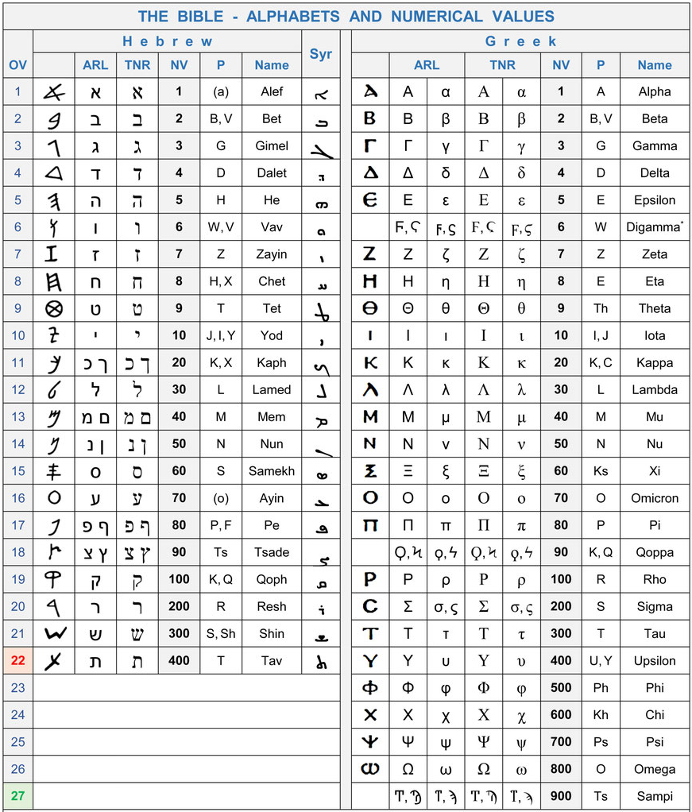
It is through gematria that many, though not all, of the speculative Antichrist candidates have been deduced.
However, another idea is that you understand that the number six represents not a man, but mankind. It was on the sixth day that man was created. Curiously, there is a creation link to the beasts that correspond to the order of the creation of the creatures on days 4-6.

Creation | Monster/enemy
Day 4: Sun, moon, stars | Dragon in the sky, 12:1–17
Day 5: Sea monsters | Beast from sea, 13:1–10
Day 6a: Land animals | Beast from land, 13:11–18
Day 6b: Man and woman | Harlot Babylon, 14:8; 17–18
Day 7: Sabbath | Destruction of harlot, beasts, and dragon

In this way of thinking, you take those 6-6-6 ideas of the speed of sound or the positions of the tropics and so on. Six has a special relationship to earth, man’s home, and so the number is not evil in itself, but man is fallen. Nevertheless, it is a number of the beast, because that beast is human satanic evil.
As interesting as these are, and I think there is a degree of credibility in both basic approaches, though both have huge pits a person can fall into if not careful, neither one is really tethered to exegesis of the words and context the way I think they should be. Better is the idea of looking to the OT for precedent. There are two candidates. The first is 1Kgs 10:14 where 666 talents of gold were accumulated by Solomon. This is mentioned immediately after Solomon reached the pinnacle of his kingship and it comes in a series of how Solomon broke a series of God’s laws for kings (Dt 17:14-17), by multiplying gold, horses, chariots, wives, and committing idolatry. This passage and number fits the perversion of kings through idolatry and economic evil.
A second is Nebuchadnezzar who made an “image” of himself that was sixty cubits high and six cubits wide (Dan 3:1). This also fits the context and could show that symbolism, not literalism, is what is in view with this number. These two OT passages help us bring our chapter to a conclusion. As we do, I want to focus in on the clear theological implications that the beasts have driven us to see and then look to John’s Gospel for one piece of further help that will fit nicely with it.
As many have noticed, “whispers of Trinity” can be found throughout the chapter. We see this in its seven pairings of “threes”:

Revelation 13’s Seven Lists of “Threes”
Sea Beast has: | Horns | Heads | Diadems | (13:1)
Sea Beast is: | Leopard | Bear | Lion | (13:2a)
Dragon gives: | Power | Throne | Authority | (13:2b)
Sea Beast blasphemes: | God | Tabernacle | Heaven-dwellers | (13:7)
“If anyone…” | … has an ear | … is taken | … is slain | (13:9-10)
Receive the mark: | Small and Great | Rich and Poor | Free and Slave | (13:16)
No Buy/Sell with: | Mark | Name | Number | (13:17)

It has been suggested that these triads overlap and interpret each other in a series of mock parodies of the Trinity:

Beasts | Features of sea beast | Gifts of Dragon | Office | Trinity
Sea | Feet/head | Throne | King | Father
Land | Mouth/diadems | Authority | Prophet | Son
Image | Leopard/horns | Power | Priest | Spirit

Listen to this summary from Peter Leithart:

The dragon is the first of the beasts, the sea beast is his exact image and character, as the Son is the express image of the Father. The land beast is a slightly modified sea beast, who does the sea beast’s bidding, who does not speak his own and seeks no glory for himself, but rather speaks what he hears and seeks the glory of the sea beast. The land beast has the power to give life by his breath (πνεύμα, 13:15; a parody of the “Johannine Pentecost” in John 20... Alternatively, the triad within Revelation 13 is a mock Trinity. The sea beast stands in the place of the Father, the land beast is his image, the Son, and the image of the sea beast constructed by the land beast corresponds to the Spirit. Overall, we have a quadrinity: Dragon, sea beast, land beast, image, but this too has its divine original—Father, Son, Spirit, Bride; Father, Son, Spirit, Temple. The parodic trinities thus help us determine the significance of the beast’s image (→13:15–17).

Whichever way you choose to see it (they are not mutually exclusive because it’s a story), the point is, what we have before us, throughout the entire chapter, is a mockery of God the Father, God the Son, and God the Holy Spirit, and possibly also Christ’s bride the Church. That’s what this whole chapter is about.
As with God, so with anti-God. We are dealing here with worship. They worshiped the dragon. As with Christ, so with anti-Christ. We are dealing here with worship. They worshiped also the beast. As with the Holy Spirit, so with Unholy-Spirit. They are worshiping the beast and image. In other words, first and foremost, above all other things, we you must be thinking of worship when you read the totality of Revelation 13. Anti-worship.
This liturgical context will help you understand the Mark of the Beast and 666 in ways that simply escape most people. A recent series of articles dealing with the Covid vaccine and the Mark of the Beast raise anew old questions. Not a few Christians who have been taught ghastly theology have been terrified by thoughts like what if they force me to get it and it is the Mark? Or, what if I accidently already took it? And so on. These didn’t begin in 2020-2021. Beloved, whether the vaccine or a microchip or a tattoo on a person’s forehead or right hand is good or bad, none of those are the Mark of the Beast.
The Mark of the Beast is parallel to the Mark of the Saints that we have already seen and that begins ch. 14. “Then I looked, and behold, on Mount Zion stood the Lamb, and with him 144,000 who had his name and his Father's name written on their foreheads” (Rev 14:1). This is the promised “seal” of the Holy Spirit (Rev 7:4-8), which we saw had an exact parallel in John 6:27, “Do not work for the food that perishes, but for the food that endures to eternal life, which the Son of Man will give to you. For on him God the Father has set his seal” (cf. 2Co 1:22; Eph 1:13; 4:30).
The seal of God is invisible, spiritual, supernatural. It is being born again by the Spirit, given new breath by the Spirit, made a new creation by the Spirit, being conformed into the image of God by the Spirit. The opposite is also spiritual. You can’t see it. You get it when you are born into this fallen world that worships man and Satan. It is having the counterfeit Trinity inside your heart, soul, mind, and strength, such that with every breath you worship your master and father, the Devil.
We can see this exemplified from the parallel to Revelation 13 found in John 13. The important set-up comes in John 12:6. Judas, who has just acted in parallel to the Dragon against the woman Mary who was anointing Christ, attacks her because she poured out good expensive ointment that could have been used to help the poor. Notice, how outwardly Judas’ words seem pious and religious and good. But vs. 6 says, “He said this, not because he cared about the poor, but because he was a thief, and having charge of the moneybag he used to help himself to what was put into it.” To put it another way, Judas wants to control buying and selling. And Judas had the mark to prove it.
In ch. 13, we learn that “the devil” put it into the heart of Judas Iscariot to betray Jesus (John 13:2). But this clever man fooled everyone on the very night he betrayed Jesus. It says that even after when Judas “dipped his hand” (Matt 26:23) in the dish and ate the morsel. His hand was marked and “Satan entered into him” (27) Jesus had seemingly laid it all out on the table and started talking to him, but the disciples thought that he was simply telling him to use the moneybag and “go buy what we need for the feast” (29).
Curiously, in a second parallel that we will see later in Revelation 17, the beast goes to “perdition” (Rev 17:8, 11). In John’s Gospel, in the exact right spot for the parallel, Judas is the only person said to go to perdition in the entire book (John 17:12). Do you hear all the echoes with Revelation 13? Judas is a living, breathing picture of the Earth-Beast and of the heart of the mark! This beast is not the Gentile kingdoms of the world and their fallen-systems. This beast is the spiritual deceivers of the world with their feigned religiosity. It is the counterpart of the Mark of the Lamb, being sealed by the Spirit in the very next verse.
This is made plain in one more way. Remember that the two beasts of Revelation 13 parallel one another to a remarkable degree. The only big difference where there should be a parallel is that with the second beast you have a mark on the forehead that allows you to buy and sell (Rev 13:17). The parallel with the first beast is that the land-dwellers worship the beast (8). To get the mark is to worship the beast and vice-versa, to worship the beast is to have the mark.
The heart of the matter is therefore not to fear that you have accidentally taken the mark or that some truly bestial system might force you not to buy food (that’s happened to Christians before). The heart of the matter is the three “ifs” in the middle of the chapter. “If anyone has a ear, let him hear” (9). Jesus said this often. Unfortunately, I fear far too many do not when it comes to this topic.
“If anyone is to be taken captive, to captivity he goes; if anyone is to be slain with the sword, with the sword must he be slain” (10). This is a paraphrase from Jeremiah 15:2 and 43:11. Jeremiah tells them that God has cursed the unbelieving Israelites to go into captivity and suffer from the sword because of their unbelief. Of course, it wasn’t just unbelievers. True believers suffered too, which is what so many are trying to escape from in their view of the Mark of the Beast.
Thus the center ends, “Here is a call for the endurance and faith of the saints” (Rev 13:10b). When faced with 666 or the Mark of the Beast, the solution is not to decipher the newspaper to figure out how you might escape. The solution is to run to the cross and love not your life, even unto death. We conquer by the blood of the Lamb, through faith alone in Christ alone. It is faith that achieves the victory, because Jesus already has. Don’t be deceived by the second beast. Be illuminated by the Holy Spirit of truth. The only alternative is a beastly, unholy trinity that devours all it touches.

Select Bibliography

“14 People Accused of Being the AntiChrist.” Rose Publishing (March 16, 2016). https://blog.rose-publishing.com/2016/03/16/14-people-accused-of-being-the-anti-christ/#.YL6McjZKi8Y.

Aophos (Adam). “NASA’s 33 666s (Banned by IFERS).” The Flat Earth Society (Jan 23, 2018). https://www.theflatearthsociety.org/forum/index.php?topic=73984.0.

Aune, David E. Revelation 6–16, vol. 52B. Word Biblical Commentary. Dallas: Word, Incorporated, 1998.

Beale, G. K. The Book of Revelation: A Commentary on the Greek Text. New International Greek Testament Commentary. Grand Rapids, MI; Carlisle, Cumbria: W.B. Eerdmans; Paternoster Press, 1999.

Beale, G. K. and Campbell, David H. Revelation: A Shorter Commentary. Grand Rapids, MI; Cambridge, U.K.: William B. Eerdmans Publishing Company, 2015.

Berg, Leo. The Superman in Modern Literature. London: Jarrold & Sons, 1915.

Bohlinger, Tavis. “COVID-19 and The Mark of the Beast.” theLAB (May 9, 2020). http://academiclogos.wpengine.com/covid-19-and-the-mark-of-the-beast/;

Friesen, Steven J. “Myth and Symbolic Resistance in Revelation 13.” Journal of Biblical Literature 123.2 (2004): 281-313. https://www.academia.edu/8660357/Myth_and_Symbolic_Resistance_in_Revelation_13.

Gage, Warren Austin. John’s Gospel: A Neglected Key to Revelation? Fort Lauderdale, FL: Warren A. Gage, 2001.

Gentry Kenneth L. Jr. The Divorce of Israel: A Redemptive-Historical Interpretation of Revelation. Dallas, GE: Tolle Lege Press, forthcoming.

“H.R.6666 – COVID-19 Testing, Reaching, and Contacting Everyone (TRACE) Act.” congress.gov (5-1-2020). https://www.congress.gov/bill/116th-congress/house-bill/6666/text.

Halsted, Matthew L. PhD. “The Covid Vaccine has 666 Written All Over It… and Why that Doesn’t Matter According to Revelation.” theLAB (May 18, 2020). https://academic.logos.com/the-covid-vaccine-has-666-written-all-over-it-and-why-that-doesnt-matter-according-to-revelation/#easy-footnote-bottom-1-12281.

Heiser, Michael S. “666: What Theories Add Up?” LogosBlog (March 12, 2019). https://blog.logos.com/666-what-theories-add-up/.

Jericho, Jay & The Free School. 666 Phenomenon (July 2019). https://www.slideshare.net/thefreeschool/666-phenomenon-the-simpsons-et-al-free-book?from_action=save.

Larkin, Clarence. The Book of Revelation: A Study of the Last Prophetic Book of Holy Scripture. Philadelphia, PA: Rev. Clarence Larkin Estate, 1919.

Leithart, Peter J. Revelation. The International Theological Commentary on the Holy Scripture of the Old and New Testaments. Ed. Michael Allen and Scott R. Swain, vol. 2. London, Bloomsbury Publishing Plc, 2018.

Mauro, Philip. The Number of Man: The Climax of Civilization. Boston: Hamilton Bros, 1909.

Omanson, Roger L. and Metzger, Bruce Manning. A Textual Guide to the Greek New Testament: An Adaptation of Bruce M. Metzger’s Textual Commentary for the Needs of Translators. Stuttgart: Deutsche Bibelgesellschaft, 2006.

Prikryl, Nelson The Face of Jesus. Murrells Inlet, SC: Covenant Books, Inc., 2020.

Russell, Todd. “List of Movies with 666 In Title.” MovieReviewsByUs (June 6, 2020). https://moviereviewsbyus.com/2020/06/06/list-of-movies-with-666-in-title/.

Strand, Kenneth A. “Chiastic Structure and Some Motifs in the Book of Revelation.” Andrews University Seminary Studies (AUSS) 16.2 (1978): 401-08. https://core.ac.uk/download/pdf/232862857.pdf.

Todd Russell, “List of Movies with 666 In Title,” MovieReviewsByUs (June 6, 2020), https://moviereviewsbyus.com/2020/06/06/list-of-movies-with-666-in-title/.
Most of these logos were in a book I downloaded free. Jay Jericho & The Free School, 666 Phenomenon (July 2019), https://www.slideshare.net/thefreeschool/666-phenomenon-the-simpsons-et-al-free-book?from_action=save.
A short summary with some helpful short information on how these were “figured out” is “14 People Accused of Being the AntiChrist,” Rose Publishing (March 16, 2016), https://blog.rose-publishing.com/2016/03/16/14-people-accused-of-being-the-anti-christ/#.YL6McjZKi8Y.
Aophos (Adam), “NASA’s 33 666s (Banned by IFERS),” The Flat Earth Society (Jan 23, 2018), https://www.theflatearthsociety.org/forum/index.php?topic=73984.0.
For example, “Oregon Reports 666 new COVID-19 cases, 3 more deaths.” FOX 12 Oregon (Jan 18, 2021), https://www.kptv.com/news/oregon-reports-666-new-covid-19-cases-3-more-deaths/article_8bd13bac-59d3-11eb-8ffd-7b550e1d1059.html; “SC Announces 666 new COVID-19 cases, 25 more deaths Tuesday,” WIS 10 News (Oct 20, 2020), https://www.wistv.com/2020/10/20/sc-announces-new-covid-cases-more-deaths-tuesday/; “Tennessee Reports 666 New COVID-19 Cases, 7 Deaths, and 1,697 Recoveries on Friday,” ABC 6 wate.com (Oct 16, 2020), https://www.wate.com/health/coronavirus/tennessee-reports-666-new-covid-19-cases-7-deaths-and-1697-recoveries-on-friday/; “Hospitals Report Uptick in COVID-19 Patients as Arizona Adds 666 New Cases,” AZ Central (Nov 2, 2020), https://amp.azcentral.com/amp/6121736002;
“1. W02020060606 – Cryptocurrency System Using Body Activity Data,” Patentscope, https://patentscope.wipo.int/search/en/detail.jsf?docId=WO2020060606.
“H.R.6666 – COVID-19 Testing, Reaching, and Contacting Everyone (TRACE) Act,” congress.gov (5-1-2020), https://www.congress.gov/bill/116th-congress/house-bill/6666/text.
Curiously, decades before the comic Superman even appeared, people were calling the Antichrist “Superman” (sometimes while discussing Nietzsche’s Übermensch; sometimes not). See Philip Mauro, The Number of Man: The Climax of Civilization (Boston: Hamilton Bros, 1909), 234-35; Leo Berg, The Superman in Modern Literature (London: Jarrold & Sons, 1915), 64; Clarence Larkin, The Book of Revelation: A Study of the Last Prophetic Book of Holy Scripture (Philadelphia, PA: Rev. Clarence Larkin Estate, 1919), 124. Larkin calls him “Satan’s Superman” (Rightly Dividing the Word, 105). On krypton and 36 see R. Nelson Prikryl, The Face of Jesus (Murrells Inlet, SC: Covenant Books, Inc., 2020). He’s not actually making this full argument, but he’s the source I first found. https://books.google.com/books?id=VckuEAAAQBAJ&newbks=0&printsec=frontcover&pg=PT21&dq=Orbital+velocity+of+the+earth+around+the+sun+666+beast&hl=en&source=newbks_fb#v=onepage&q=Orbital%20velocity%20of%20the%20earth%20around%20the%20sun%20666%20beast&f=false
Kenneth A. Strand, “Chiastic Structure and Some Motifs in the Book of Revelation,” Andrews University Seminary Studies (AUSS) 16.2 (1978): 403 [401-08], https://core.ac.uk/download/pdf/232862857.pdf.
Also 1En 60:7-9, 24; 3 Enoch 48D.8; 2 Baruch 29:4; Cave of Treasures 1:22; 4Ezra 6:49. See Steven J. Friesen, “Myth and Symbolic Resistance in Revelation 13,” JBL 123.2 (2004): 281-313. https://www.academia.edu/8660357/Myth_and_Symbolic_Resistance_in_Revelation_13. I wanted to mention this in a note because he has a fascinating little chart describing the difference between fable, legend, history, and myth:
Peter J. Leithart, Revelation, ed. Michael Allen and Scott R. Swain, vol. 2, The International Theological Commentary on the Holy Scripture of the Old and New Testaments (London; Oxford; New York; New Delhi; Sydney: Bloomsbury; Bloomsbury T&T Clark: An Imprint of Bloomsbury Publishing Plc, 2018), 45–46.
As it is the center of a chiasm, it is not just the first beast, but the two together that the warning composes.
These two verses are full of interesting relationships. For example: vv. 9-10 vs. 9a vs. 9b a. If anyone: Has an ear / hear A. Anyone taken A. Anyone slain b. If anyone: Taken captive B. Captive B. With the sword c. If anyone: Slain with the sword B¹. To captivity B¹. With the sword Concl. Here is a call to endure by faith A¹. He goes A¹. He must be slain
Kenneth A. Strand, “Chiastic Structure and Some Motifs in the Book of Revelation,” Andrews University Seminary Studies (AUSS) 16.2 (1978): 403 [401-08], https://core.ac.uk/download/pdf/232862857.pdf.
Going Deeper: The only difference being that Daniel’s first beast has eagle’s wings. Curiously, just prior to this beast of the sea, the woman was “given the two wings of the great eagle” so that she might fly from the serpent into the wilderness (Rev 12:14). In the Exodus (which is also related to Revelation 12, God bore Israel “on eagles wings” and brought them to himself” (Ex 19:4). Given the proximity of this woman’s wings to Daniel and the overlap with the Exodus, it seems plausible that God is sending the woman into the wilderness via this beast so that he might force her to gain her nourishment from Him in its time of trial and testing.
Leithart, 2:51.
Larkin, 120–121.
Gentry cites A. Collins, Moffat, Stuart, deSilva, and Court, and takes the same view. Gentry, 2:204.
G. K. Beale and David H. Campbell, Revelation: A Shorter Commentary (Grand Rapids, MI; Cambridge, U.K.: William B. Eerdmans Publishing Company, 2015), 269.
Ibid., 270.
Beale, 269.
For fear of running out of space with stuff we’ve seen before, here is a recap: As we’ve seen in our interpretation, the numbers are all significant. 42 months is lunar time, time reckoned by the moon. As such, it is the time of darkness. 1,260 days is solar time, time reckoned by the sun. As such, it is the time of light. The Gentiles are trampling the holy city, the heavenly Jerusalem, for forty-two months. Now, the beast is exercising authority for forty-two months. At the same time, the two witnesses are prophesying for 1260 days—a parallel time frame, but from the perspective of God rather than Satan. Those witnesses are the church, who is sent into the wilderness for the same period of time to be nourished by God. But the chiasm matters, because its center is the 3 ½ days, a time frame which closely resembles and is certainly tied in the text to Jesus’ death and resurrection. And so, for a period that is the same basic number in all three instances, the church is attacked by the devil as the body emulates the Head.
“ נרון nrwn = 306 plus קסר qsr = 360, making 666 (נ = 50; ר = 200; ו = 6; נ = 50; ק = 100; ס = 60; ר = 200).” David E. Aune, Revelation 6–16, vol. 52B, Word Biblical Commentary (Dallas: Word, Incorporated, 1998), 770. Going Deeper. There is a textual variant that Metzger gives almost no credibility which is the number 616 rather than 666. Aune explains, “One possible origin for 616 as a variant of 666 in the MS tradition is the fact that the Latin form “Nero Caesar” transliterated in Hebrew characters is spelled נרו קסר nrw qsr, the numerical equivalent of which is 616: נרו nrw = 256 plus קסר qsr = 360 (נ = 50; ר = 200; ו = 6; ק = 100; ס = 60; ר = 200).” David E. Aune, Revelation 6–16, vol. 52B, Word Biblical Commentary (Dallas: Word, Incorporated, 1998), 770–771. See also Roger L. Omanson and Bruce Manning Metzger, A Textual Guide to the Greek New Testament: An Adaptation of Bruce M. Metzger’s Textual Commentary for the Needs of Translators (Stuttgart: Deutsche Bibelgesellschaft, 2006), 539.
Aune, 722.
Leithart, 45.
See the excellent discussion in G. K. Beale, The Book of Revelation: A Commentary on the Greek Text, New International Greek Testament Commentary (Grand Rapids, MI; Carlisle, Cumbria: W.B. Eerdmans; Paternoster Press, 1999), 727-28. Heiser gives a third idea, which is deals with “magic squares” that match like an ancient form of Sudoku. Magic squares were associated with the seven “wandering stars.” This one deals with the Sol (Sun) square which has numbers 1-36 (we’ve seen that number today) set into six rows of lines each equaling 111 (111 x 6 = 666). Zeus was associated with the Sun and Zeus was associated with Baal. Baal and Satan are clearly related, and thus, the mark of the beast would be 666. This one is curious in that it takes the eyes off the earth and puts them back in the heavens. See Michael S. Heiser, “666: What Theories Add Up?” LogosBlog (March 12, 2019), https://blog.logos.com/666-what-theories-add-up/.
In Leithart, 2:46-47.
Ibid., 47.
Leithart, 2:47.
See Tavis Bohlinger, “COVID-19 and The Mark of the Beast,” theLAB (May 9, 2020), http://academiclogos.wpengine.com/covid-19-and-the-mark-of-the-beast/; Matthew L. Halsted, PhD, “The Covid Vaccine has 666 Written All Over It… and Why that Doesn’t Matter According to Revelation,” theLAB (May 18, 2020), https://academic.logos.com/the-covid-vaccine-has-666-written-all-over-it-and-why-that-doesnt-matter-according-to-revelation/#easy-footnote-bottom-1-12281.
This is in Gage’s book on John and Revelation as well as many online talks he has done.
Leithart sees two more structures with the second beast, both of which have the beast’s deception at the center. Smith and others see the same center. Deception is the heart of the second beast’s work, just like illumination is the counterpart work of the Holy Spirit.

