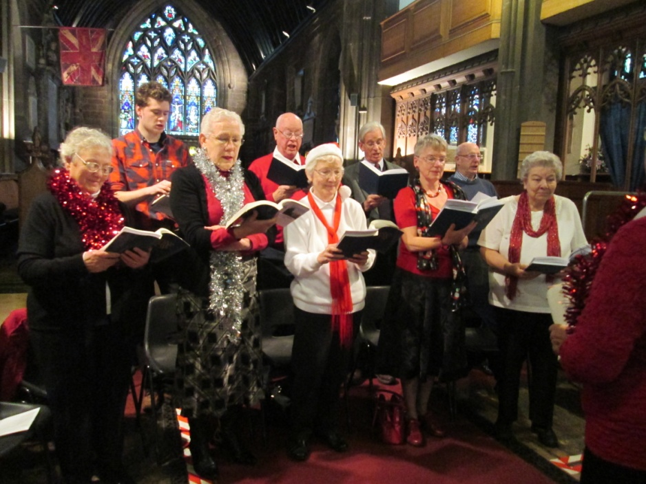
Lunchtime Carols on Tuesday with the “St Mary’s Tuesday Choir” led by Eileen Lockett

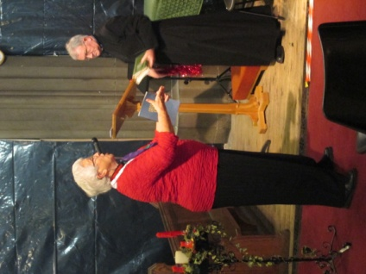

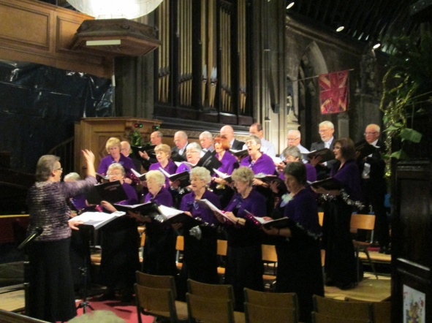
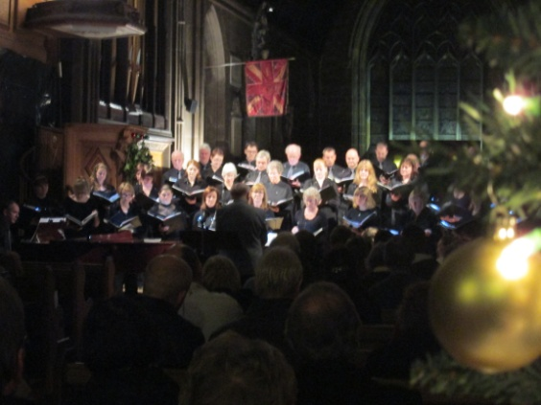
Thursday and it was the turn of Vernon Park School, over 150 children singing carols and reading Christmas stories and poems. Once again it was a full-house and a most enjoyable service for children and adults alike. Friday, and the Shopmobility Stockport Carol Service with Offerton Methodist Choir. The week ended in semi-candle
light with “Sing Christmas” and
the Maia Singers and Stockport
Youth Choir.

We wish you all
a Very Happy Christmas & New Year
St Mary’s in the Marketplace.

Issue No 23 (23rd December)
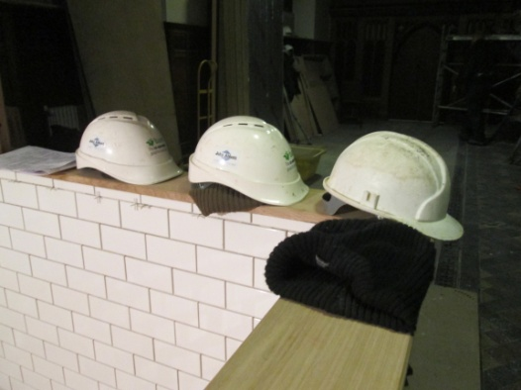
“Securing the future for the next 100 years”
Hats off….
Temporary silence from the
roof and behind the black
screens as everyone takes a
well earned break over
Christmas and New Year.
Before going home for the holidays our contractors have been busy doing as much work as possible and to clear the decks (as it were) ready for starting again in the New Year. We wish them all a very Happy Christmas and look forward to their return in January.
The last lap towards completion of Phase 5 of the Tower and Phase 1 (in the most part) of the Interior. We still need a little more “cash” to pay for the glazing of the Memorial Chapel and if at all possible sufficient funding to authorise the building of the raised platform and chair stores.
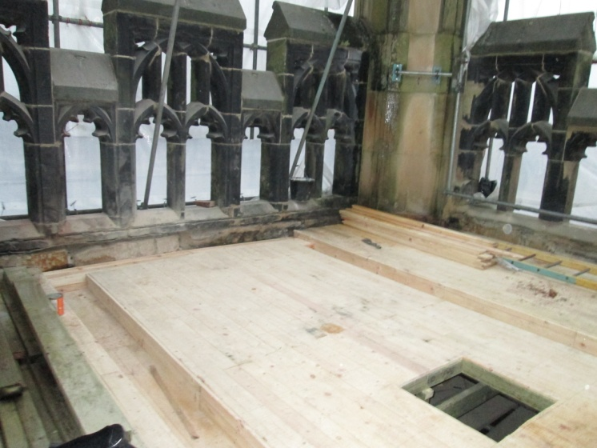
As can be seen from the photograph, the re-roofing of the tower is taking shape – what’s that square bit you may be wondering – well that is where the new flag pole will be fitted, it won’t be long now before we flying the flag in 2013.
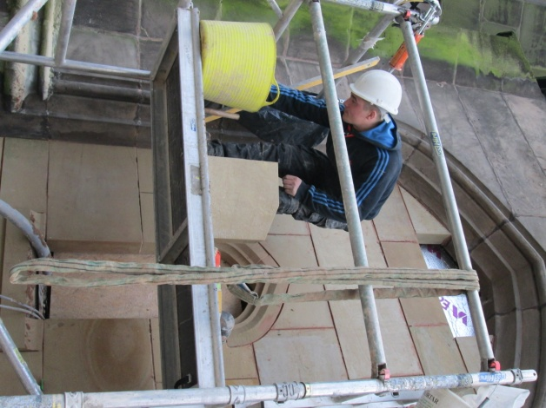
There is still quite a lot
of work to be completed
on the stonework,
replacing and restoring,
drilling and securing
with new rods.
Quite a task!

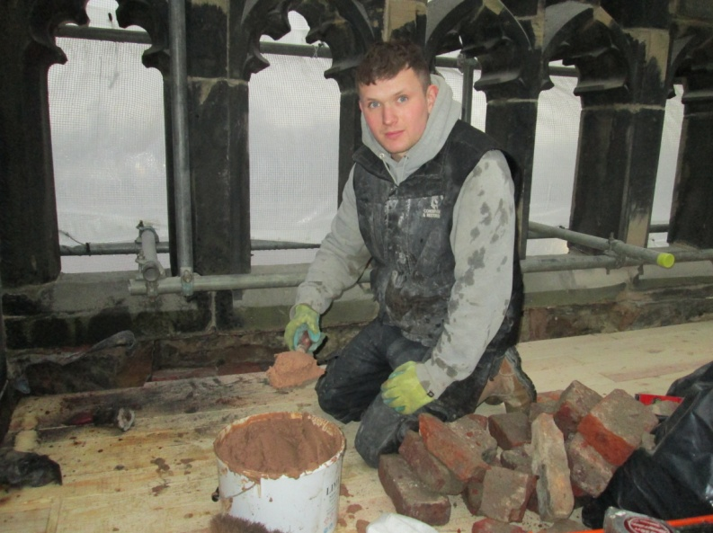
.

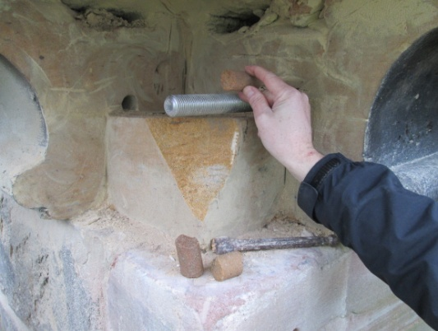

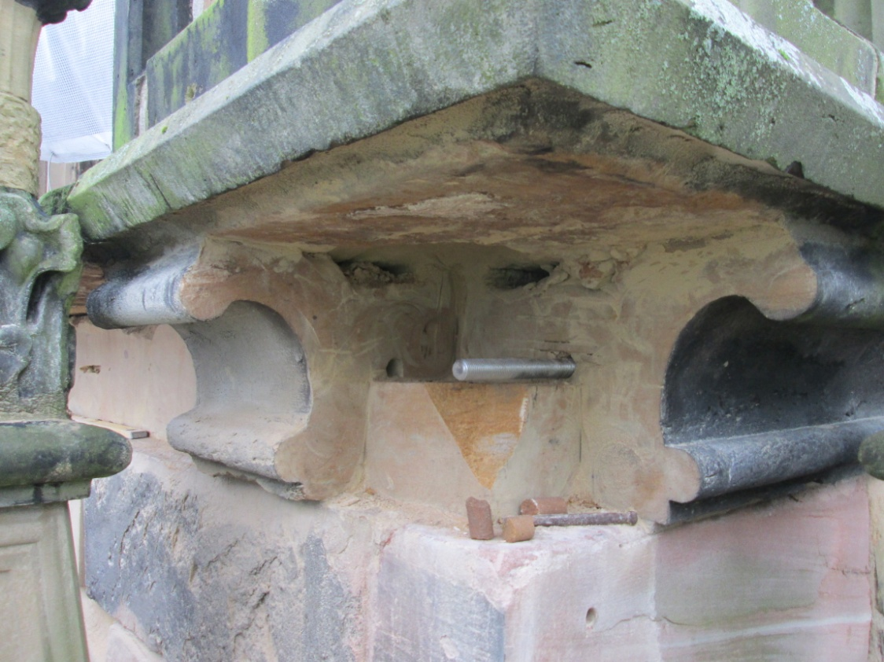

Meanwhile indoors and the new toilet cubicles and looking rather smart, the stonework on the outside most impressive and the kitchen floor is finished. A gentleman with a briefcase called in during the week - who turned out to be the kitchen equipment supplier – so we certainly are on the last lap ….
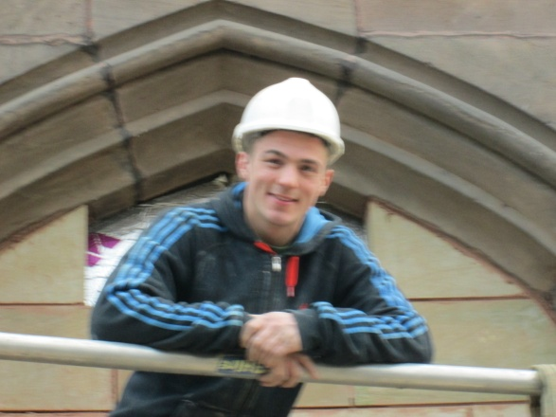

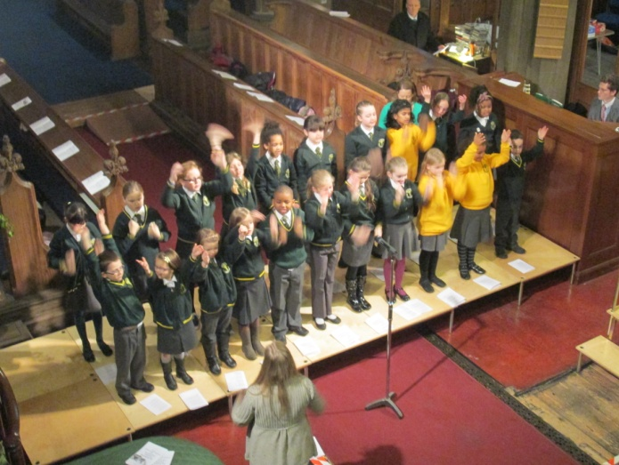
For the “St Mary’s Team” it has been another busy but fantastic week starting with The Wellspring Carol Service on Monday with St Joseph’s Catholic Primary School and Wellspring representative Abdul Dene singing a wonderful solo item.

